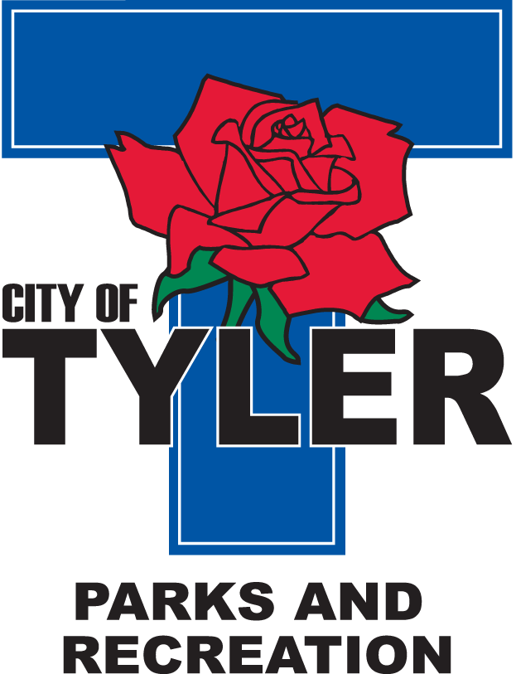  Welcome to The Tyler Senior Center  Open 9a.m.-5p.m. Monday-Friday    1915 Garden Valley Road (903) 597-0781    Meals on Wheels Lunch Served Daily 11:30a.m.-12:30p.m. | January  2023  Activities are subject to change
Monday | Tuesday | Wednesday | Thursday | Friday
2  CLOSED  for New Year Holiday   | 3  10:00 Painting 11:00 Range of Motion  11:30 Clogger  12:30 Line Dancers  12:30 POPCORN | 4  10:00 Coffee Center Chat  11:00 Bodyworks  12:30 Bridge Club  12:30 BINGO with Brookdale Senior Living | 5  11:00 Range of Motion  12:00 G.V. Singers  12:30 Line Dancers  12:30 Vision Board Party | 6  11:00 Bodyworks  12:00 42 Game  12:30 Bridge Club  12:30 POPCORN
9  11:00 Bodyworks  12:00 UT Health Lifestyle Programs  12:30 Bridge Club | 10  10:00 Painting 11:00 Range of Motion  11:30 Clogger  12:30 Line Dancers  12:30 POPCORN  2:00 AARP | 11  11:00 Bodyworks  12:30 Bridge Club  12:30 BINGO with Quita from Oakstreet | 12  11:00 Range of Motion  12:00 G.V. Singers  12:30 Line Dancers  12:30 Left, Right, Center Game  1:00 Line Dance Class  2:00 AARP | 13  11:00 Bodyworks  12:00 42 Game  12:30 Bridge Club  12:30 POPCORN
16  CLOSED  for MLK DAY | 17  10:00 Painting 11:00 Range of Motion  11:30 Cloggers  12:00 Line Dancers  12:30 POPCORN | 18  11:00 Bodyworks  12:30 Bridge Club  12:30 BINGO with Madison Cannedy from Reunion Plaza | 19  11:00 Range of Motion  12:00 G.V. Singers  12:30 Line Dancers  12:30 Left, Right, Center Game  National Popcorn Day  | 20  11:00 Bodyworks  12:00 42 Game  12:30 Bridge Club  12:30 POPCORN  Friday Night Dance-doors open at 6pm-Music by Ruffshod Band
23  11:00 Bodyworks  12:30 Bridge Club  12:30 Cooking Club with Brittany from Visiting Angels | 24  10:00 Painting  10:00 Medicare by Steve Davis 11:00 Range of Motion  11:30 Cloggers  12:30 Line Dancing  12:30 POPCORN | 25  11:00 Bodyworks  12:30 Bridge Club  12:30 BINGO with Jessilyn from Humana | 26  11:00 Range of Motion  12:00 Lunch N Learn with Pinecrest Nursing and Rehab  12:00 G.V. Singers  12:30 Line Dancers  12:30 Left, Right, Center Game  1:00 Line Dance Class | 27  11:00 Bodyworks  12:00 42 Game  12:30 Bridge Club  12:30 POPCORN
30  11:00 Bodyworks  12:00 UT Health Lifestyle Programs  12:30 Bridge Club | 31  10:00 Painting 11:00 Range of Motion  11:30 Cloggers  12:30 Line Dancing  12:30 Musical Chairs

