Beauty and the Box Program

Boxes by Intersection

 | Picture | Intersection | Artist/Sponsor | Date
1 | 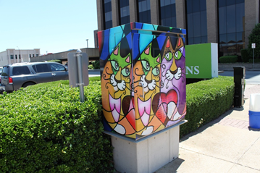 | #25  Broadway Ave. & Locust St. | Valeria Barnhill /  KTyB | 2016
2 | 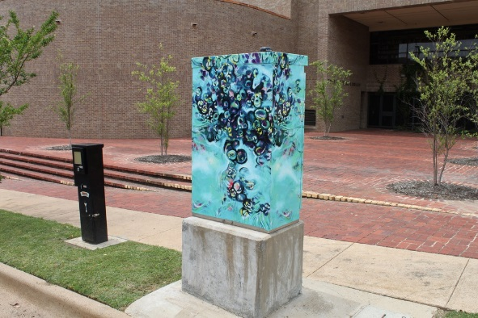 | #41  College Ave. & Elm St. | Lisa Horlander / KTyB | 2016
3 | 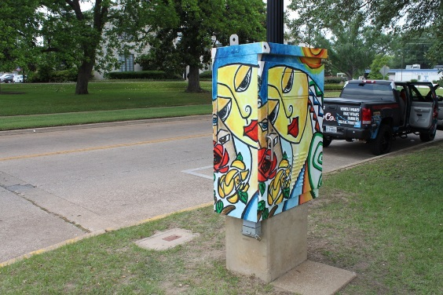 | #29  Bonner Ave. and W Ferguson St. | Debbie Kirkland Waffer  / KTyB | 2016
4 | 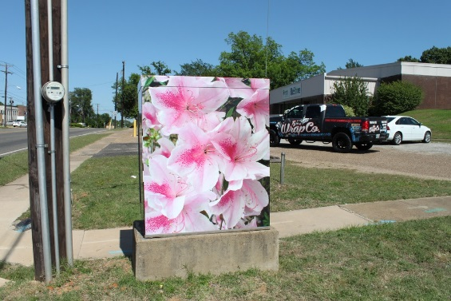 | #52  Front St. & W Palace Ave. | Sylvia Morse  / KTyB | 2016
5 | 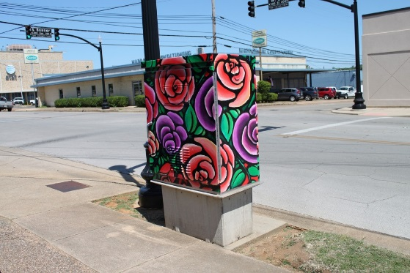 | #43  Bonner Ave. and W Elm St. | Valeria Barnhill / KTyB | 2016
6 | 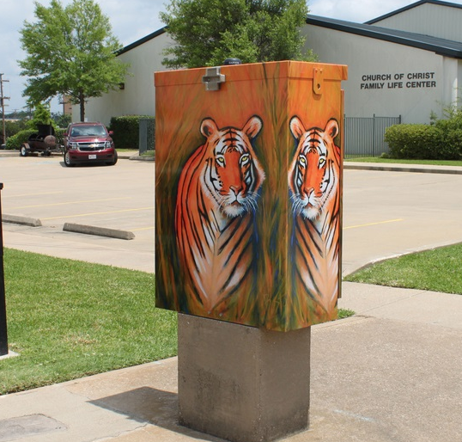 | #29  Bonner Ave. and Erwin St. | Brian Stone /  KTyB | 2016
7 | 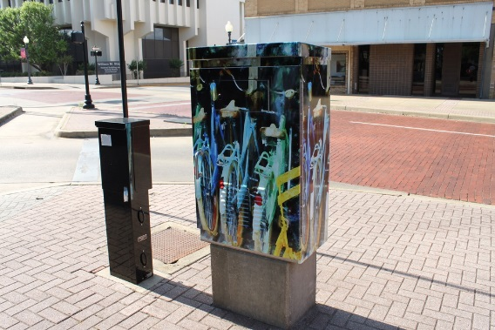 | #27  N. College Ave. & W. Ferguson St. | Dennis Carson / KTyB | 2016
8 | 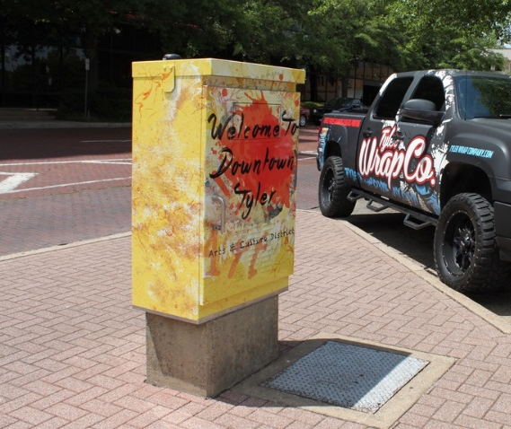 | Erwin St. and N. College Ave. | Matthew Martin | 2016
9 | 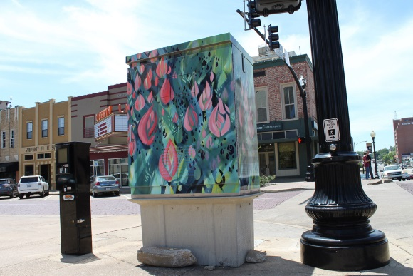 | #32  Broadway Ave. & Erwin St. | Lisa Horlander / KTyB | 2016
10 | 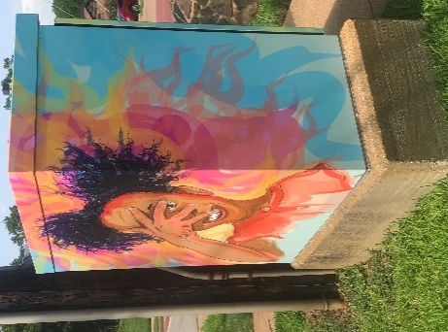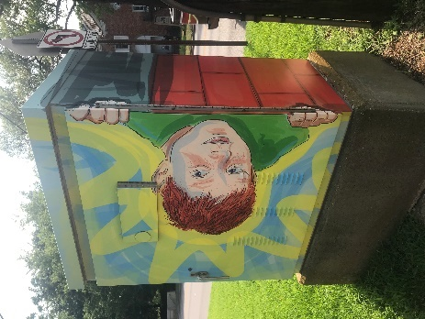 | #64  Broadway Ave. & Dobbs St. | April Moore / KTyB | 2016
11 | 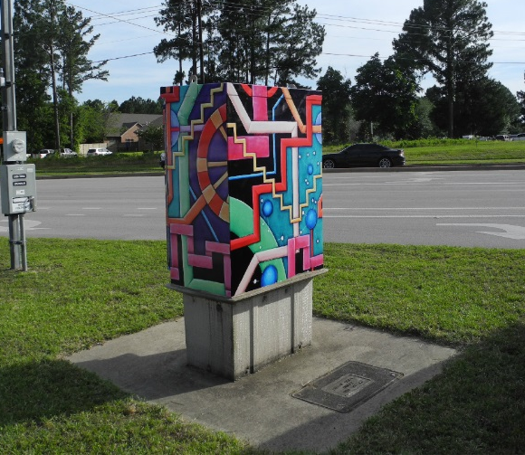 | #103  University Dr. & Old Omen. | Valeria Barnhill / KTyB | 2016
12 | 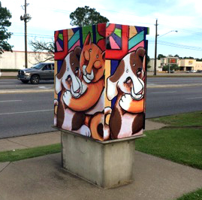 | #115 Broadway Ave. & Independence Dr. | Valeria Barnhill / KTyB | 2016
13 | 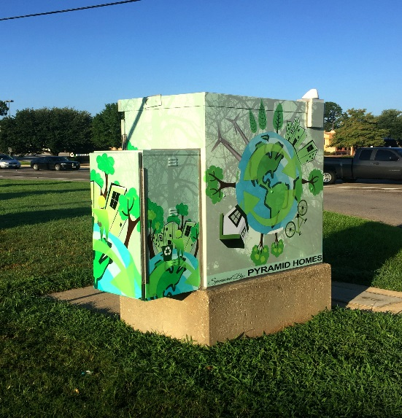 | #109  Loop 323 & Broadway Ave. | Anwar Khalifa / Pyramid Homes | 2017
14 | 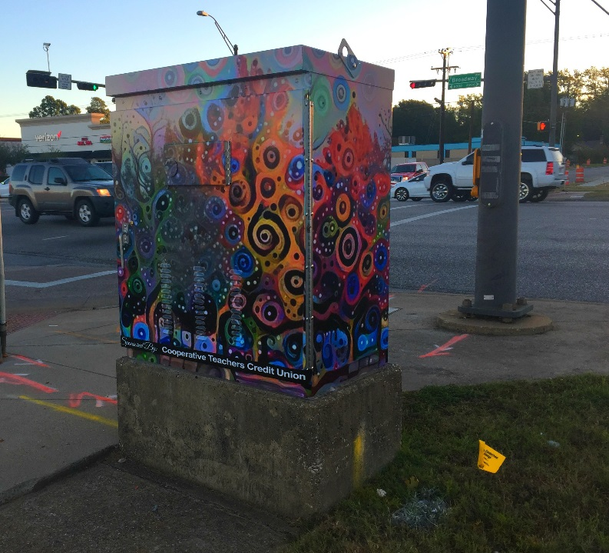 | #137  Broadway Ave. & Southtown Dr. | William Wright / CTCU | 2017
15 | 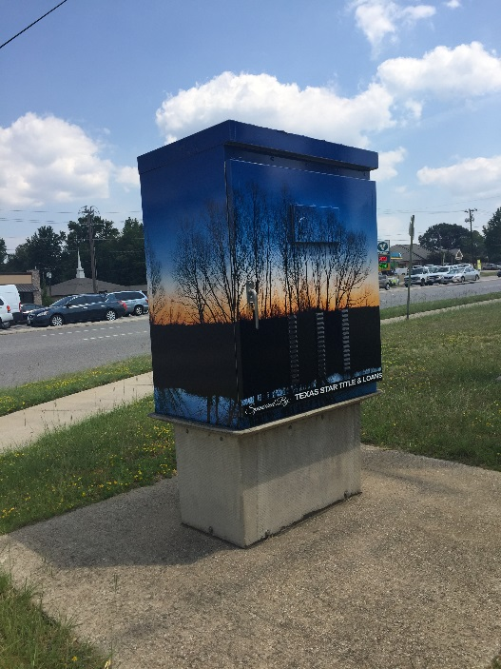 | #133  Broadway & Grande Blvd. | Dolph Miller | 2017
16 | 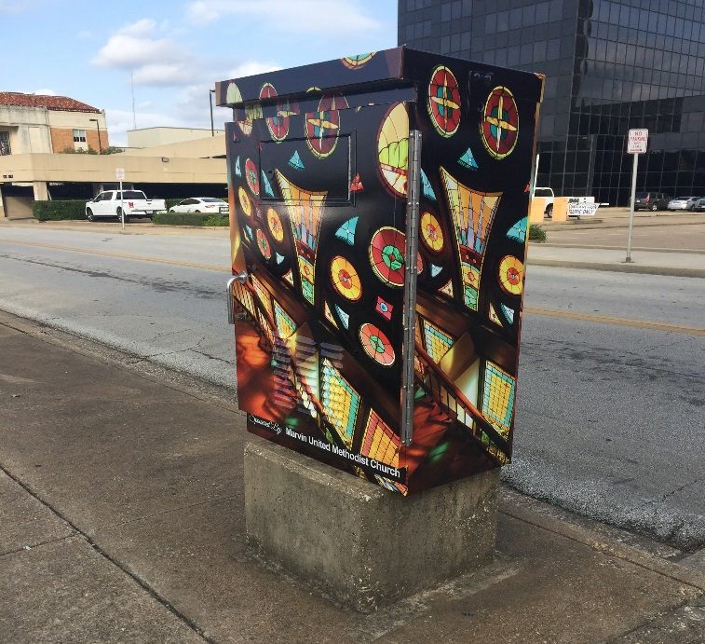 | #34  Bois D’arc Ave. & Erwin St. | Linda Davidson | 2017
17 | 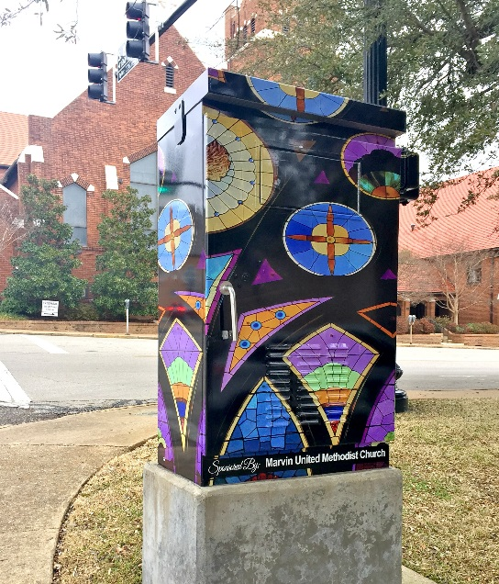 | #42  Elm St. & Bois D’arc Ave. | Diane Hawkins | 2018
18 | 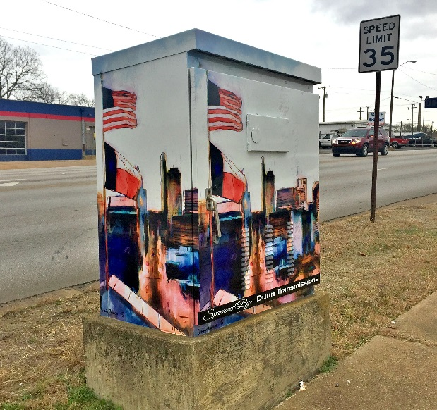 | #36  Palace Ave. & Erwin St. | Dennis Carson | 2018
19 | 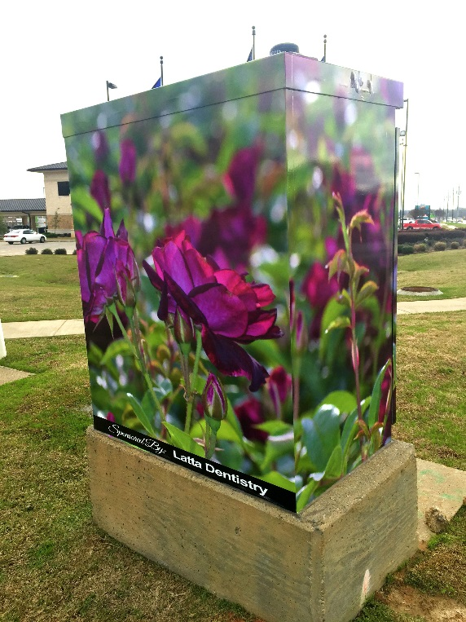 | #135  Old Jacksonville Hwy & Grande Blvd. | David  Di Paolo / Latta Dentistry | 2018
20 | 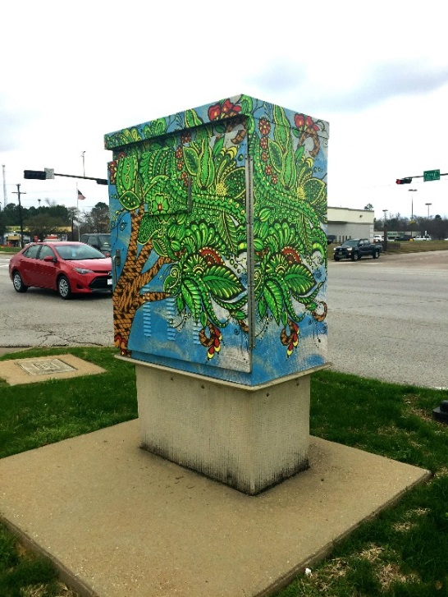 | #114  Troup Hwy. & Lindbergh | Julia Bradshaw  Maudlin / Expedition Texas | 2018
21 | 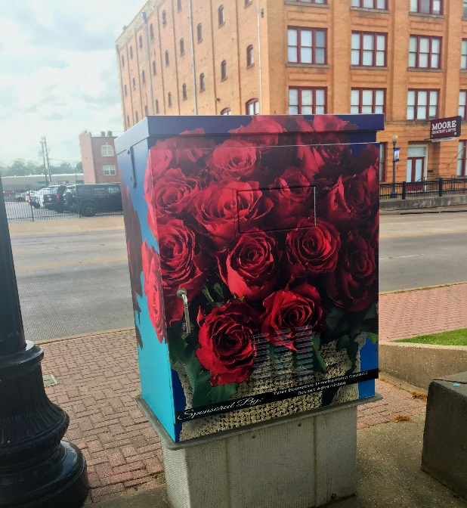 | #24  Broadway Ave. & Line St. | Route2 Advertising / Tyler Chamber & Visit Tyler | 2018
22 | 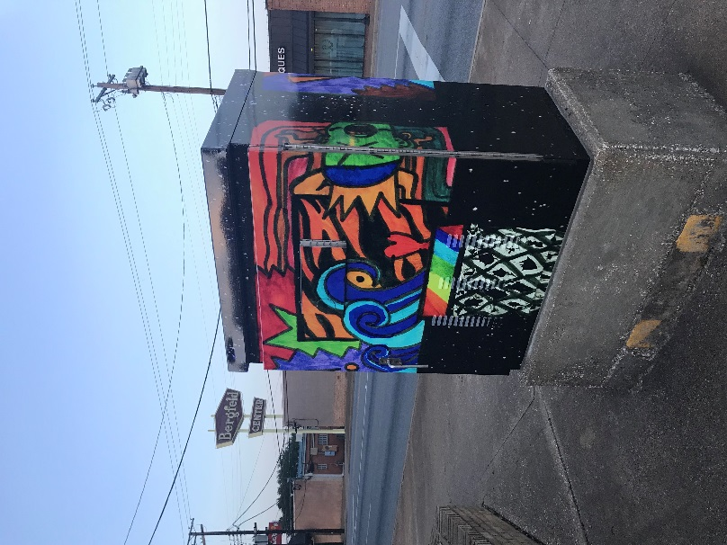 | #85  Broadway Ave. & 8th St. | Daryll Phillips | 2018
23 | 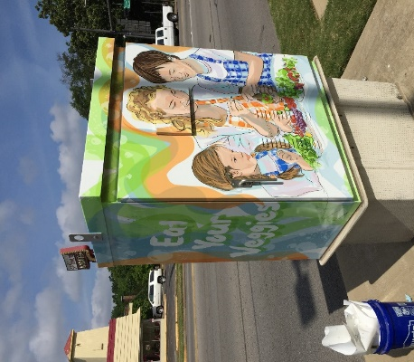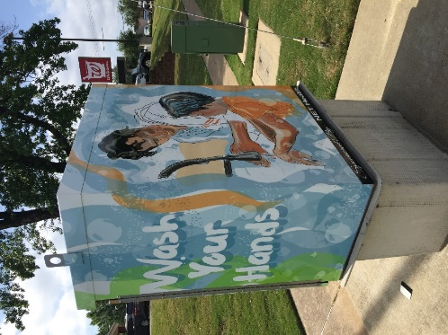 | #79  Broadway & 4th / 5th | April Moore / NET Health | 2018
24 | 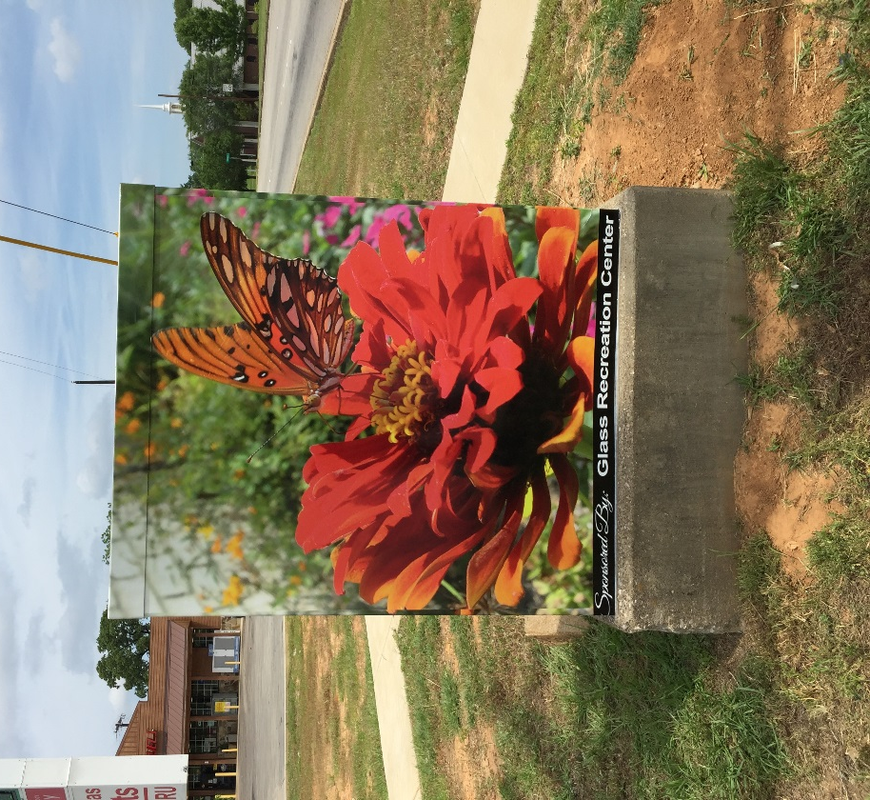 | #7  Broadway Ave. & MLK Blvd. | Dorothy Hersey / GRC | 2018
25 | 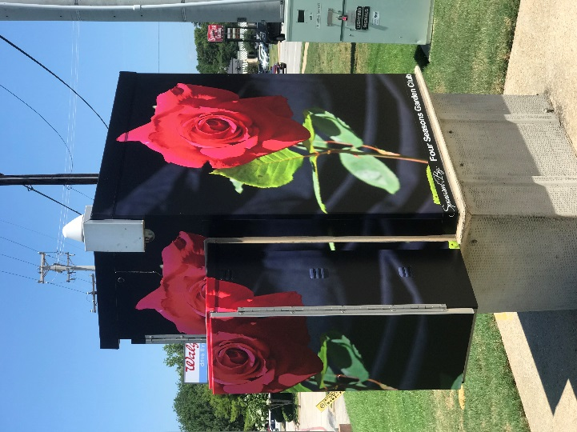 | #105  Troup Hwy. & Loop 323 | Linda Davidson / Four Seasons Garden Club | 2018
26 | 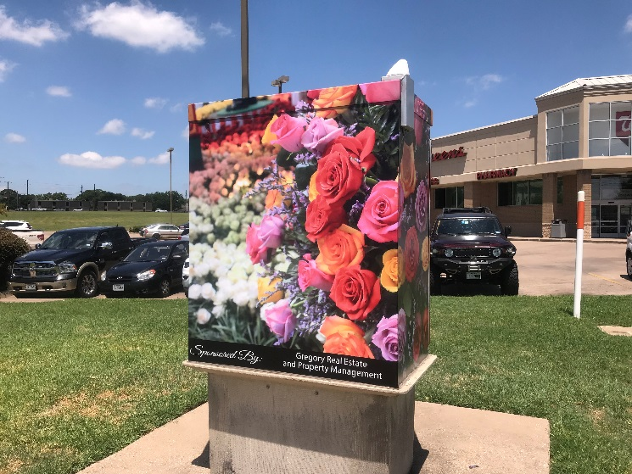 | #126  Broadway Ave. & Rieck Rd. | Dorothy Hersey | 2018
27 | 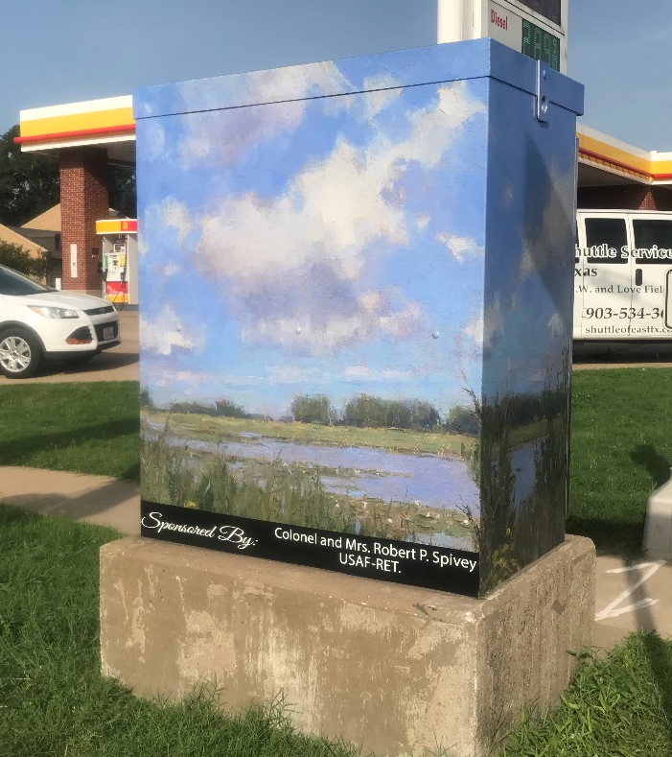 | #128 Broadway Ave. & Chimney Rock / Donnybrook | Diane Frossard / Col. & Mrs. Robert P. Spivey | 2018
28 | 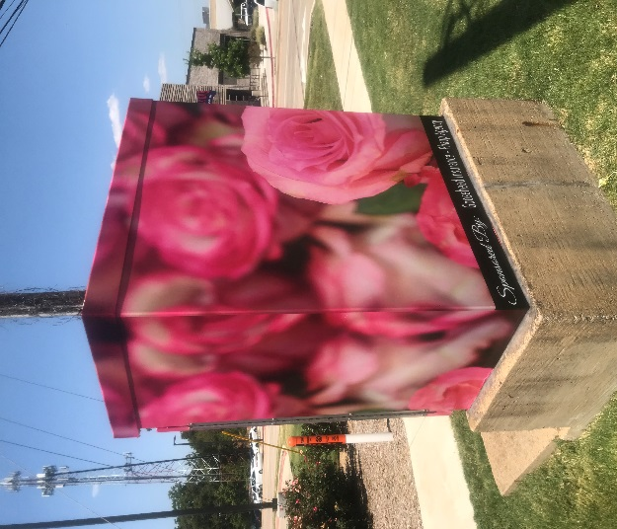 | #136  Broadway Ave. & Robert E. Lee Dr. | Unknown / Goosehead Insurance | 2018
29 | 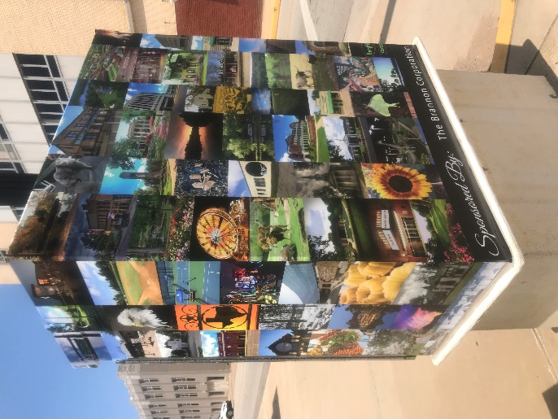 | #40  Broadway Ave. & Elm St. | Various / The Brannon Corp. | 2018
30 | 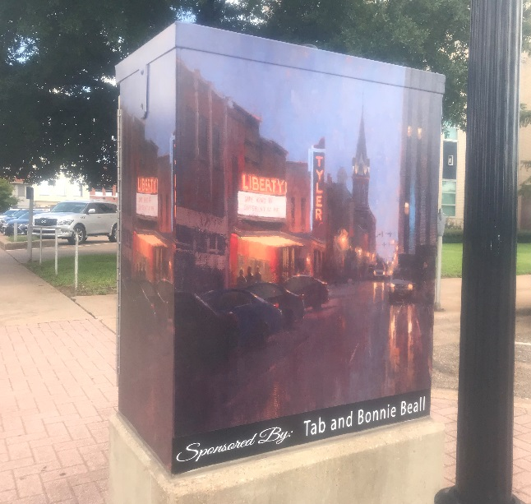 | #26  Broadway Ave. & Ferguson | Diane Frossard / Tab & Bonnie Beall | 2018
31 | 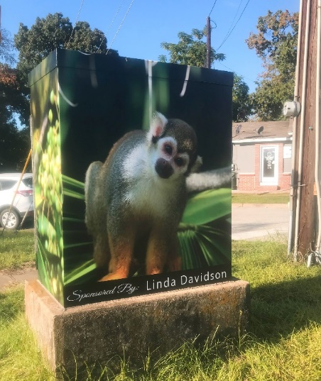 | #9  W. Gentry & MLK | Linda Davidson / Linda Davidson | 2018
32 | 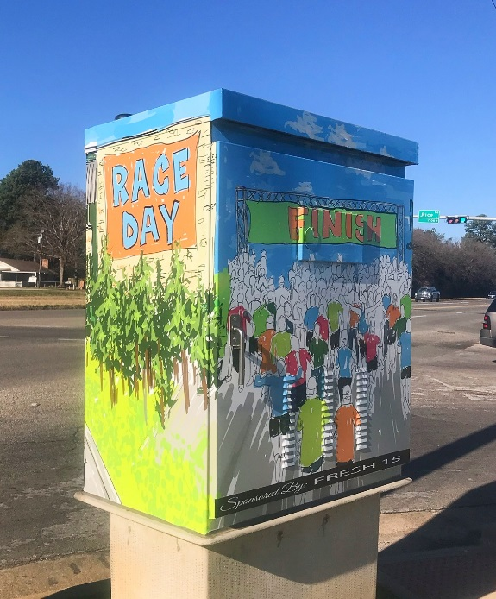 | #124  Old Jacksonville Hwy. & Rice Rd. | Brookshire’s / Fresh 15 | 2018
33 | 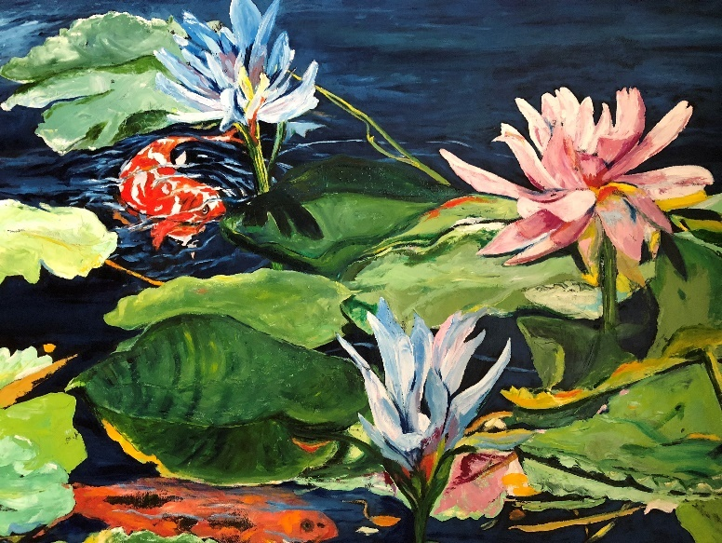 | #142  Broadway Ave. & Cumberland | Linda Schooley / Heather & David Zimmerman | 2018
34 | 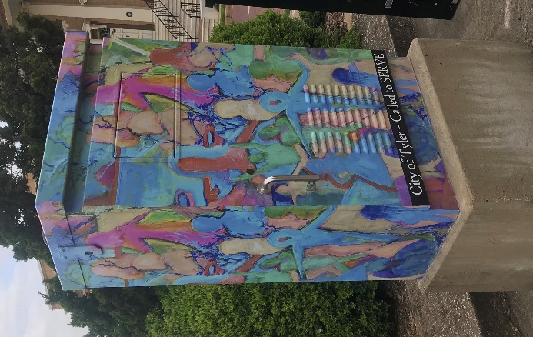 | #34  Bois D’Arc & Ferguson | Linda Schooley / City of Tyler Called2SERVE | 2019
35 | 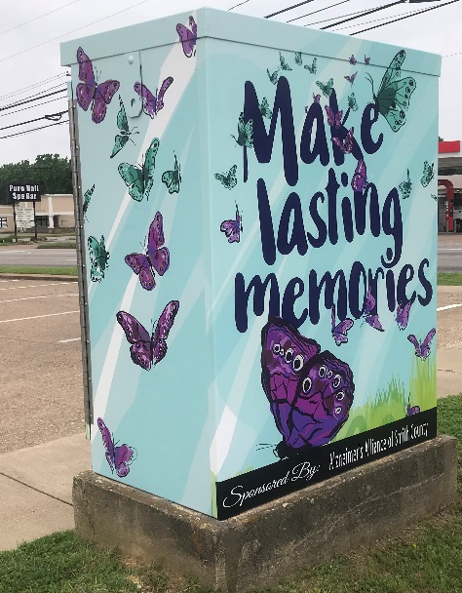 | #100  Broadway Ave. & Amherst | April Moore / Alzheimer’s Alliance | 2019
36 | 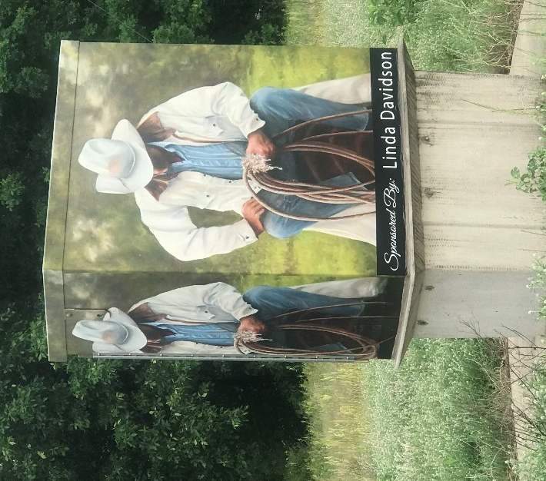 | #96  Loop 323 & Briarwood | Linda Davidson / Linda Davidson | 2019
37 | 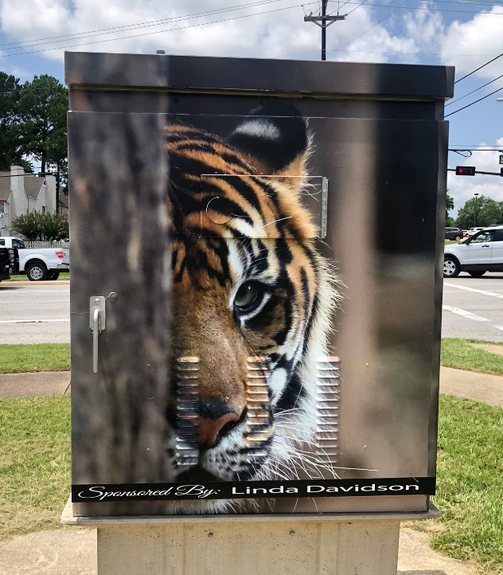 | #99  Troup Hwy & Golden Rd. | Linda Davidson / Linda Davidson | 2019
38 | 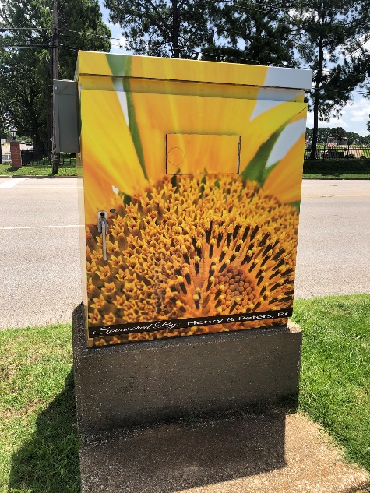 | #94  Broadway Ave. & Old Troup Hwy. | David DiPaolo / Henry & Peters P.C. | 2019
39 | 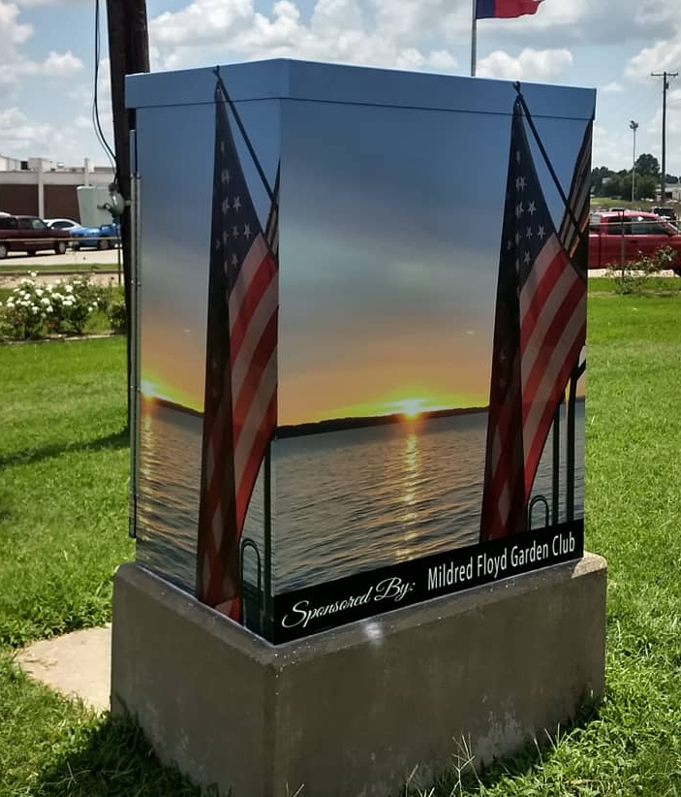 | #112  Loop 323 & Old Jacksonville | Marsha Harrison / Mildred Floyd Garden Club | 2019
40 | 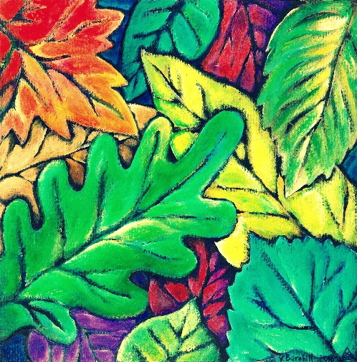 | Bergfeld Park by Splasher | Valeria Barnhill / KTyB | 2019
41 | 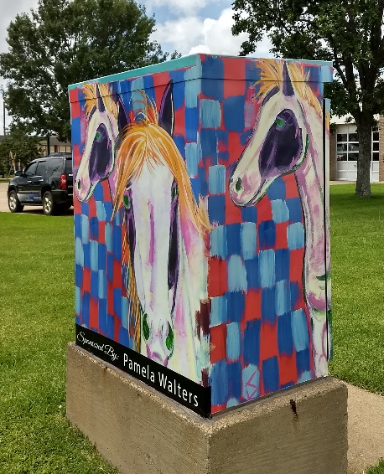 | #127  Old Bullard & Rieck Rd. | Unknown / Pamela Walters Group | 2019
42 | 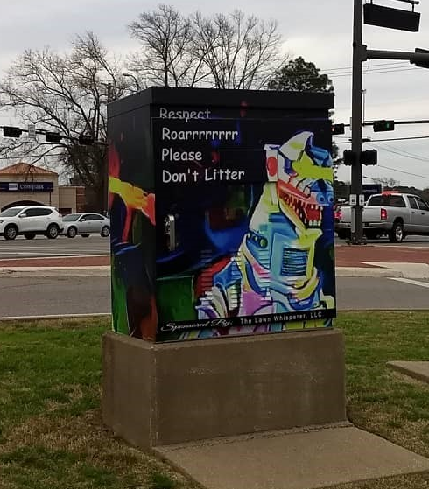 | #110  Loop 323 & Old Bullard | William Wright / The Lawn Whisperer | 2019
43 | 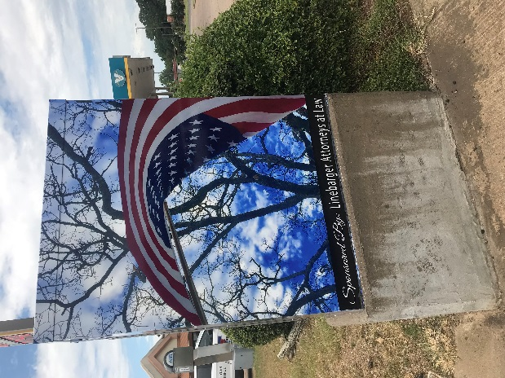 | #53  Front St. & Glenwood Blvd. | Unknown / Linebarger | 2019
44 | 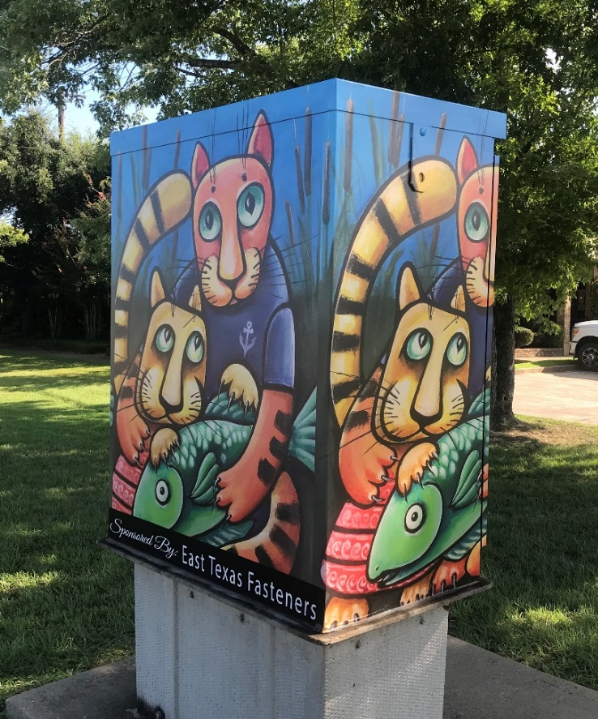 | #140  Broadway Ave. & Heritage | Valeria Barnhill / ET Fasteners | 2019
45 | 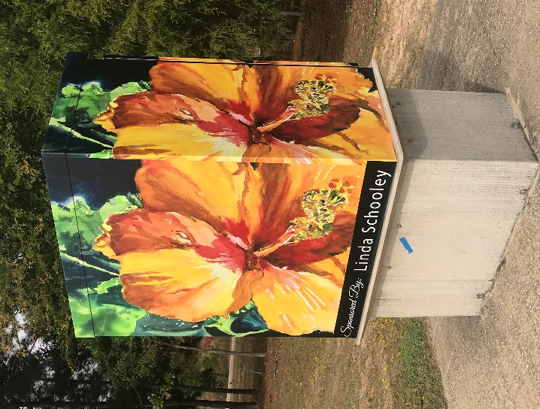 | #131  New Copeland Rd & Grande Blvd. | Linda Schooley / Linda Schooley | 2019
46 | 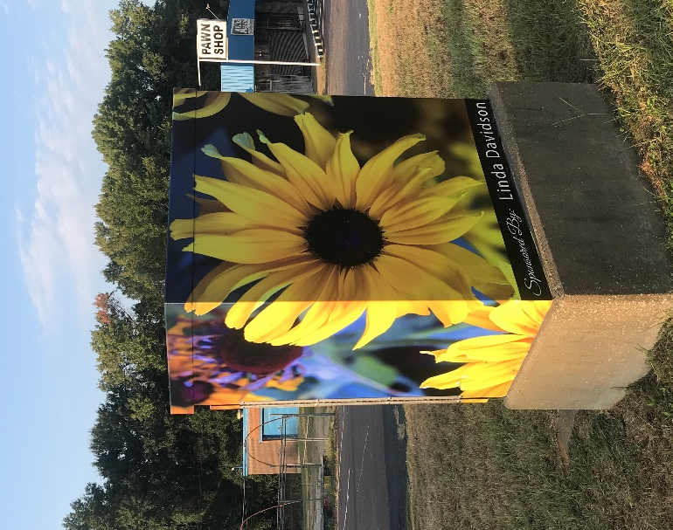 | #45  Front St. & Old Henderson Hwy. | Linda Davidson / Linda Davidson | 2019
47 | 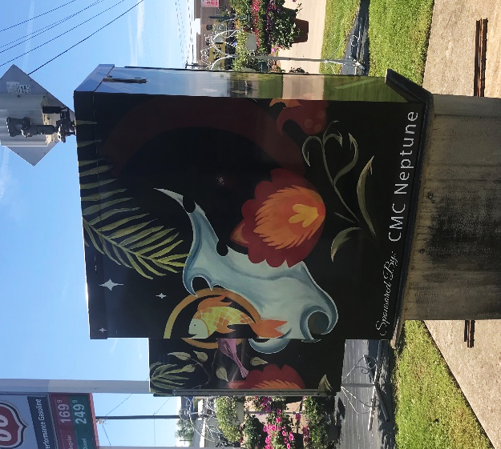 | #104  University & Loop 323 | Amber Payne / CMC Neptune | 2020
48 | 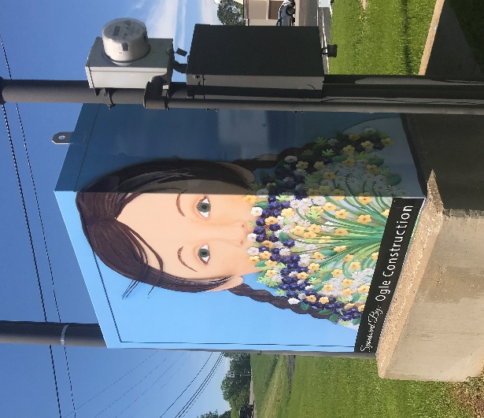 | #76  Beckham & 5th St. | Carrie McFerron / Ogle Construction | 2020
49 | 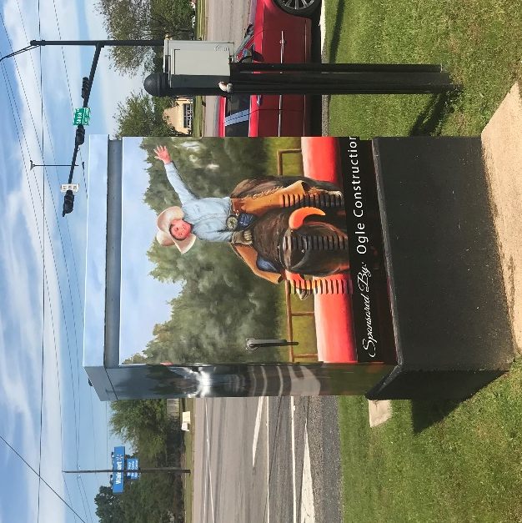 | #118  Troup Hwy. & Shiloh Rd. / Rhones Quarter | Linda Davidson / Ogle Construction | 2020
50 | 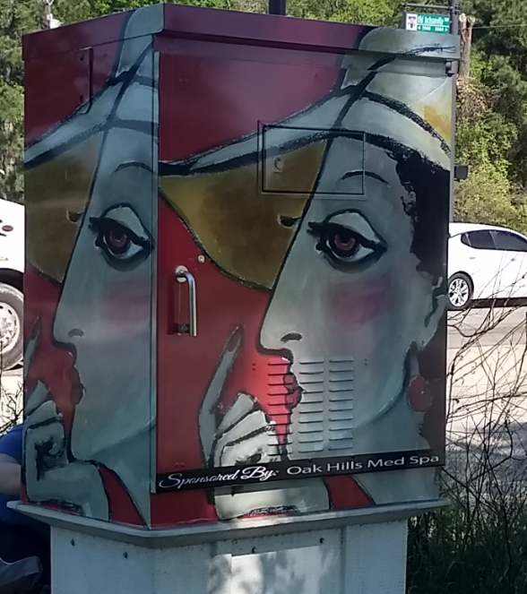 | #144  Old Jacksonville Hwy. & Cumberland | Valeria Barnhill / Oak Hill Med Spa | 2020
51 | 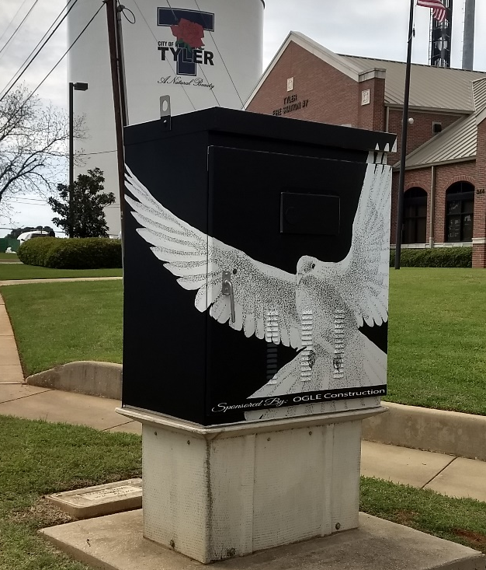 | #91  Old Troup Hwy. & Donnybrook | Joel Nichols / Ogle Construction | 2020
52 | 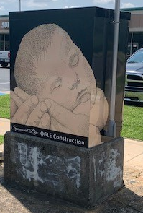 | #97  Troup Hwy. & Dulse | Joel Nichols / Ogle Construction | 2020
53 | 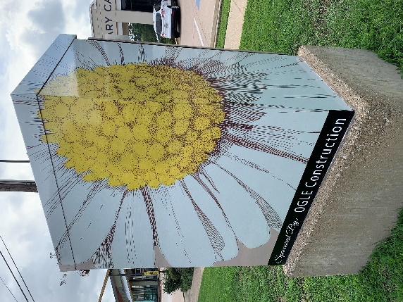 | #  Broadway & Old Grande | Joel Nichols / Ogle Construction | 2020
54 | 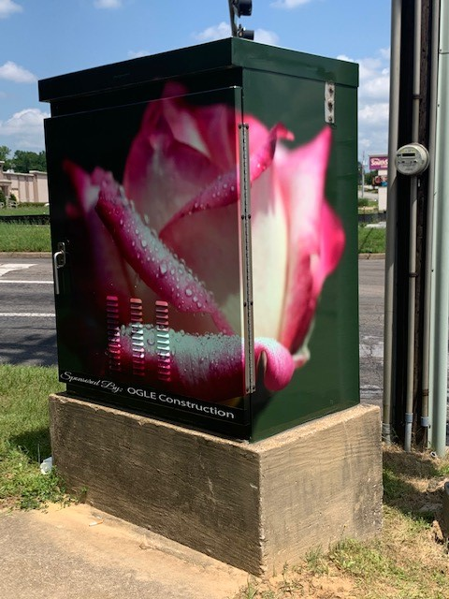 | #122  Old Bullard Rd. & Rice Rd. | Linda Davidson / Ogle Construction | 2020
55 | 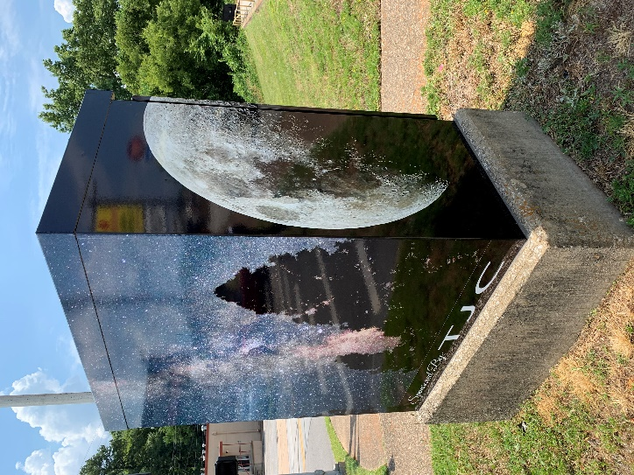 | #75  5th St. & Fleishel | Tom Hooten / TJC | 2020
56 | 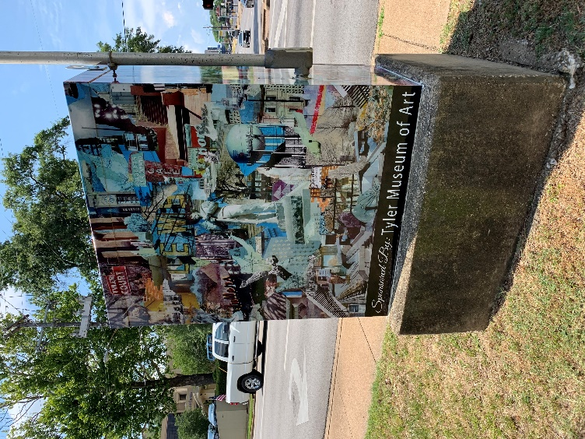 | #59  Beckham Ave. & Houston St. | Courtney Wrenn / Tyler Museum of Art | 2020
57 | 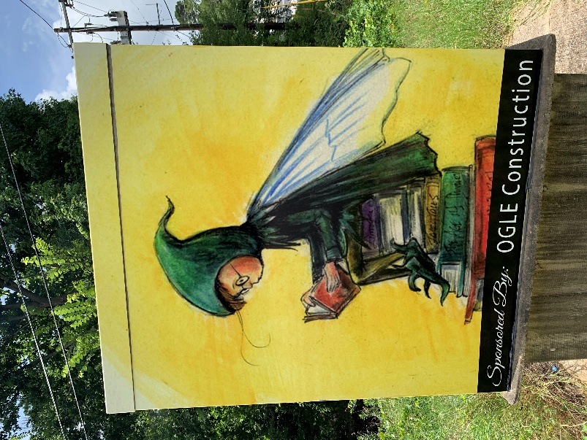 | #149  University Blvd. & Lazy Creek Dr. | John York / Ogle Construction | 2020
58 | 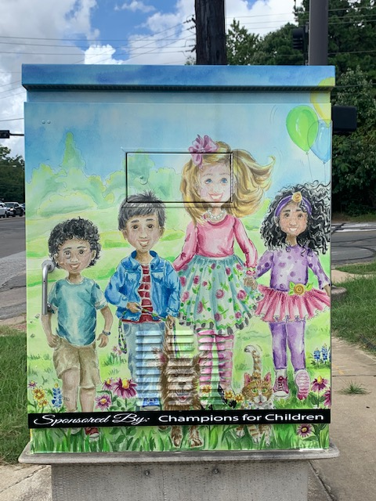 | #106  Loop 323 & Paluxy | Susan Sellars / Champions for Children | 2020
59 | 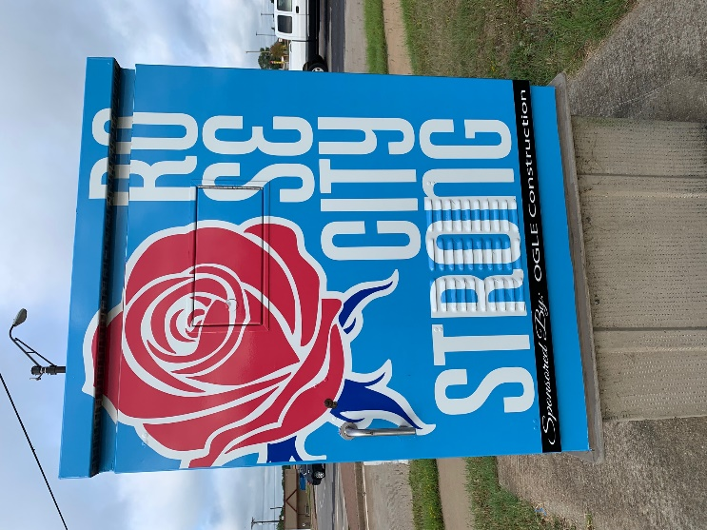 | #130  Paluxy & Grande Blvd | Dace Kidd / Ogle Construction | 2020
60 | 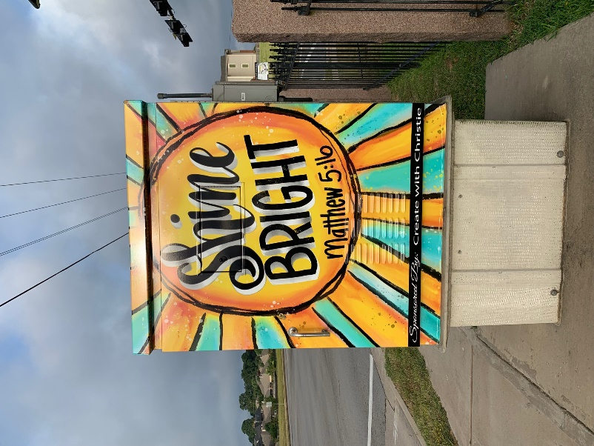 | #143  Cumberland & Blue Mountain Blvd. | Christie Daugherty / Create with Christie | 2020
61 | 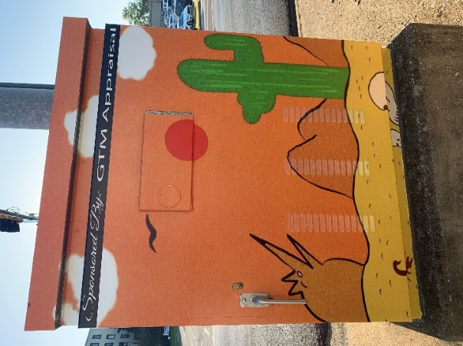 | #63  Beckham Ave. & Dawson | Stephen Morrison / GTM Appraisal | 2020
62 | ‘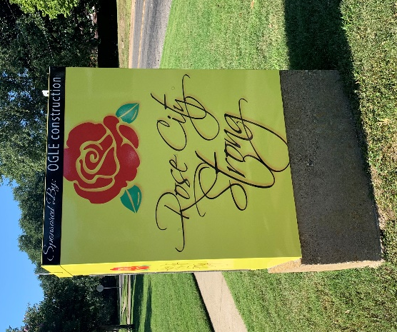 | #89  Beckham Ave. & Fleishel | EGuide Magazine | 2020
63 | 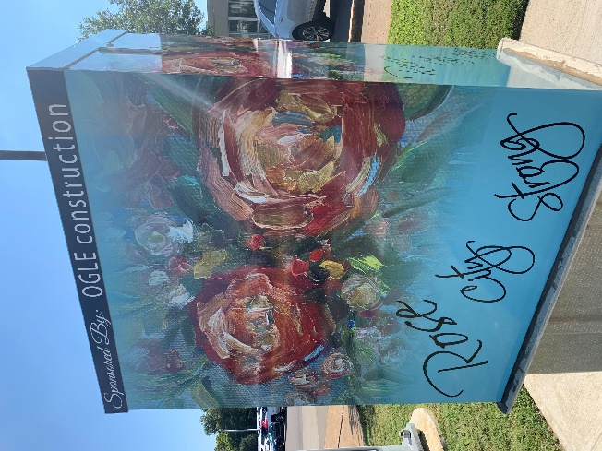 | #148  Broadway Ave. & Rose Plaza | Dana Cargile / Ogle Construction | 2020
64 | 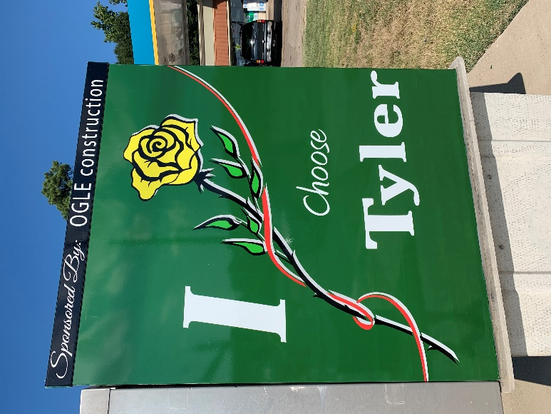 | #55 - W. Front St. & W. Loop 323 | Brent McNeil / Ogle Construction | 2020
65 | 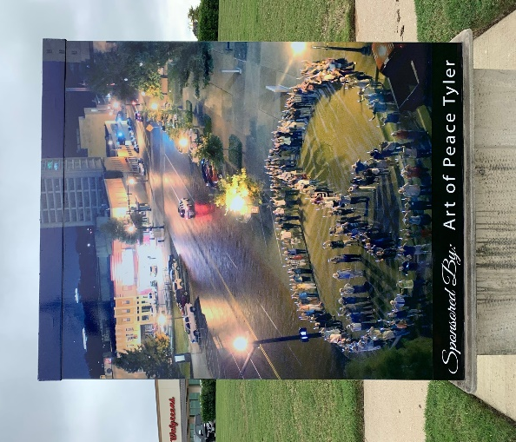 | #30  Loop 323 & Erwin (Hwy. 64 W.) | Dr. Scott Liberman / Art of Peace | 2020
66 | 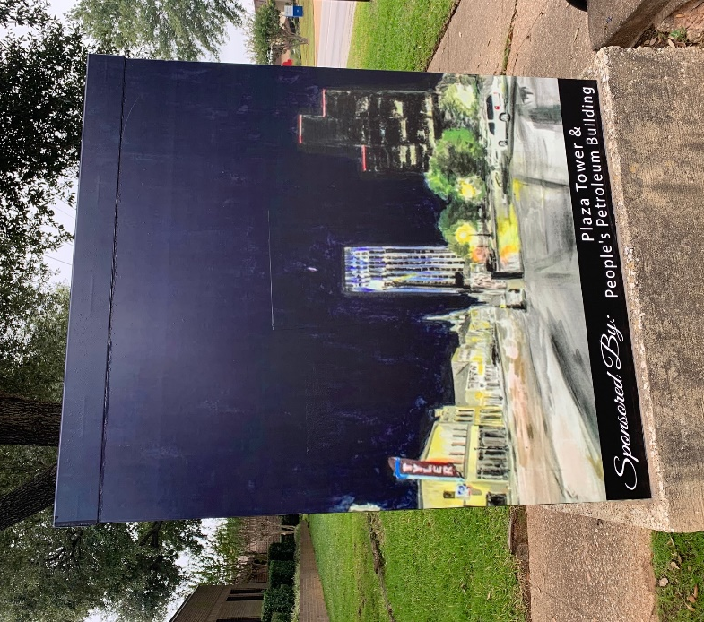 | #78  5th St & Donnybrook | Dace Kidd / Plaza Tower & People’s Petroleum Bldg. | 2020
67 | 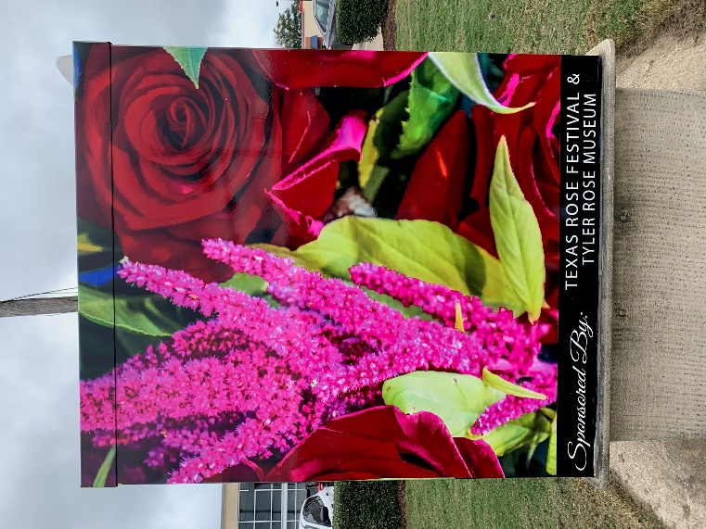 | #113  Loop 323 & Frankston (155) | John Anderson / Texas Rose Festival & Rose Museum | 2020
68 | 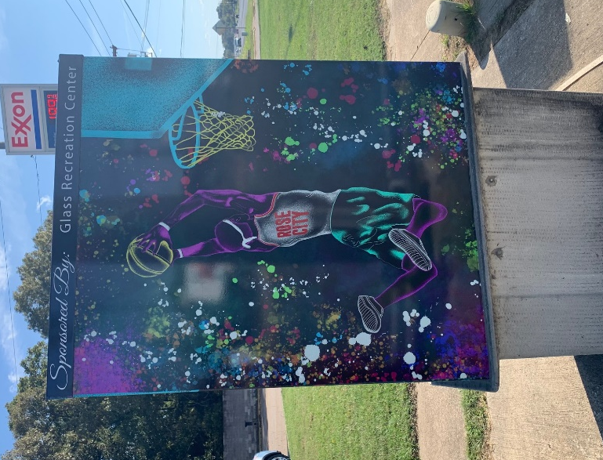 | #4  Loop 323 & Hwy. 69 | Allan Piedra / GRC | 2020
69 | 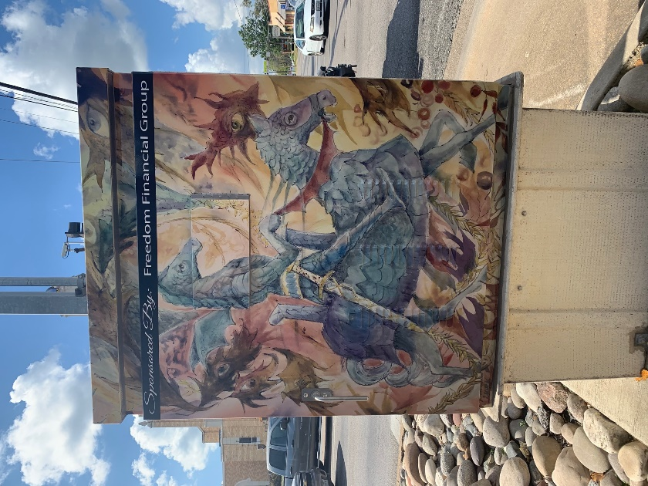 | #49  Broadway Ave. & Front St. | John York / Freedon Financial Group | 2020
70 | 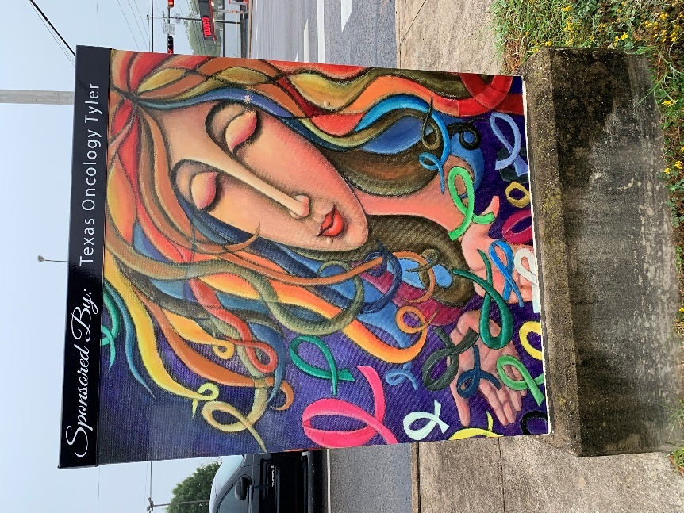 | #47  Front St. & Beckham Ave. | Valeria Barnhill / Texas Oncology Tyler | 2020
71 | 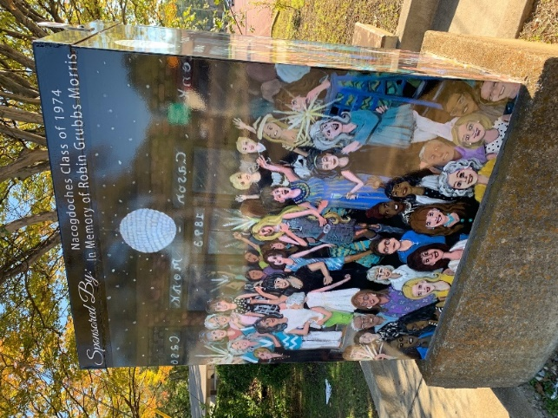 | #61  Houston St. & Vine | Robin Grubbs Morris / Nacogdoches Class of 1974 | 2020
72 | 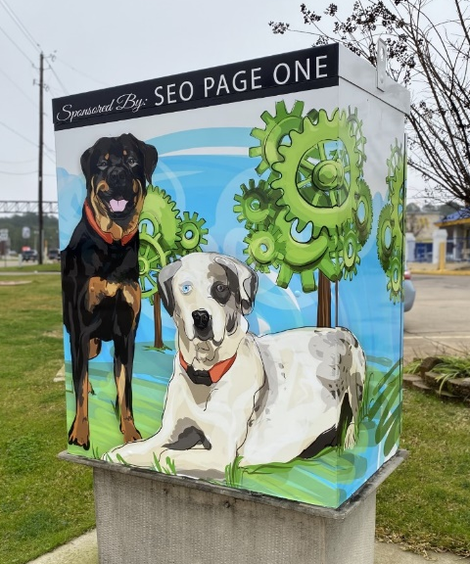 | #71  Loop 323 & 5th St. | April Moore / SEO Page One | 2021
73 | 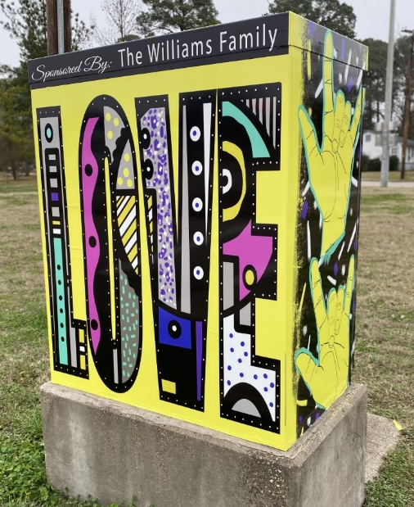 | $86  Earl Campbell Pkwy. & Vine | Amber Williams / The Williams Family | 2021
74 | 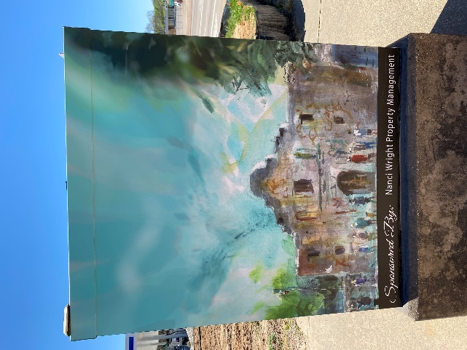 | #84  S Glenwood Blvd & S Vine Ave. | John York / Nanci Wright Property Management | 2021
75 | 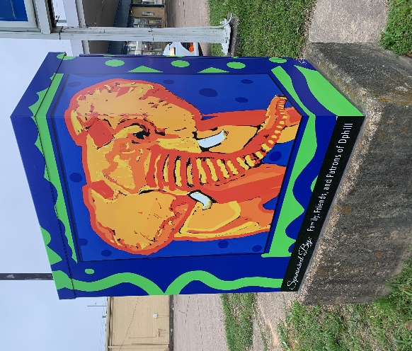 | #15  W Gentry Pkwy (271) & Ross Ave. | Dphill / Family & Friends of Daryll Phillips | 2021
76 | 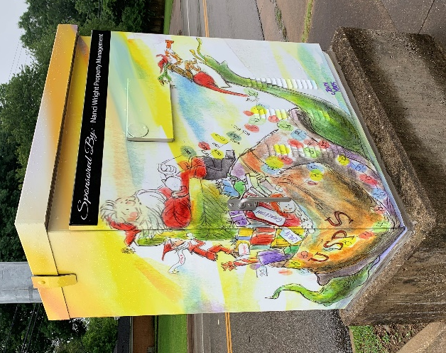 | #72  E 5th St. & Golden Rd. | John York / Nanci Wright Property Management | 2021
77 | 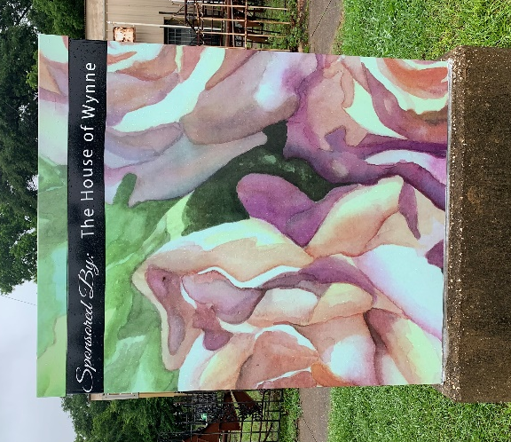 | #62  S Glenwood Blvd. & S. Houston St. | Donna Cariker / The House of Wynne | 2021
78 | 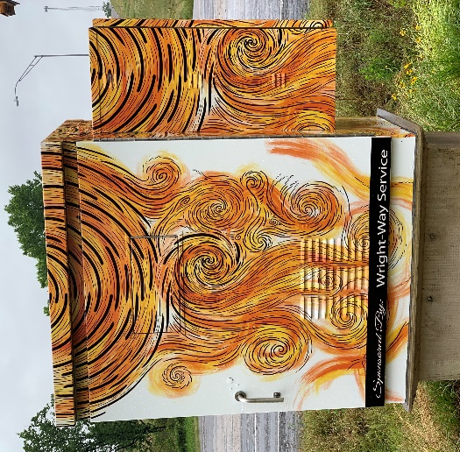 | #56  State Hwy 31 West (Chandler Hwy.) & TX-364 Spur | Jordan Mears / Wright Way Service | 2021
79 | 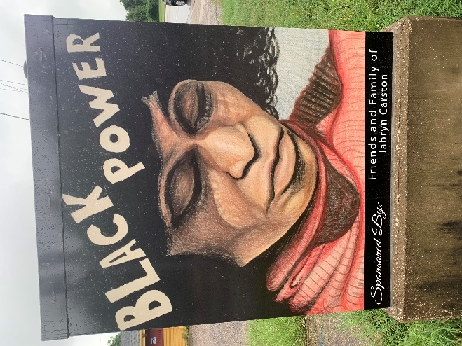 | #6  US-271 (E. Gentry Pkwy.) & Martin Luther King Jr Blvd. | Jabryn Carston / Friends & Family of Jabryn Carston | 2021
80 | 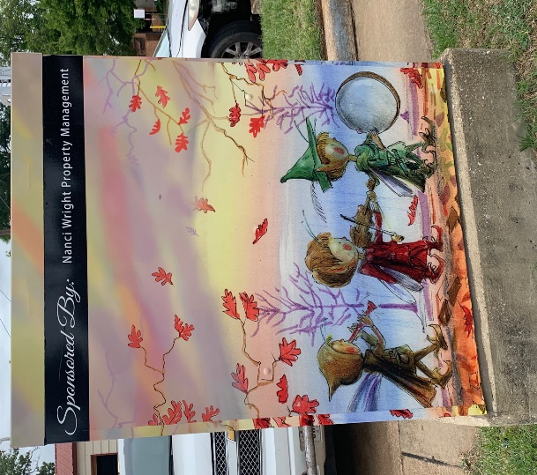 | #48  E. Front St. & S. Fannin Ave. | John York / Nanci Wright Property Management | 2021
81 | 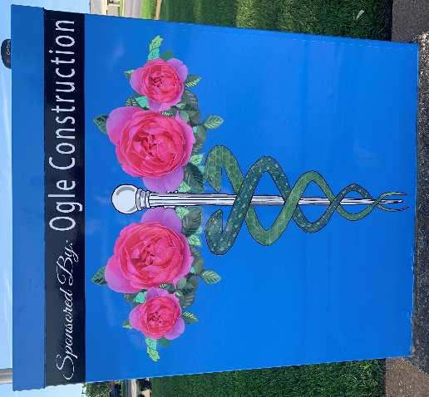 | #66  S. Beckham Ave. & E. Lake St. | Jennifer Moreman / Ogle Construction | 2021
82 | 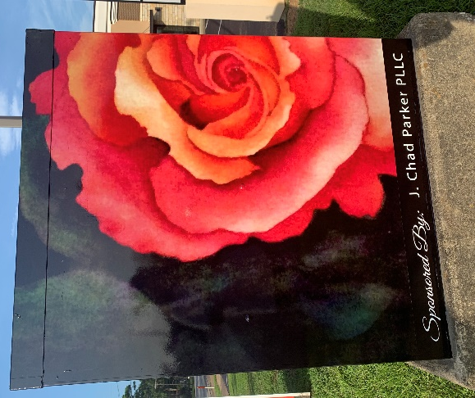 | #17  W. Gentry Pkwy. & N. Parkdale Dr. | Donna Cariker / J. Chad Parker PLLC | 2021
83 | 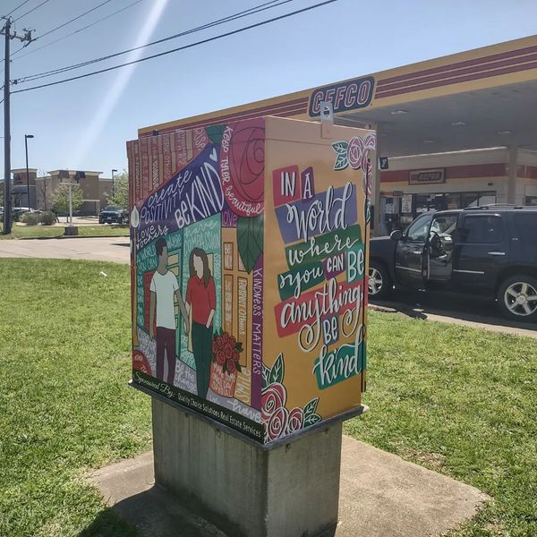 | #111  Loop 323 & Kinsey | Christie Daugherty / Quality Choice Solutions | 2022
84 | 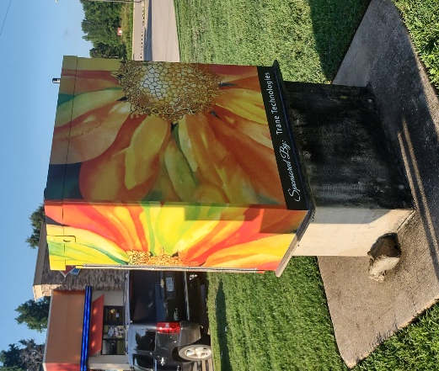 | #1  US-271 & TX-155 | Donna Cariker / Trane Technologies | 2022
85 | 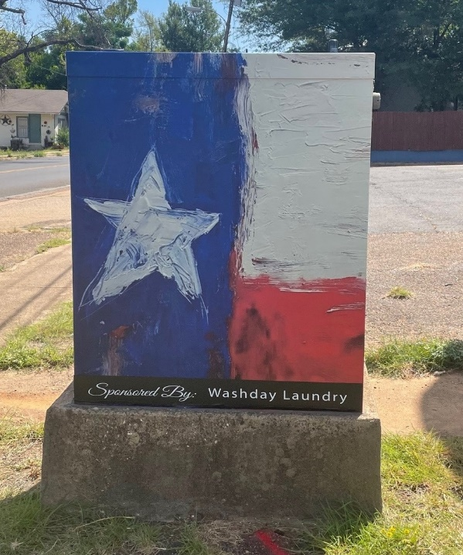 | #18  N. Palace Ave. & Bow | Cassie Bartley / Washday Laundry | 2022
86 | 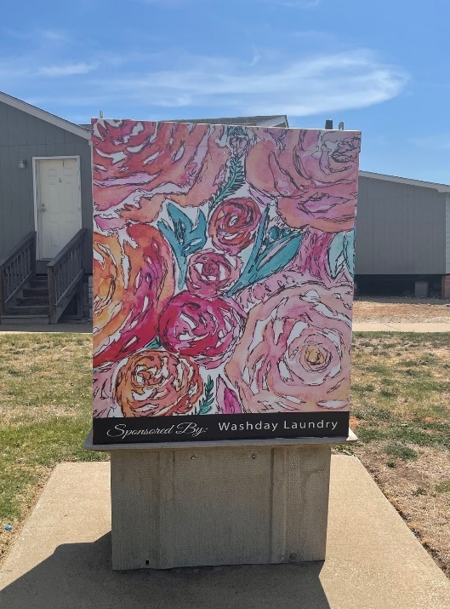 | #91  Loop 323 & Old Henderson Hwy. | Dayna Watkins / Washday Laundry | 2022
87 | 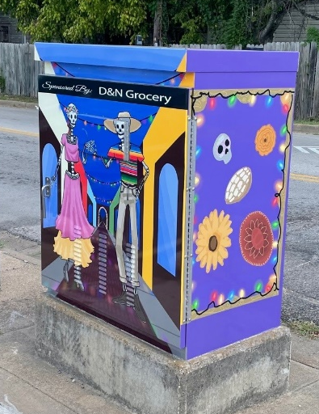 | #38  Lyons Ave. & Erwin St. | Sophie Coss / D&N Grocery | 2022
88 | 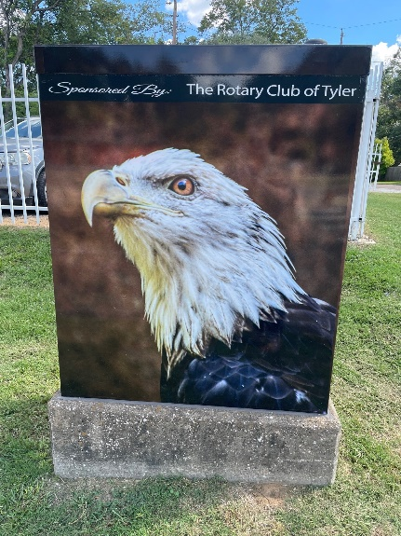 | #11  US-271 & Hillsboro | Linda Davidson / Tyler Rotary Club | 2022
89 | 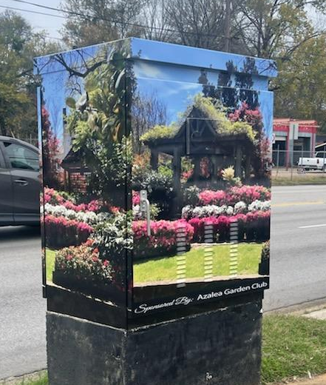 | #50  Front St. & Bonner Ave. | Janet Majors / Azalea Garden Club | 2022
90 | 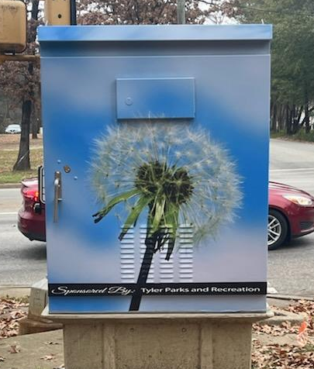 | #54  Front St. & Lyons Ave. | David DiPaolo / Tyler Parks and Rec | 2022
91 | 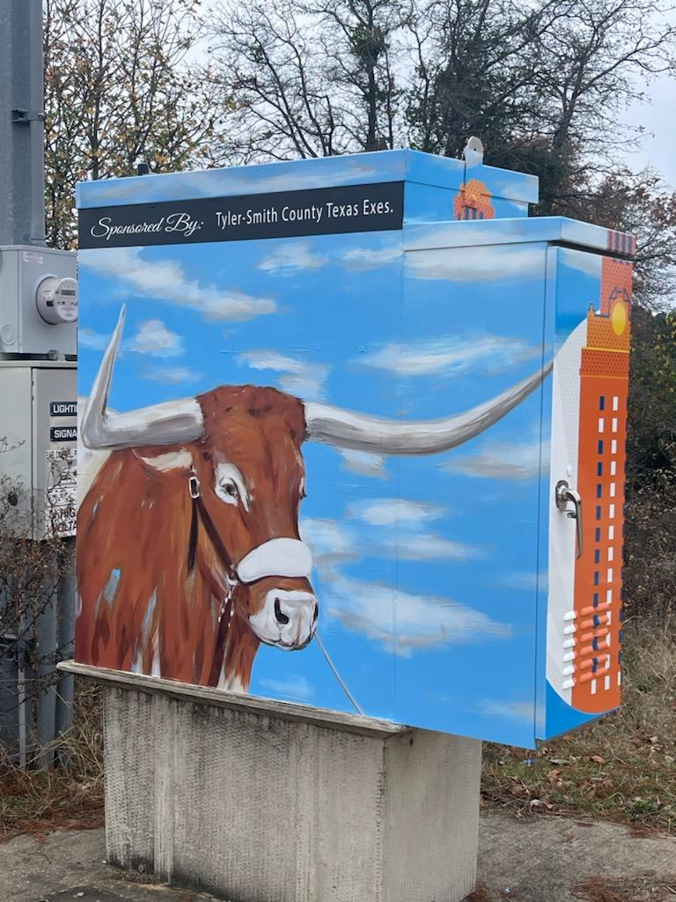 | #88  Loop 323 and Earl Campbell Pkwy. | Dace Kidd / Tyler Smith County Texas Exes | 2022
92 | 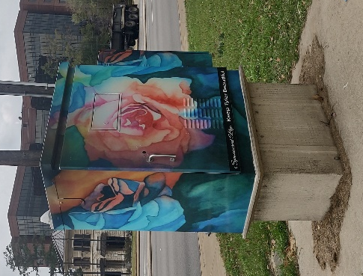 | #107  Loop 323 & New Copeland Rd. | Donna Cariker / Keep Tyler Beautiful | 2022
93 | 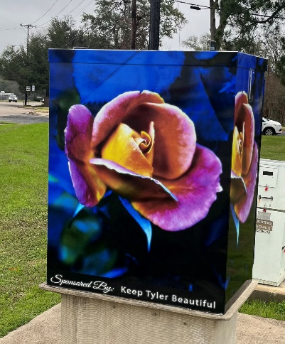 | #121  Broadway Ave. & Rice Rd./Shiloh Rd. | Claudia Holland / Keep Tyler Beautiful | 2022
94 | 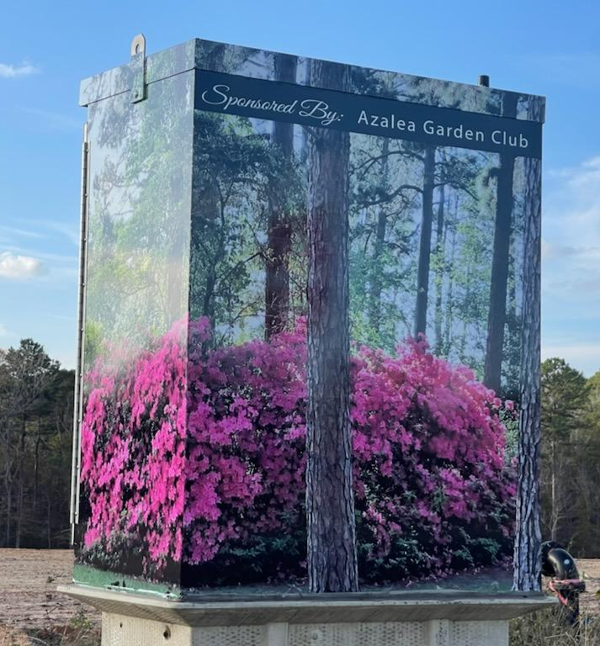 | #145  Broadway Ave. & Centennial Pkwy. | Carolyn Webb / Azalea Garden Club | 2022

