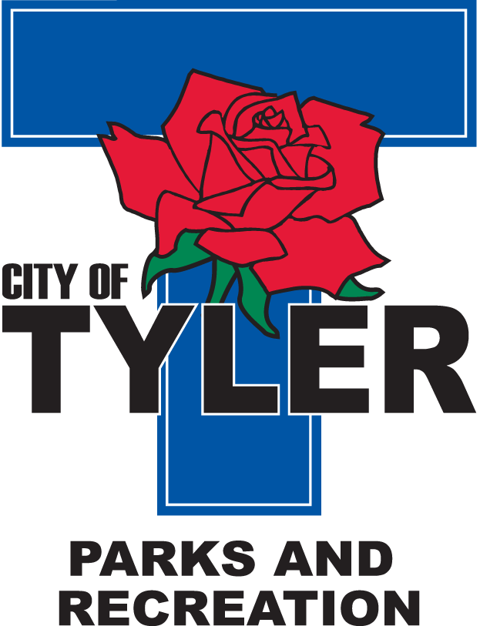  Welcome to The Tyler Senior Center  Open 9a.m.-5p.m. Monday-Friday    1915 Garden Valley Road (903) 597-0781    Meals on Wheels Lunch Served Daily 11:30a.m.-12:30p.m. | July  2022  Activities are subject to change
Monday | Tuesday | Wednesday | Thursday | Friday
1
11:00 Bodyworks
12:00 42 Game
12:30 Bridge Club
12:30 POPCORN
4  CLOSED!!!!!  IN CELEBRATION OF  INDEPENDENCE DAY | 5  10:00 Painting 11:00 Range of Motion  11:30 Cloggers  12:30 Line Dancers  12:30 Ut Speaker  1:00 Ice Cream Social | 6  10:00 Coffee Center Chat  11:00 Bodyworks  12:30 Bridge Club  12:30 BINGO with Brookdale Senior Living | 7  11:00 Range of Motion  12:00 G.V. Singers  12:30 Line Dancers12:30 Left, Right, Center Game  2:00 Singers at Garden Estates | 8  11:00 Bodyworks  12:00 42 Game  12:00 Puzzle Contest  12:30 Bridge Club  12:30 POPCORN  Friday Night Dance-doors open at 6:00pm-Country Drive Band
11  11:00 Bodyworks  12:30 Lisa Caudle with Homestead  12:30 Bridge Club | 12  10:00 Painting 11:00 Range of Motion  11:30 Cloggers  12:00 Line Dancers  2:00 Line Dancers @ Garden Estates | 13  11:00 Bodyworks  12:30 Bridge Club  12:30 BINGO with Hollie from Traditions Health | 14  11:00 Range of Motion  12:00 G.V. Singers  12:30 Line Dancers  12:30 Musical Chairs | 15  11:00 Bodyworks  12:00 42 Game  12:30 Bridge Club  12:30 POPCORN
18  11:00 Bodyworks  12:00 Crossword Puzzle Games  12:30 Bridge Club | 19  10:00 Painting 11:00 Range of Motion  11:30 Cloggers  12:30 Line Dancing  12:30 Bingo with Painters  2:45 Prestige Memory Care | 20  11:00 Bodyworks  12:30 Bridge Club  12:30 BINGO with Keith Koehler with Reunion Plaza | 21  11:00 Range of Motion  12:30 Line Dancing  12:30 Free Dance- Come join us for all types of music, fun and dancing! | 22  11:00 Bodyworks  12:00 42 Game  12:30 Bridge Club  12:30 POPCORN  Friday Night Dance-doors open at 6:00pm- Bobby Jackson Band
25  11:00 Bodyworks  12:30 Bridge Club  12:30 Cooking Club with Shona from Visiting Angels | 26  10:00 Painting 11:00 Range of Motion  11:30 Cloggers  12:30 Line Dancing  12:30 POPCORN | 27  11:00 Bodyworks  12:30 Bridge Club  12:30 BINGO with Jessilyn from Humana & Quita from Oakstreet | 28  11:00 Range of Motion  12:00 G.V. Singers  12:30 Line Dancing  12:30 Left, Right, Center Game | ²⁹  11:00 Bodyworks  12:00 42 Game  12:30 Bridge Club  12:30 POPCORN

