June 2022 | Senior News Today  Latest news and bulletin updates |  |  |  |  |  | Issue  #01
The News  of the Month  Senior Member of the Month  Let’s congratulate Ms. Earlena English, as our Senior Member of the Month. Earlena is a Line Dancer and a Clogger here at the Senior Center who brings joy and positive vibes when she comes through the door. We appreciate you, Ms. Earlena for all your steps and great performances at the Retirement Homes and thanks for blessing us with all your moves!  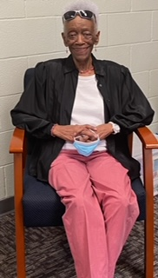  Tuesday Scoop- Crochet Class  Join us every Tuesday in June from 10am to 11am for crochet class. Beginners and experts welcome!  Garden Valley  Singers will  Sing at  Reunion Plaza on  Thursday June 16th  At 2:00 pm |  |  |  | The Talk  of the Week  Join us every week for our daily activities that include bingo,  line dancing, clogging, crafts, exercise, singing and painting.  Check your monthly calendar for date and times.  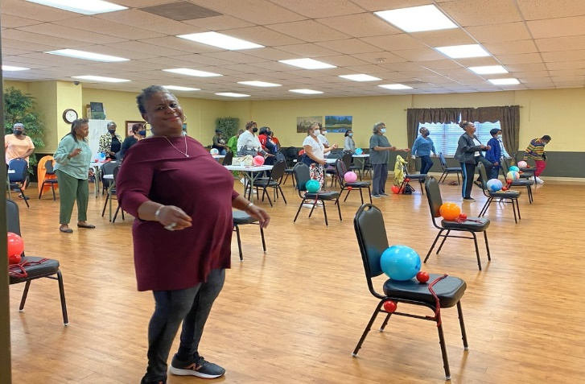
New Activity of the Week
Beachball Musical Chairs

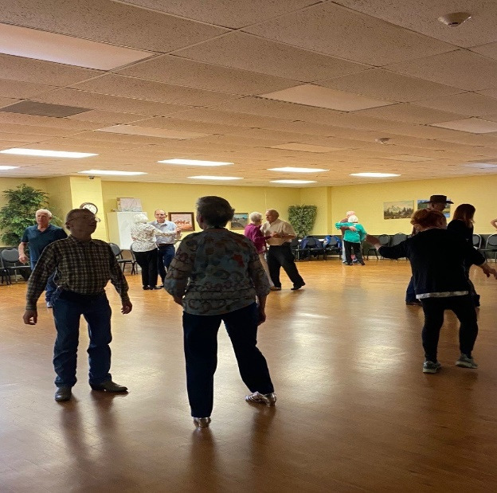
Friday Night Dance

The Scoops of the Month
 |  | 
We are now adding a second dance to each month on Friday nights. Dances will be held on June 10th and June 24th from 7-9:30PM. |  | Closed on June 20th for  Celebration  of Juneteenth |  |  | AARP will meet on  Thursday June 16th  at 2:00pm

Welcome to The Tyler Senior Center
Open 9a.m.-5p.m. Monday-Friday
1915 Garden Valley Road (903) 597-0781

Meals on Wheels Lunch Served Daily 11:30a.m.-12:30p.m.
Monday | Tuesday | Wednesday | Thursday | Friday
 |  | 1  10:00 Coffee Center Chat  11:00 Bodyworks  12:30 Bridge Club  12:30 BINGO with Cory Fierbaugh with Brookdale Senior Living | 2  11:00 Range of Motion  12:00 G.V. Singers  12:30 Line Dancers  12:30 Left, Right, Center Game | 3  11:00 Bodyworks  12:00 42 Game  12:30 Bridge Club  12:30 POPCORN
6  11:00 Bodyworks  12:00 Becky Edwards from The Heights about Medicare  12:30 Bridge Club | 7  10:00 Painting 11:00 Range of Motion  11:30 Cloggers  12:30 Line Dancers  12:30 POPCORN | 8  11:00 Bodyworks  12:30 Bridge Club  12:30 BINGO with Susie from The Center at Grande | 9  11:00 Range of Motion  12:00 G.V. Singers  12:30 Line Dancers  12:30 Left, Right, Center Game  Blood Pressure check by Prime Star Home Health Rep Vicki  2:00 AARP | 10  11:00 Bodyworks  12:00 42 Game  12:00 Puzzle Contest  12:30 Bridge Club  12:30 POPCORN  Friday Night Dance-doors open at 6:00pm- Smooth Cactus Band
13  11:00 Bodyworks  12:00 Ginger Conner-Owens “My Checkbook”  12:30 Bridge Club | 14  10:00 Painting 11:00 Range of Motion  11:30 Cloggers  12:30 Bingo with Painters  12:30 Line Dancing  12:30 POPCORN | 15  11:00 Bodyworks  12:30 Bridge Club  12:30 BINGO with Arletha from  Petal Hill Nursing & Rehab | 16  11:00 Range of Motion  12:00 G.V. Singers  12:30 Line Dancers  12:30 Left, Right, Center Game  2:00 Line Dancers at Reunion Plaza | 17  11:00 Bodyworks  12:00 42 Game  12:30 Bridge Club  12:30 POPCORN
20  11:00 Bodyworks  12:30 Bridge Club  12:30 Craft Class | 21  10:00 Painting 11:00 Range of Motion  11:30 Cloggers  12:30 Line Dancing  12:30 POPCORN | 22  11:00 Bodyworks  12:30 Bridge Club  12:30 BINGO with Jessilyn Edwards from Humana & Quita from Oakstreet Healtrh | 23  11:00 Range of Motion  12:30 Line Dancing  12:30 Free Dance- Come join us for all types of music, fun and dancing! | 24  11:00 Bodyworks  12:00 42 Game  12:30 Bridge Club  12:30 POPCORN  Friday Night Dance-doors open at 6:00pm- Mr. C (50’s) Band
27  11:00 Bodyworks  12:30 Bridge Club  12:30 Cooking Club- Visiting Angels, Shonda Guenther | 28  10:00 Painting 11:00 Range of Motion  11:30 Cloggers  12:30 Line Dancing  12:30 POPCORN | 29  11:00 Bodyworks  12:30 Bridge Club  12:30 BINGO with | 30  11:00 Range of Motion  12:30 Line Dancing

