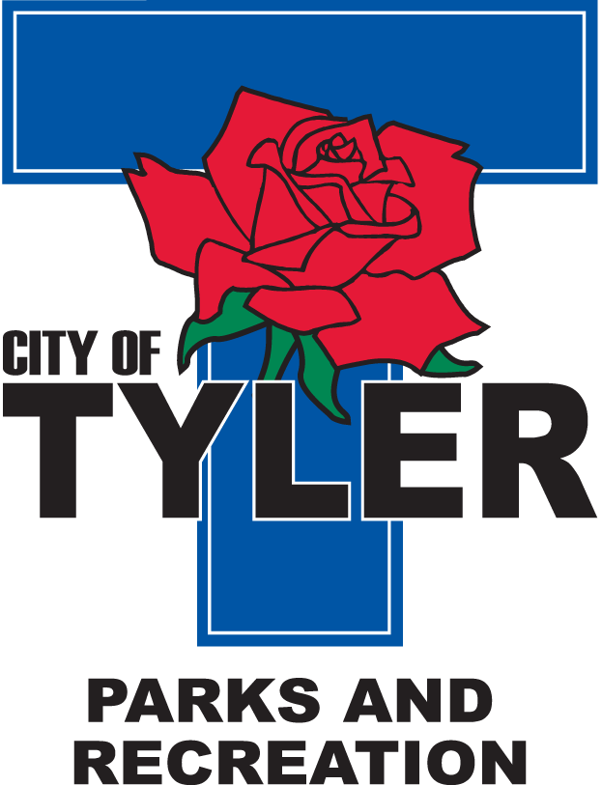  Welcome to The Tyler Senior Center  Open 9a.m.-5p.m. Monday-Friday    1915 Garden Valley Road (903) 597-0781    Meals on Wheels Lunch Served Daily 11:30a.m.-12:30p.m. | May  2022  Activities are subject to change
Monday | Tuesday | Wednesday | Thursday | Friday
2  11:00 Bodyworks  12:30 Megan Anderson speaks on 55 Plus Program (AARP)  12:30 Bridge Club | 3  10:00 Painting 11:00 Range of Motion  11:30 Cloggers  12:30 Line Dancers  12:30 POPCORN | 4  10:00 Coffee Center Chat  11:00 Bodyworks  12:30 Bridge Club  12:30 BINGO with Cory Fierbaugh with Brookdale Senior Living | 5  11:00 Range of Motion  11:30 Cloggers  12:00 G.V. Singers  12:30 Left, Right, Center Game | 6  11:00 Bodyworks  12:00 42 Game  12:30 Bridge Club  12:30 POPCORN
9  11:00 Bodyworks  12:00 Mallory Marsh with Heart of Texas Hospice  12:30 Bridge Club | 10  10:00 Painting 11:00 Range of Motion  11:30 Cloggers  12:30 Line Dancers  12:30 Speaker Jenna Moore-Mental Health  12:30 POPCORN | 11  10:00 Coffee Center Chat  11:00 Bodyworks  12:30 Bridge Club  12:30 BINGO with Susie from The Fountains | 12  11:00 Range of Motion  11:30 Cloggers  12:00 G.V. Singers  12:30 Left, Right, Center Game  Blood Pressure check by Prime Star Home Health Rep Vicki  2:00 AARP | 13  11:00 Bodyworks  12:00 42 Game  12:00 Puzzle Contest  12:30 Bridge Club  12:30 POPCORN
16  11:00 Bodyworks  12:30 Bridge Club  12:30 Craft Class | 17  10:00 Painting 11:00 Range of Motion  11:30 Cloggers  12:30 Bingo with Painters  12:30 Line Dancing  12:30 POPCORN  2:00 Line Dancers @ Prim Rose | 18  11:00 Bodyworks  12:30 Bridge Club  12:30 BINGO with Arletha from  Petal Hill Nursing & Rehab | 19  11:00 Range of Motion  11:30 Cloggers  12:00 G.V. Singers  12:00 Area Agency on Aging with Nellie Spencer Henry  12:30 Left, Right, Center Game | 20  11:00 Bodyworks  12:00 42 Game  12:30 Bridge Club  12:30 POPCORN
23  11:00 Bodyworks  12:30 Bridge Club  12:30 Cooking Club-Visiting Angels, Shona Guenther | 24  10:00 Painting 11:00 Range of Motion  11:30 Cloggers  12:30 Line Dancing  12:30 POPCORN | 25  11:00 Bodyworks  12:30 Bridge Club  12:30 BINGO with Jessilyn Edwards from Humana | 26  11:00 Range of Motion  12:30 Line Dancing  12:30 Free Dance- Come join us for all types of music, fun and dancing! | 27  11:00 Bodyworks  12:00 42 Game  12:30 Bridge Club  12:30 POPCORN  Senior Dance-doors open at 6:00pm  (The Ruffshod Band)
30  CLOSED FOR MEMORIAL DAY HOLIDAY | 31  10:00 Painting 11:00 Range of Motion  11:30 Cloggers  12:30 Line Dance |  | Mother’s Day- May 8th  Memorial Day-May 30th

