 | CONFIDENTIAL APPLICATION FOR CONTRACTOR  PRE-APPROVAL FOR PUBLIC UTILITY, STREET  AND DRAINAGE CONSTRUCTION

I. INSTRUCTIONS

- All Contractors wishing to construct public improvements within the City of Tyler must complete this Qualification Statement in full. Contractors may either submit this Qualification Statement to be considered for approval for the annual Approved Contractors List, or they may submit this Qualification Statement to be considered for approval on a one-time only, project-specific basis.
- If a project is a Joint Venture, both Contractors must complete the qualification form.
- The Contractor is to ensure that all pages of the Qualification Statement are complete and that all supporting documentation, as required, is attached and submitted for review.
- Allow up to ninety (90) days for review and processing of applications.
- Upon completion of the review by the City, all hard copy financial statements will be returned to the Contractor and electronic copies will be deleted. The City of Tyler does not retain financial statements.
- If, after review, the Qualification Statement is rejected in whole or in part, the Contractor may resubmit additional information for reconsideration by the City of Tyler.
- Please check the box indicating the desired type of approval:
☐ | I am submitting this Qualification Statement to be considered for the annual Approved Contractors List.
☐ | I am submitting this Qualification Statement to be considered on a one-time only basis for the following project:

For the Annual Approved Contractors List Only:
Upon approval, the Contractor shall be approved for specific types of work with specified dollar values until notified in writing that either: 1) the Contractor must re-apply or 2) the Contractor has been removed from the Approved Contractors List. Contractors stay on the Approved Contractors List for up to a year based on the Contractor's financial year-end date. Contractors must submit updated qualification statements including financial documentation within 90 days after their year-end date in order to remain on the Approved Contractors List. For example, if a Contractor's financial documentation has a year-end date of July 31, the Contractor's approval is valid through July 31 of the following year and they must submit an updated qualification statement and financial documentation on or before October 31 in order to remain on the Approved list. Contractors may continue to do work for the City of Tyler during the 90 day period while they are preparing their updated information.
For Project-Specific Approvals Only:
Upon approval, the Contractor shall be approved for specific types of work with specified dollar values for a specific project only and for any follow-up work related to that project that may be required during the one-year warranty period.
- Qualification statements and financial documentation may be submitted for review to Tyler Water Utilities:
By Mail: | By Email: | By Fax:
City of Tyler  Attn: Engineering Services  PO Box 2039  Tyler, TX 75710 | Engineering Services  cchaney@tylertexas.com | Attn: Engineering Services  903-531-1126

II. GENERAL INFORMATION

☐ Sole Proprietor ☐ Partnership ☐ Corporation ☐ Joint Venture

Firm Name:
Contact Name: Mailing Address, if Different:
Physical Address: Mailing Address:
City, State, Zip: City, State, Zip:
Principal Place of Business:
County State
Phone: Email:

If Partnership or Joint Venture:

Partner or JV Firm Name:
Contact Name: Mailing Address, if Different:
Physical Address: Mailing Address:
City, State, Zip: City, State, Zip:
Principal Place of Business:
County State
Phone: Email:

If Corporation:

State of Incorporation:
Location of Principal Office:
Contact Persons at Office:
Person Executing Contracts on Behalf of Corporation:
Name: Address:
Title: City, State:
Phone: Zip Code:

Name(s) of Officers (if applicable):
Please indicate the following type(s) of work you wish to be considered for and the number of years in business as a General Contractor performing that type work:

Paving:
Wish to Perform | Type of Work | Years of Experience |  | Wish to Perform |  | Type of Work |  | Years of Experience
☐ | Asphalt Paving |  |  | ☐ |  | Seal Coating
☐ | Concrete Paving
Drainage:
☐ | Box Culverts |  |  |  | ☐ |  | Inlets
☐ | Bridge Work |  |  |  | ☐ |  | Junction Boxes
☐ | Channel Lining |  |  |  | ☐ |  | Storm Sewer
☐ | HDPE Pipe (requires manufacturer’s training certification)
Utilities:
☐ | Water Systems  (new construction) |  |  |  | ☐ |  | Water/Sewer Treatment Plants
☐ | Sewer System  (new construction) |  |  |  | ☐ |  | Booster Pump Stations (water)
☐ | Raising/Lowering Appurtenances |  |  |  | ☐ |  | Lift Stations (sewer)
☐ | Minor Relocation of Pipe and Appurtenances (as required to avoid conflicts during street or drainage projects)
Miscellaneous:
☐ | Demolition |  |  |  | ☐ |  | Painting
☐ | Earth Work |  |  |  | ☐ |  | Signal Work
☐ | Fencing |  |  |  | ☐ |  | Other:  (describe below)
☐ | Landscaping
☐ | Misc. Concrete

III. COMPANY HISTORY

1. Greatest number of contracts in excess of $500,000.00 under construction at one time in Company's history:

2. Greatest number of contracts in excess of $1,000,000.00 under construction at one time in Company's history:

3. Approximate average dollar value of incomplete work under contract at any one time:

4. Provide, as an attachment, a list of projects completed within the past five (5) years with value in excess of $500,000 (if possible) demonstrating experience with the type of work for which you are requesting approval. For each project listed, provide at a minimum the following information:

a. Project Name

b. Project Owner

c. Value of Work

d. Year Completed

e. Name and Phone Number of Contact Person / Reference

f. Brief description of type(s) of work performed (should match type(s) of work requested for approval)

5. Provide, as an attachment, a list of projects currently in progress demonstrating experience with the type of work for which you are requesting approval. For each project listed, provide at a minimum the following information:

a. Project Name

b. Project Owner

c. Value of Work

d. Name and Phone Number of Contact Person / Reference

e. Brief description of type(s) of work performed (should match type(s) of work requested for approval)

6. Has the company's management personnel changed in the last two (2) years?

☐ YES ☐ NO
If yes, please list names of staff and qualifications and/or experience of said persons

7. Have you or any present partner(s) or officer(s) failed to complete a contract?

☐ YES ☐ NO

If so, name of Owner and/or Surety:
Contact Person: Phone:

8. Are there any unsatisfied demands upon your Company as to your Company's Accounts Payable?

☐ YES ☐ NO
If your answer is yes, give names, amounts, and explanations:

9. Bank Reference:
Bank: City:
Contact Person: Phone:

10. Municipality Reference:
City: Phone:
Contact Person: Position:

11. Other Credit References:

Name:
Address: Phone:

Name:
Address: Phone:

Name:
Address: Phone:

12. Provide, as an attachment, a list of established supply sources for construction materials. Provide names, addresses and phone numbers of supply dealers serving the Contractor on a regular basis.

13. Provide, as an attachment, a list of major items of equipment owned by the Company. If particular types of equipment are leased for certain jobs, indicate the types of items that are leased and names of usual leasing agents.

14. Provide, as an attachment, the job qualifications and experience of key personnel. Also, indicate the average size of work force during the last two years.

15. State all addresses used by the Contractor in the past five years, if different than the one provided on page 2. Explain whether your location of operations would affect your ability to respond to problems encountered during the project and if it would affect the project completion (use attachments if necessary):

Pursuant to advertisement for bids and information for prospective bidders for aforementioned types of projects, I (we), the undersigned, am submitting the information as required with the understanding that the purpose is for your use, only to assist in determining the qualifications for this organization to perform the type and magnitude of work designated, and further, guarantee the truth and accuracy of all statements made, and will accept your determination of qualifications without prejudice. The surety herein named, any other bonding company, bank, sub-contractor, supplier, or any other person(s), firm(s), or corporations with whom I (we) have done business, or who have extended any credit to me (us) are hereby authorized to furnish you with any information you may request concerning performance on previous work and my (our) credit standing with any of them; and I (we) hereby release any and all such parties from any legal responsibility whatsoever on account of having furnished such information to you.

Signed: Title:
Company: Date:

COPY TO LOCAL UNDERWRITING OFFICE OF PROPOSED SURETY:

Name: Phone:
Address: City/State:
IV. QUALIFICATION STATEMENT OF BIDDER'S SURETY

To be completed by Contractor's Surety:

Surety Name:

Contractor Name:

1. Has the surety furnished contract bonds for this contractor before?
☐ YES ☐ NO

2. Is the current financial information on this Contractor satisfactory?
☐ YES ☐ NO

3. Has contractor ever defaulted on contract bonds? ☐ YES ☐ NO
If your answer is yes, give details:

4. Is it your opinion that the contractor has sufficient experience and financial resources to satisfactorily perform selected types of work? ☐ YES ☐ NO

5. Provided this Bidder does not assume other commitments or that you do not acquire further information that in your opinion will materially affect the Bidder's capacity to perform this contract, will you furnish the bonds as specified within contractors bonding limits? ☐ YES ☐ NO

6. Does your proposed Surety Bonding possess a certification as required by the State Board of Insurance to do business in the State of Texas? ☐ YES ☐ NO
Remarks:

Surety:

Signed:

Title:

Address:

City/State:

Phone No.:

Fax No.:
V. SAFETY PROGRAM

This information is not requested to regulate or oversee your safety program. It is used to evaluate the suitability of your company to perform contracts having a high safety risk probability, which could result in financial liability on the part of the City.

1. Does your company presently have a formal on-going safety program?
☐ YES ☐ NO
Briefly describe program:

2. Does your safety program include regular safety meetings, accident investigations/cause and corrections, safety committee, employee training program?
☐ YES ☐ NO
Comments:

3. Does your company comply with safety standards relating to hard hats and steel-toed shoes? ☐ YES ☐ NO
4. Has your company been cited by OSHA, EPA, TCEQ or any other regulatory agency within the last twelve (12) months? ☐ YES ☐ NO
Comments:

5. Has your company experienced a job related injury or death within the last twelve (12) months? ☐ YES ☐ NO
Comments:

6. Does your company have access to safety equipment for compliance with the Trench Safety regulations? ☐ YES ☐ NO
Comments:

Signed:

Title:

Company:

Date:

VI. FINANCIAL STATEMENTS

In order to expedite and facilitate the prompt approval of your prequalification application, the following information must accompany your submission.

Contractor to select level of contracts to be considered and submit required financial statement as supplemental submittal:
Project Size |  | Required Financial Statement
☐ | Under $15,000 | No Financial Statement required. Projects not eligible to be increased by change order.
☐ | $15,000 to $50,000 | Unaudited compilation or review using Cash/Tax Basis Financial Statements, if accompanied by CPA provided schedules for accounts receivable and accounts payable with compilation or review report (see Attachment 1 for example of format). Accrual Basis Statements also accepted (see Attachment 2 for example of format).
☐ | Over $50,000 | Audited Financial Statement prepared using Accrual Basis Statements (see Attachment 2 for example of format).

FAILURE TO PROVIDE ALL REQUESTED INFORMATION COULD RESULT IN THE RETURN OF YOUR APPLICATION.

Please note that any financial statements submitted to the City for the purposes of qualification must be prepared by an independent certified public accounting firm in current good standing with the Texas State Board of Pubic Accountancy. This is a requirement if your firm is based or located in Texas. Should the accountant sign under a firm name, that firm must also maintain a current license with the State Board. Current licenses for CPA’s may be verified online at www.tsbpa.state.tx/macros/OD006.ndm/MAIN. CPA firms located outside of Texas and preparing financial statements for firms or individuals located or based within Texas should contact the State Board of Public Accountancy, Licensing, at 512-305-7853. Some licensing requirements have changed as of September 1, 2007.
Attachment 1
Example of Cash/Tax Basis Statement Format

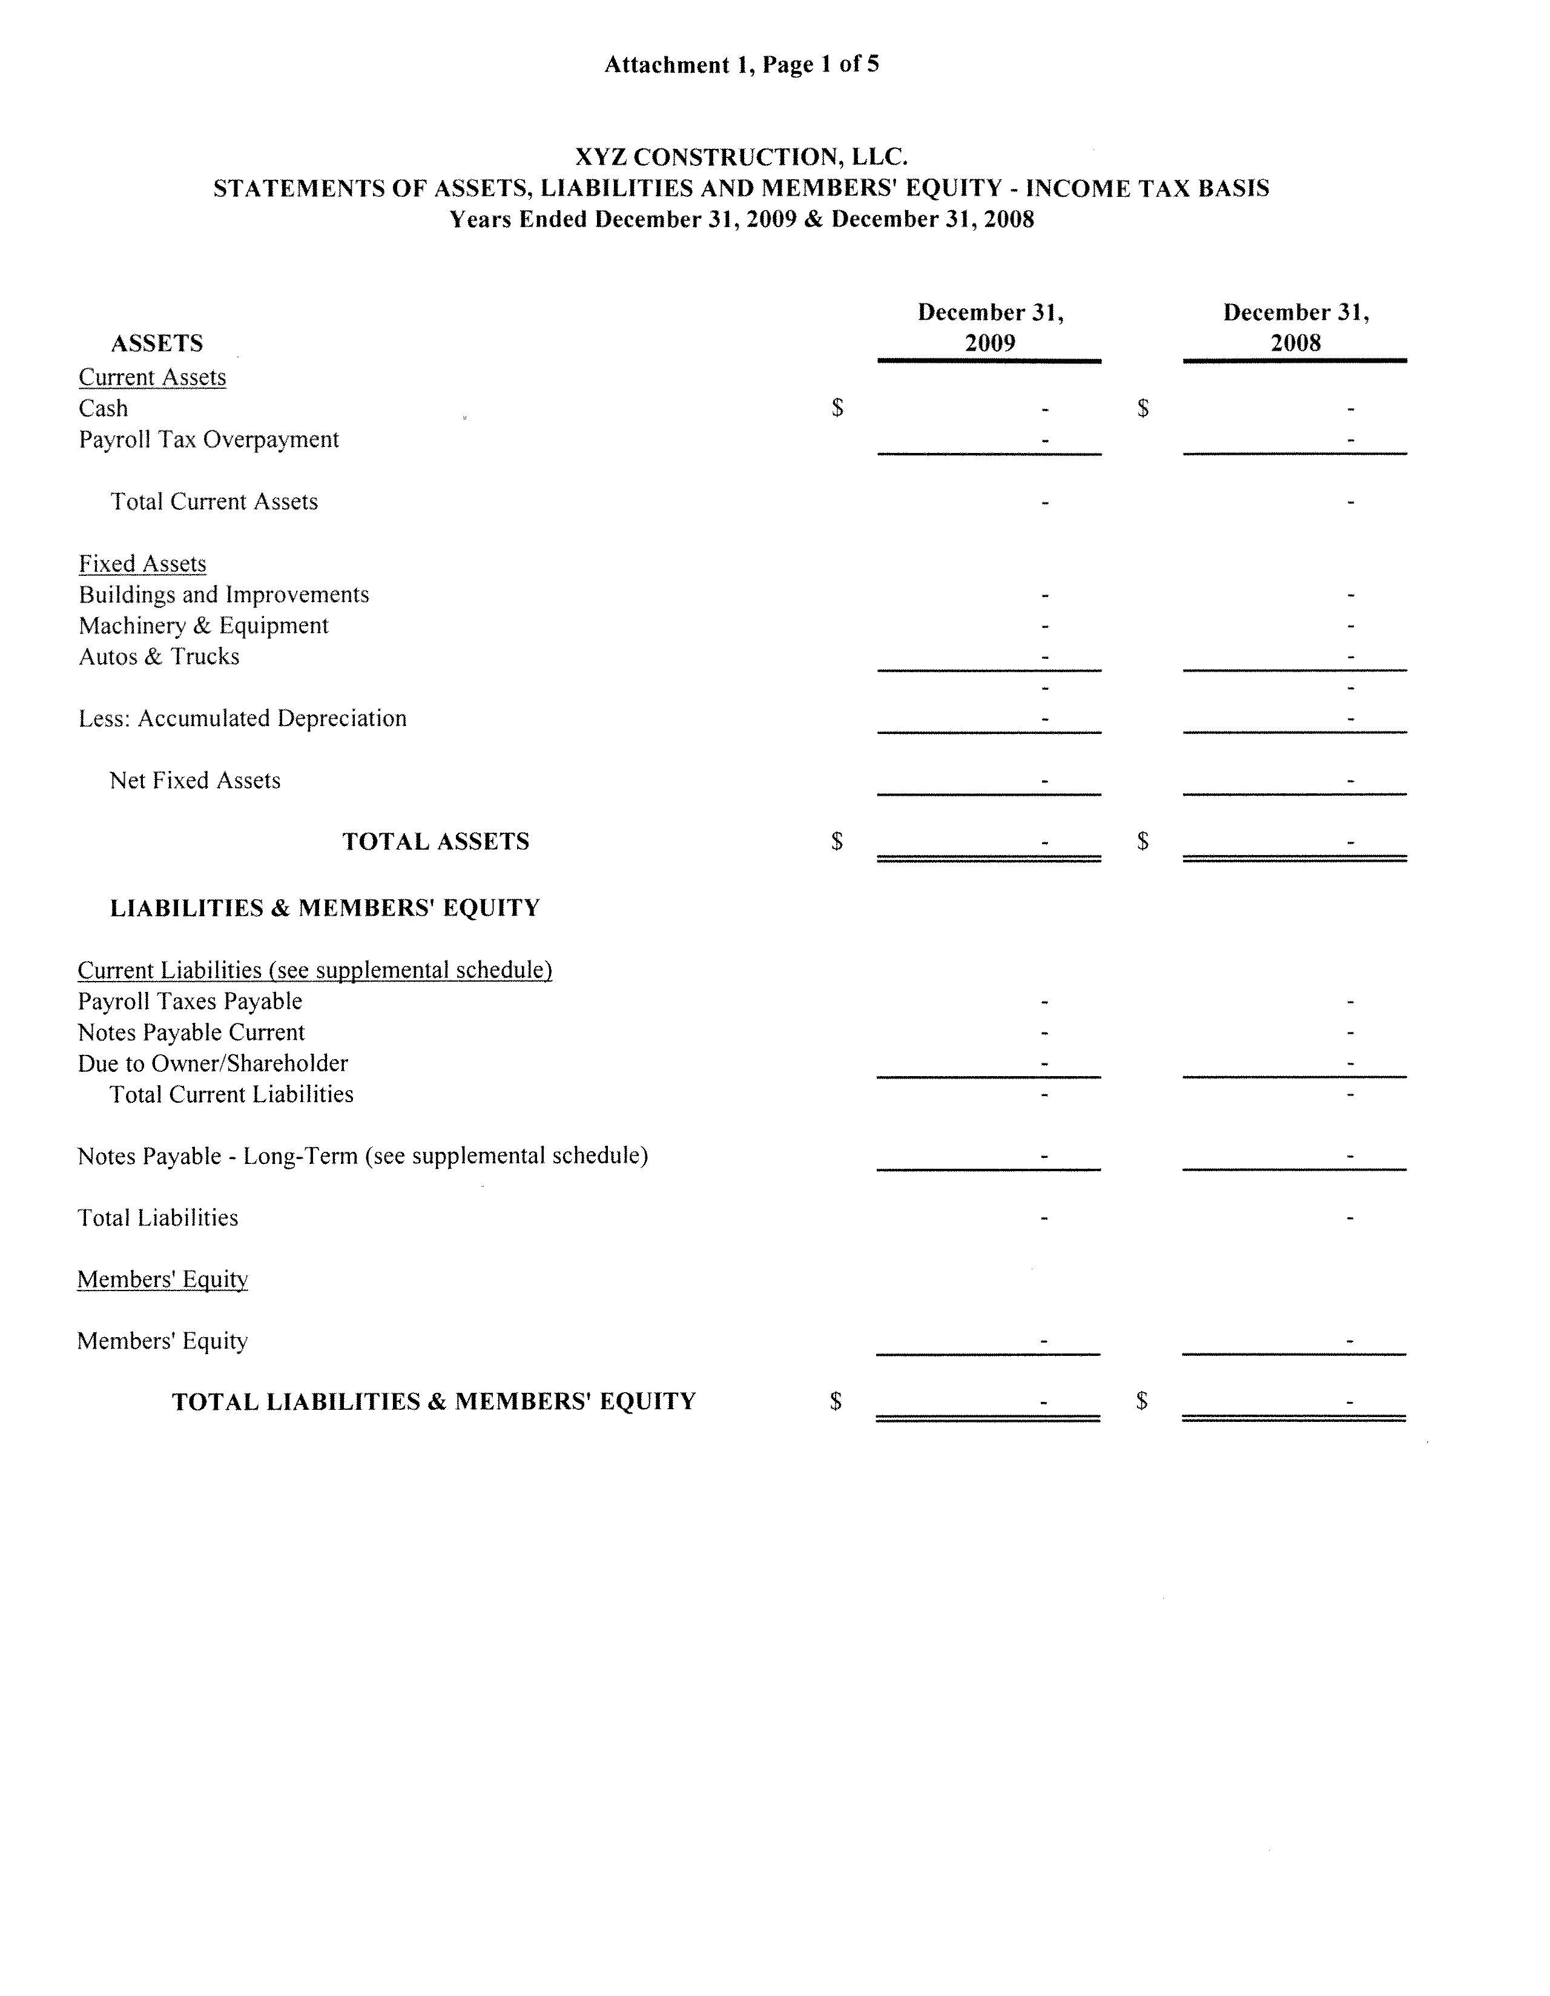
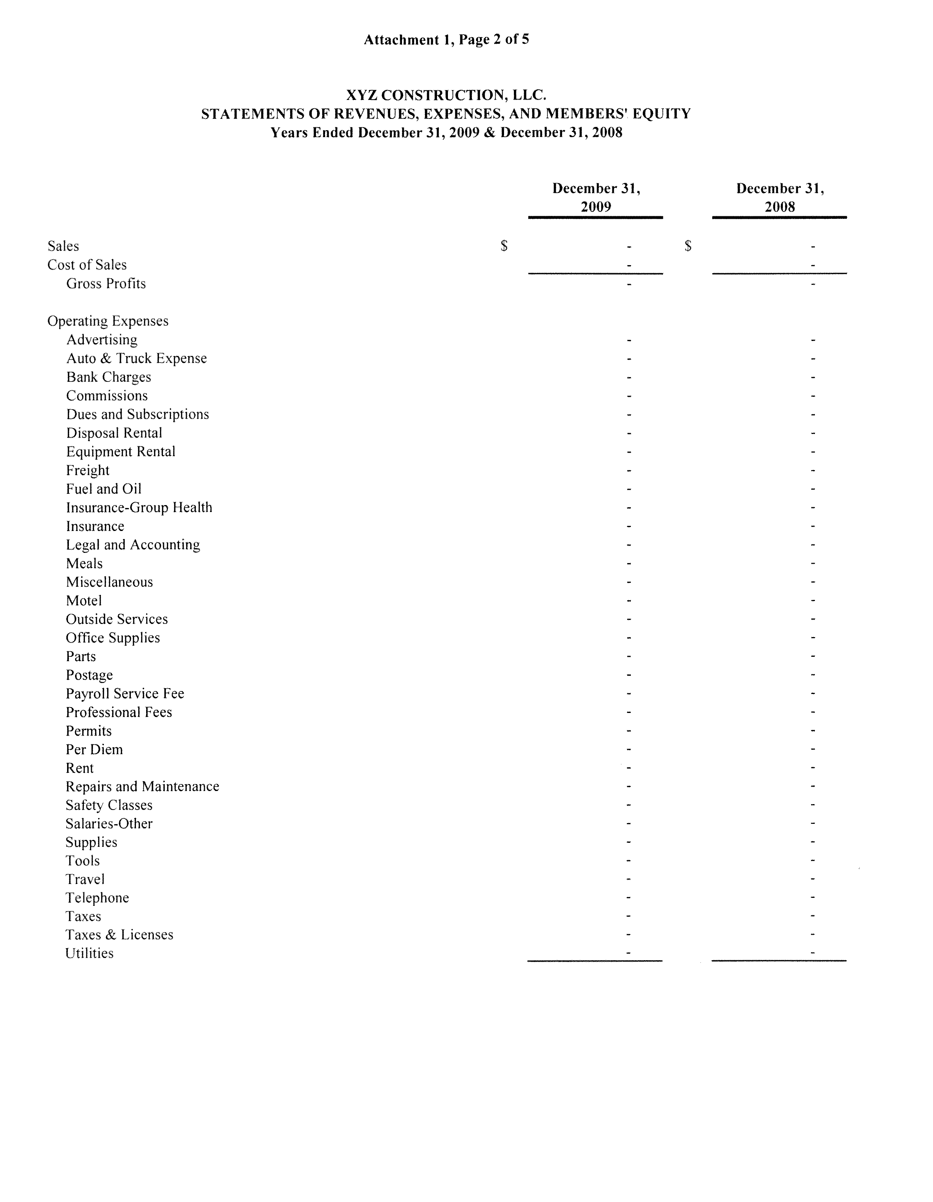
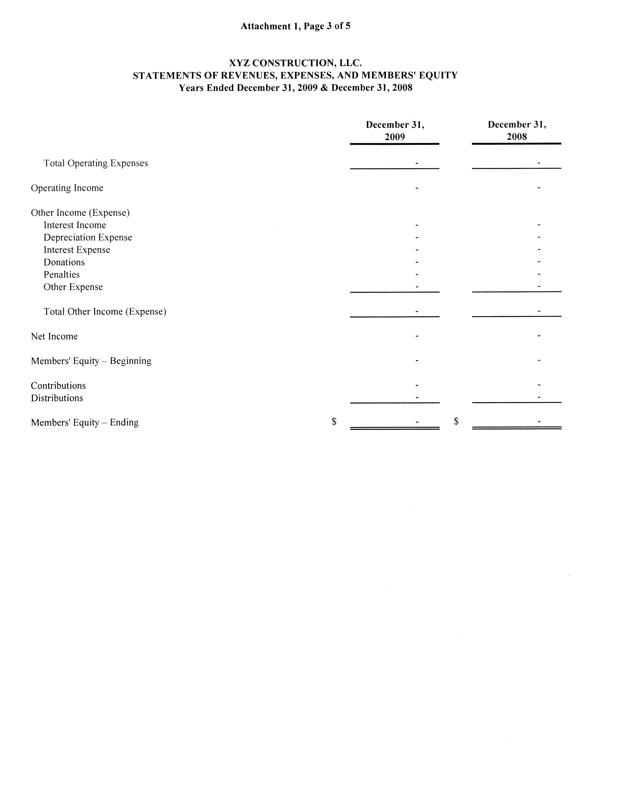
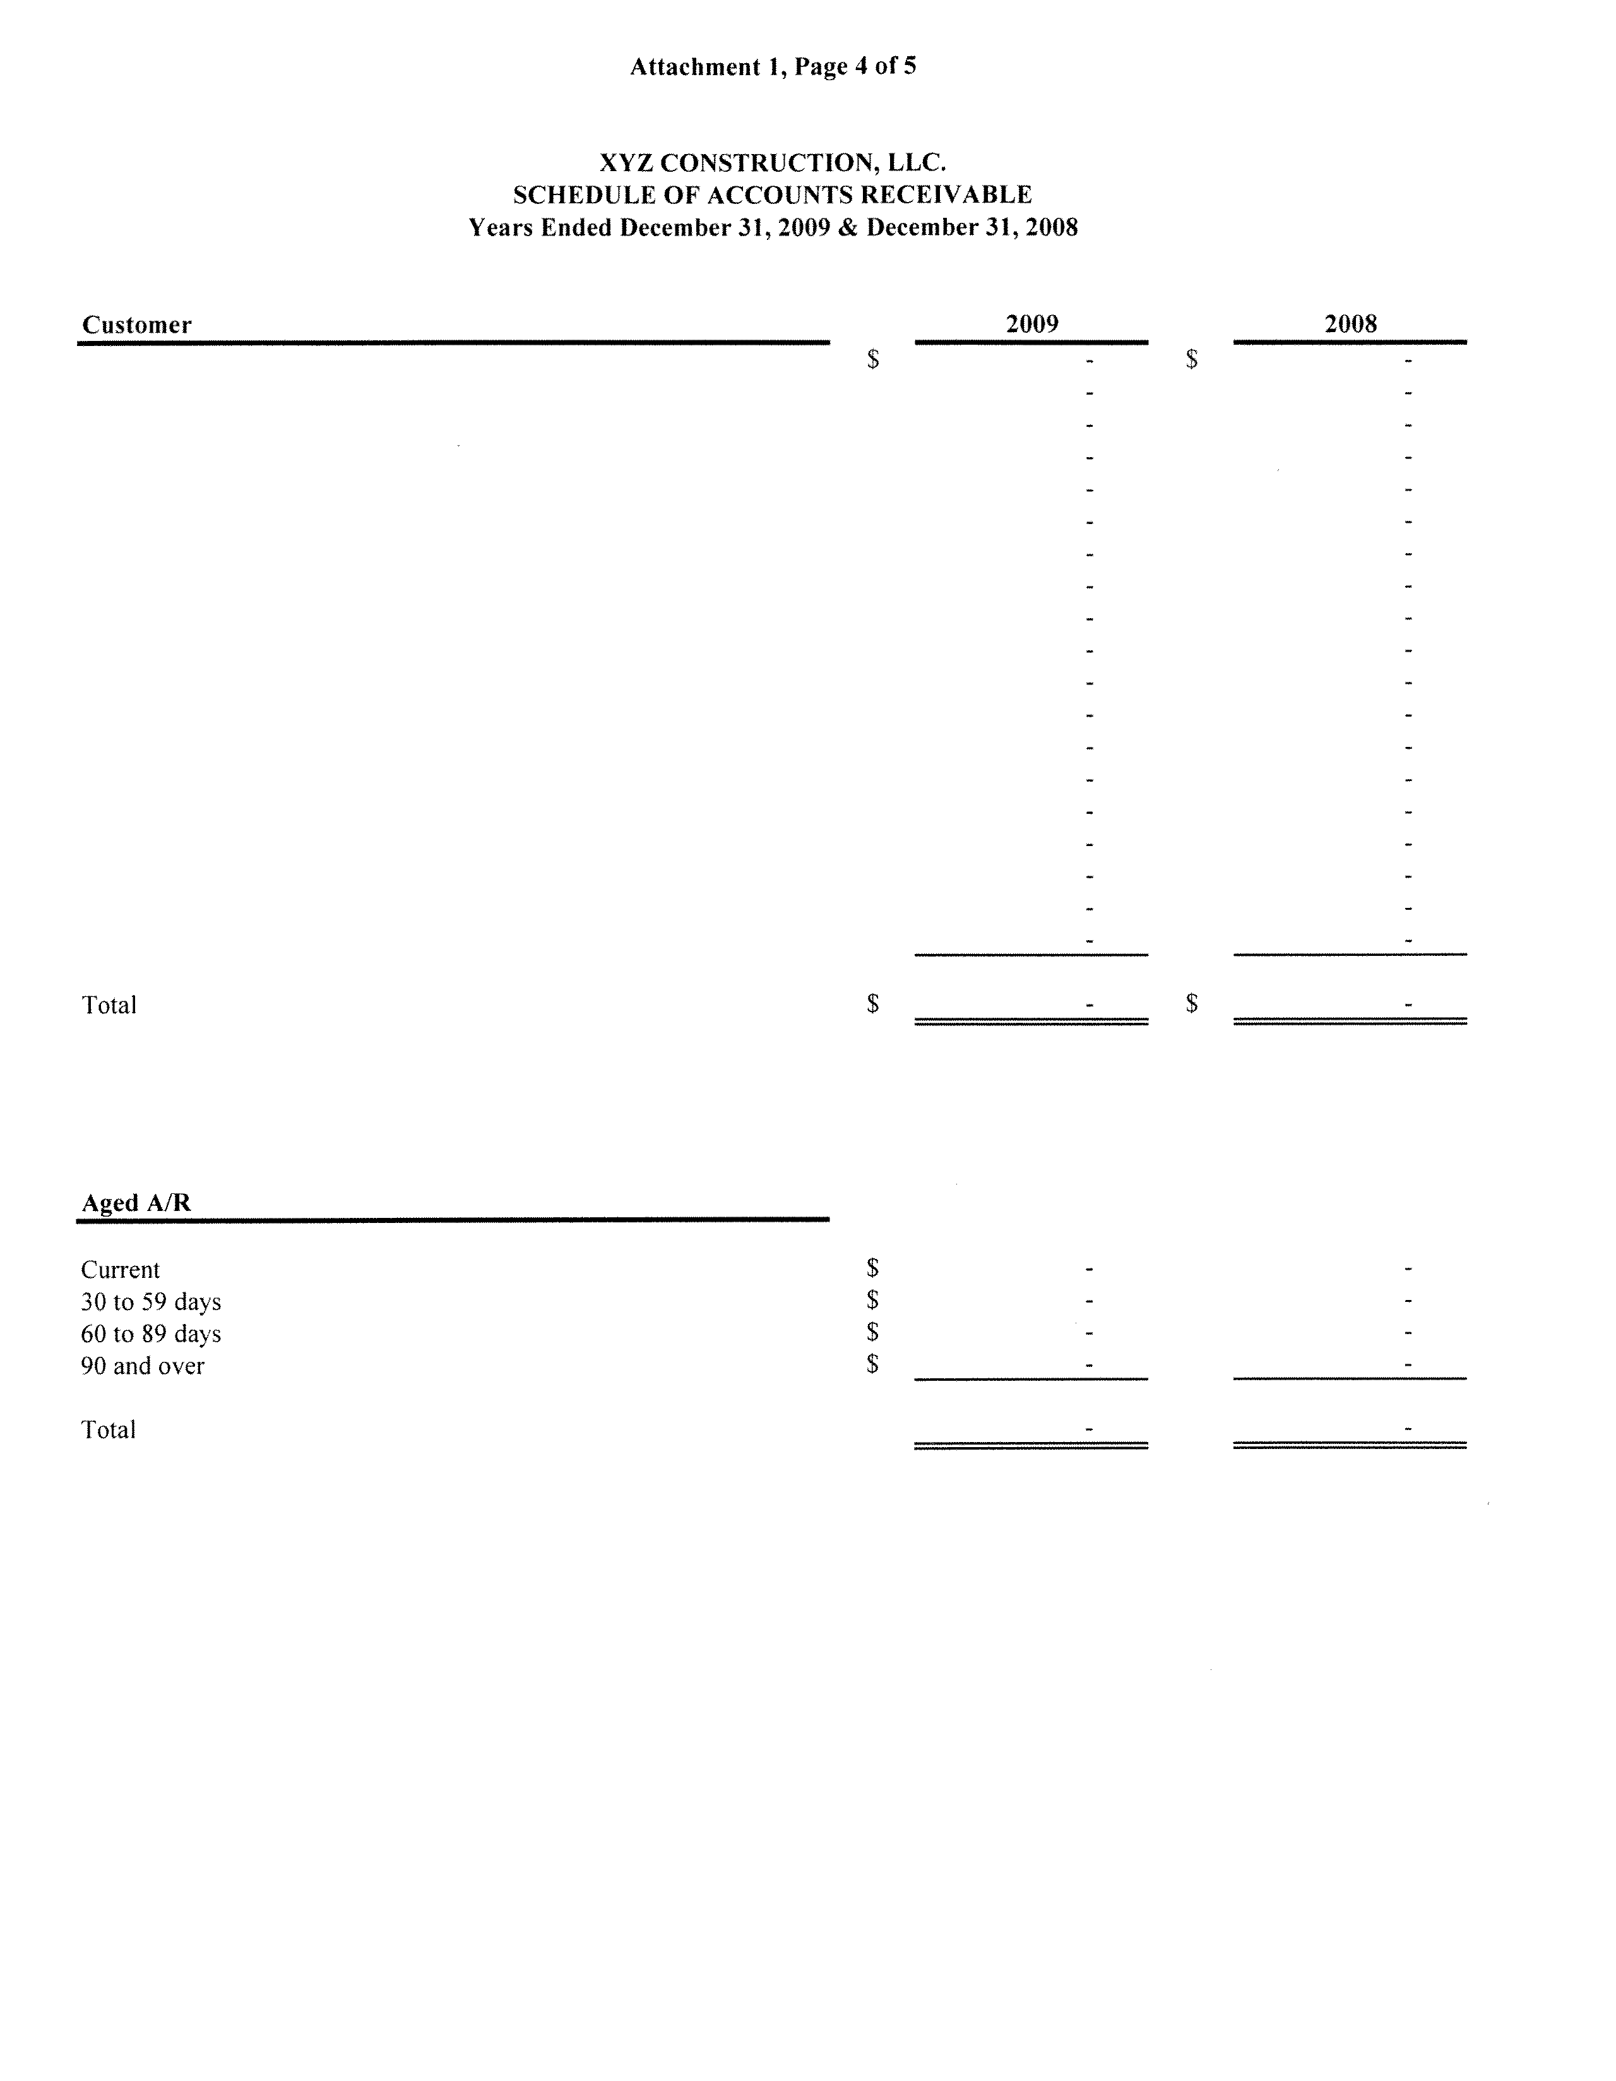
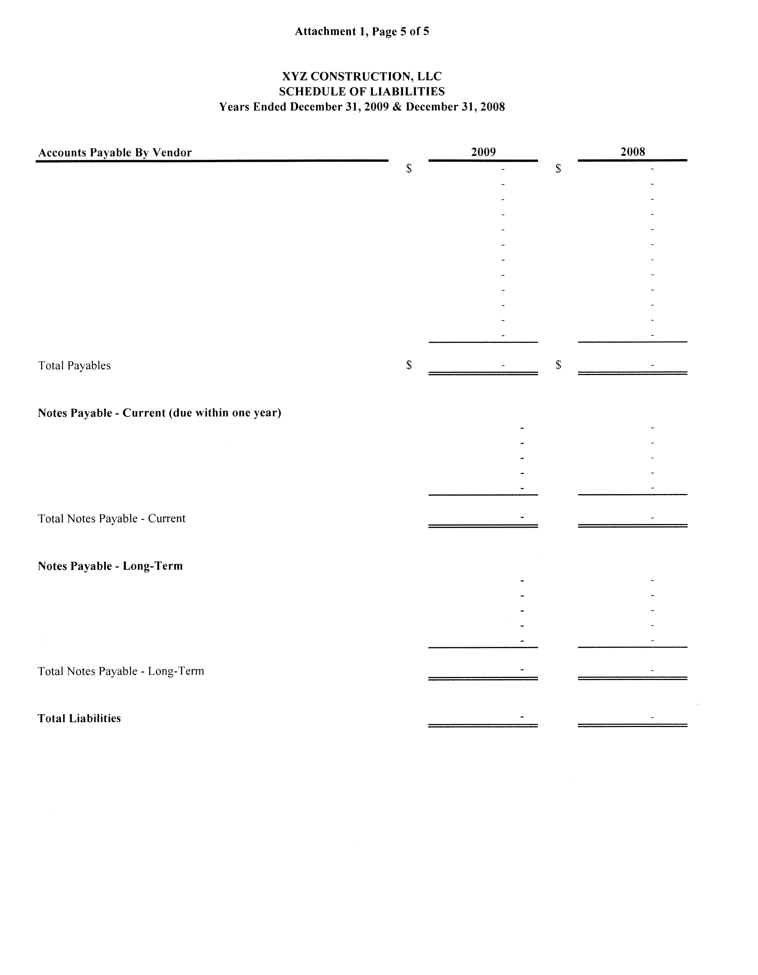
Attachment 2
Example of Accrual Basis Statement Format

