PARK SERVICE DAY 2021
Sponsorship Form
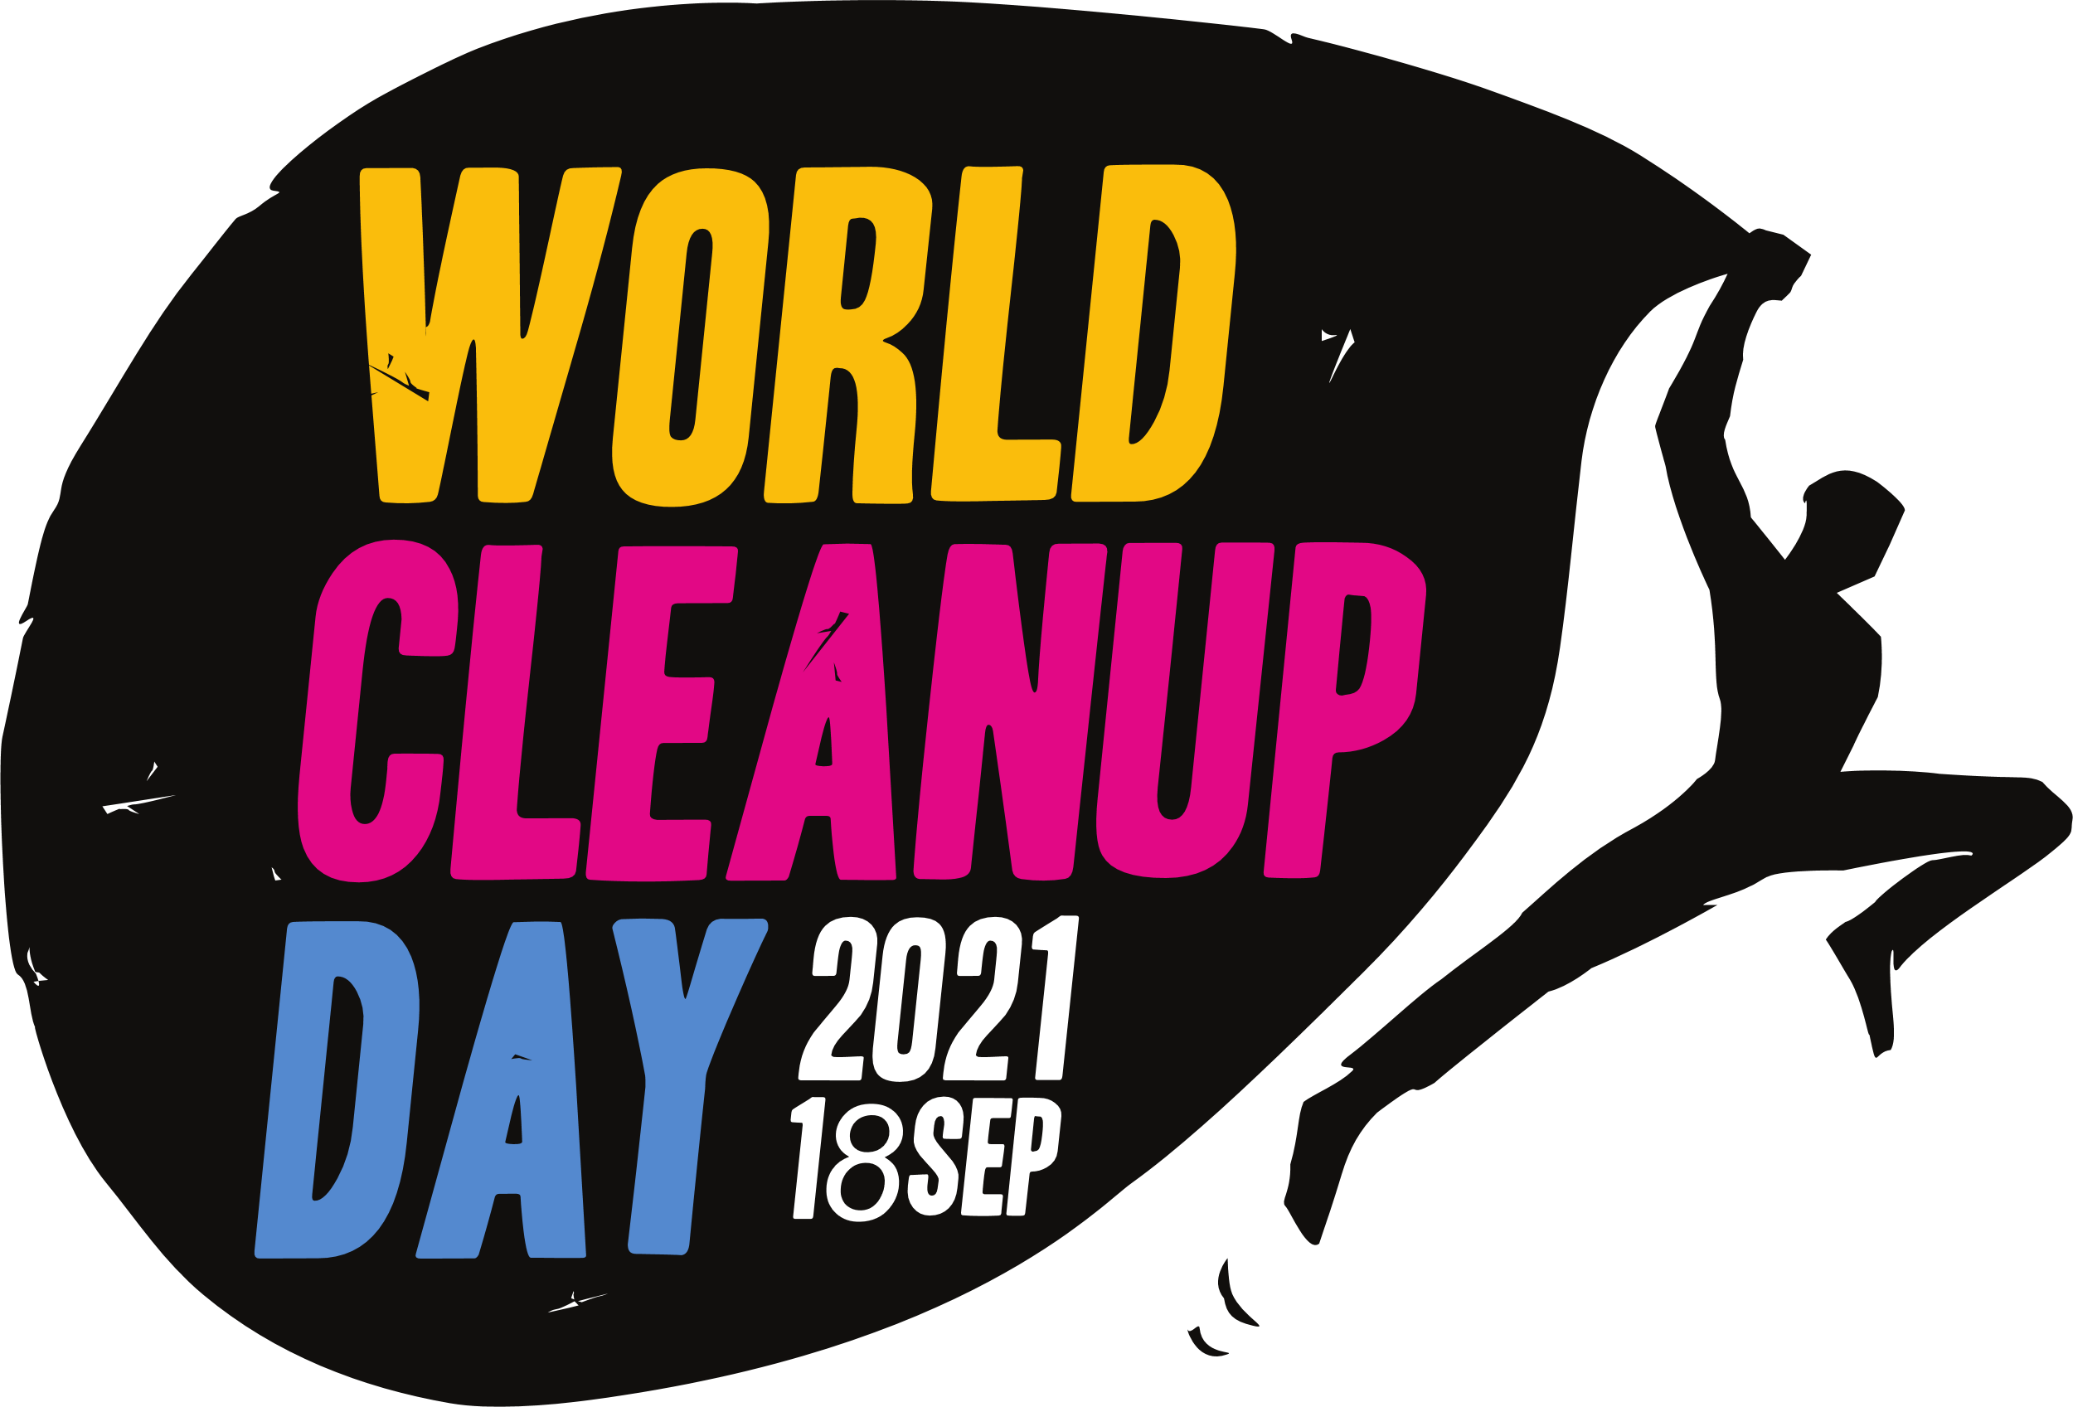

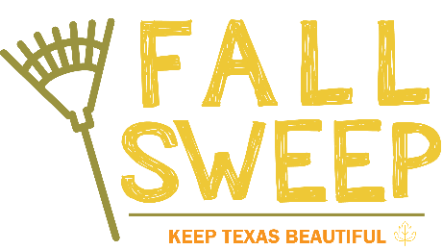

Event Information
Date: Saturday, September 18, 2021
Time: 9:00 am – 12:00 p.m.
Location: Woldert Park

Requirements
Organizations may contribute any monetary amount to the Park Service Day event. Donations of $250 and above qualify sponsors to have their logo on the event t-shirts. All sponsors will have their name/logo displayed on event sponsor banner and listed on the Keep Tyler Beautiful website. Contributions can be solely monetary, donated services or goods or any combination. Sponsors may send checks to Keep Tyler Beautiful at the following address: 1517 W. Front St. Suite 325, Tyler, TX 75702
City of Tyler Tax ID - 7560006979
What you need to know:
- All official event sponsors will have their name and/or logo displayed on the back of the Park Service Day t-shirt.
- Sponsors will be listed on the Keep Tyler Beautiful website.
- Sponsors will be allowed to set up a booth at the event if they choose.

Sponsor Information
Organization / Group: __________________________________________
Description of In-kind Donation: __________________________________
Monetary Value Donated: ______________

Sponsor Contact Name: ________________________________________
Contact Number: ___________________________________
Contact Email: _____________________________________

I would like a “We support Keep Tyler Beautiful” yard sign delivered to the below
address:

