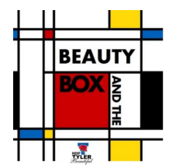
Art Guidelines

Images That May Be Submitted for Consideration

a. Submitted artworks may include:
- Digital version of existing artwork provided by the artist who owns the copyright and/or the artwork is not on display permanently in a public location within the Tyler/Smith County area.
-Artwork that is created digitally (photographs, etc.)

b. Selected artwork should be scalable to the different size boxes, including vertical and horizontal shapes.
*Note that because the boxes range in size and images could be used more than once, some cropping may occur.

c. We are seeking images that people will positively connect with emotionally and will draw people passing by on foot, bicycle or in a vehicle.

d. Images may include text or original poetry. The artist must have the rights to use this text.

e. No advertising, branding or commercial images allowed other than a small banner at the bottom of the utility box stating, “Sponsored by: Business Name”.

f. Imagery needs to be detailed enough to prevent temptation to graffiti.

