Keep Tyler Beautiful Adopt-a-Spot Program Details
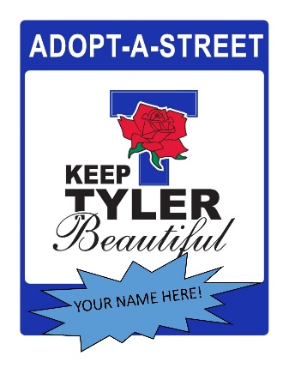
- Keep Tyler Beautiful has three litter prevention programs Adopt-A-Street, Adopt-A-Park, and Adopt-a-Campus.
- Non-profit organizations, businesses, families, service groups and others can join us in cleaning up our City’s streets and parks.
- Keep Tyler Beautiful will provide you with the supplies needed for your cleanups, such as litter grabbers, safety vests and trash bags.
- A large street sign with your group’s name will be put up so everyone can see that you are part of making a difference in our community.
- Adopt-A-Street sections are typically one mile long and inside the City Limits.
- Agreements for the Adopt-A-Street and Park programs call for a two-year commitment. Groups are expected to clean up their street or park at least once each quarter.
- There is an option to request Andrews Diversified Industries (ADI) to clean up your adopted area for a fee negotiated through ADI.

