 | G A T H E R I N G N O T I C E  City Council  and  Airport advisory board  TYLER AIR SERVICE DEVELOPMENT  Tyler Pounds Regional Airport  At Chamber of Commerce Genecov Room  Blackstone Building  315 N Broadway Suite 100 Tyler, Texas  April 29, 2026  4:00 p.m. | 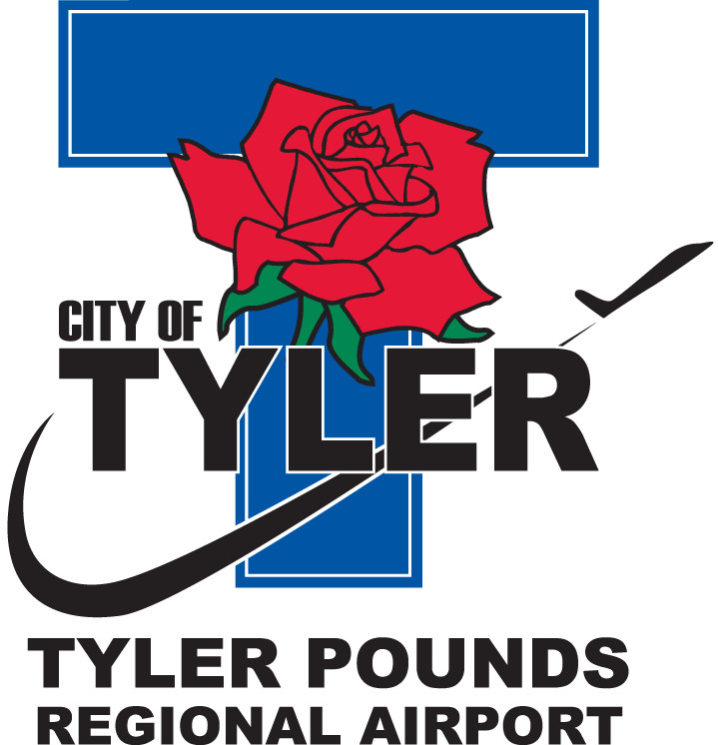.
********************************************************************************
Please call (903) 531-9825 if you need assistance with interpretation or translation for this City meeting.
Si usted necesita ayuda con la interpretación o traducción de cualquier material en este sitio o en una reunión pública de la Ciudad de Tyler por favor llame al (903) 531-9825.
******************************************************************************** AMERICANS WITH DISABILITIES ACT NOTICE
The City of Tyler wants to ensure that City Council and Board gatherings are accessible to persons with disabilities. If any individual needs special assistance or accommodation in order to attend this City Council and Board gathering, please contact Tyler Pounds Regional Airport at (903) 531-9825 in advance so accommodations can be made.
********************************************************************************There is the possibility that a quorum of the Tyler City Council and/or Airport Advisory Board will be present at the Tyler Air Service Development meeting on Wednesday, April 29, 2026 at 4:00 p.m., located the Tyler Chamber of Commerce, Genecov Room, 315 N Broadway Suite 100, Tyler, Texas.

Although some City-related items may be discussed, no action items will be considered by the City Council and/or Airport Advisory Board and no official action by the City Council and/or Airport Advisory Board is scheduled to be taken during this event.

CERTIFICATE OF POSTING

This is to certify that on the __ day of April, 2026, at _:__ _.M., the above notice was posted on the bulletin boards of City Hall.
______________________
City Clerk or Staff Designee
This is to certify that on the __ day of April, 2026, at _:__ _.M the above notice was posted at Tyler Pounds Regional Airport Westside Terminal Entrance, Tyler, Texas.
________________
Staff Designee

