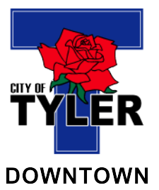 | A G E N D A  Main Street board  Regular Meeting  Main Street Office  Lower-Level Conference Room  110 N. College Ave.  Tyler, Texas  Thursday, December 11, 2025  10:00 a.m.

*********************************************************************************
Please call (903) 593-6905 if you need assistance with interpretation or translation for this City meeting.
Si usted necesita ayuda con la interpretación o traducción de cualquier material en este sitio o en una reunión pública de la Ciudad de Tyler por favor llame al (903) 595-7248.

*********************************************************************************

AMERICANS WITH DISABILITIES ACT NOTICE
The City of Tyler wants to ensure that City meetings are accessible to persons with disabilities. If any individual needs special assistance or accommodations in order to attend this board meeting please contact the Main Street Department at (903) 593-6905 in advance so accommodations can be made.
*********************************************************************************

- Call to Order and establish a quorum.
- Discuss and consider minutes from the Main Street Board meeting on October 9, 2025.
- Receive Downtown 2.0 Presentation – Fitzpatrick Architects
- Receive Downtown Improvement Project Update
- Review and approve the updated Downtown Revitalization Grant
- Main Street Director report
- Downtown Reinvestment Projects
- Strategic Plan Update
- Discuss items for next meeting agenda

********************************************
CERTIFICATE OF POSTING

This is to certify that on the _______ day of _________________, 2025, at _________ M., the above notice was posted on the bulletin boards of City Hall.
_______________________________________
City Clerk or Staff Designee

This is to certify that on the _______ day of _________________, 2025, at _________ M., the above notice was posted on the bulletin board of Main Street Office, 110 N College Ave. Ste. 105. Tyler, Texas.

________________________________________
Staff Designee

