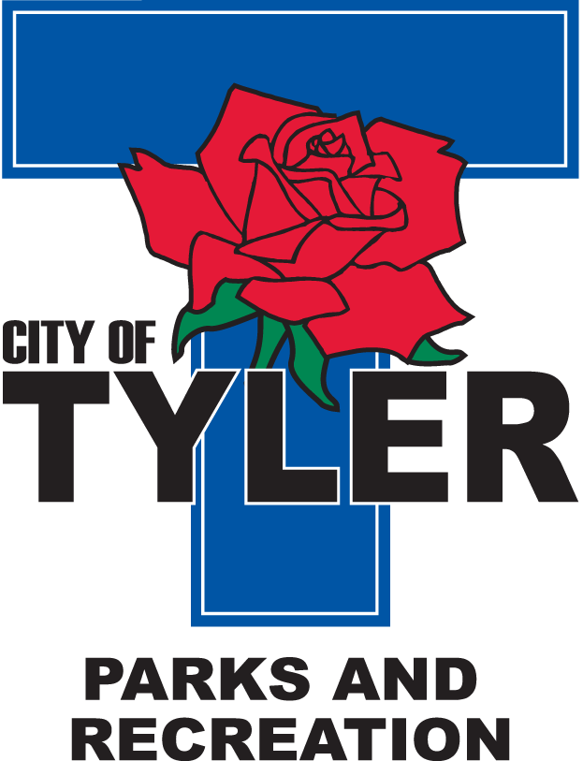  Welcome to The Tyler Senior Center  Open 9a.m.-5p.m. Monday-Friday    1915 Garden Valley Road (903) 597-0781    Meals on Wheels Lunch Served Daily 11:30a.m.-12:30p.m. | October  2025  Activities are subject to change

Monday | Tuesday | Wednesday | Thursday | Friday
Spirit Week  Oct 6th -Oct 10th |  | 1  10:00 Coffee Center Chat  11:00 Bodyworks  12:30 Bridge Club  12:30 BINGO with Hertiage Home Care | 2  11:00 Range of Motion  12:00 G.V. Singers  12:00 Angels Home Health  12:30 Line Dancers | 3  11:00 Bodyworks  12:00 42 Game  12:30 Bridge Club
6  11:00 Bodyworks  12:00 Left, Right, Center Game  12:30 Bridge Club  Crazy Sock Day  | 7  10:00 Painting 11:00 Range of Motion  12:30 Line Dancers  1:00 UT Blood Pressure Reunion  Hat day  | 8  11:00 Bodyworks  12:30 Bridge Club  12:30 BINGO with Embark Care  Western Day  | 9  11:00 Range of Motion  12:00 G.V. Singers  12:30 Line Dancers  2:00 AARP  Camo Day  | 10  11:00 Bodyworks  12:00 42 Game  12:30 Bridge Club  Jersey Day 
13  11:00 Bodyworks  12:30 Puzzle Activities  12:30 Bridge Club | 14  10:00 Painting 11:00 Range of Motion  12:00 “Senior Living” with Molina Healthcare  12:30 Line Dancers | 15  11:00 Bodyworks  12:30 Bridge Club  12:30 BINGO with Reunion Plaza | 16  11:00 Range of Motion  12:00 G.V. Singers  12:00 Angels Home Health  12:30 Line Dancers | 17  11:00 Bodyworks  12:00 42 Game  12:30 Bridge Club  Friday Night Dance-doors open at 6 p.m.-Dance from 6:30–9 p.m.  Music by Mr. C  Pink Out Day 
20  11:00 Bodyworks  12:30 Arts & Crafts w/Brookdale  12:30 Bridge Club | 21  10:00 Painting 11:00 Range of Motion  12:30 Line Dancers | 22  11:00 Bodyworks  12:30 Bridge Club  12:30 Bingo with Trek Insurance | 23  11:00 Range of Motion  12:00 G.V. Singers  12:30 Line Dancers | 24  11:00 Bodyworks  12:00 42 Game  12:30 Bridge Club
27  11:00 Bodyworks  12:30 Bridge Club  October Birthdays Celebration | 28  10:00 Painting 11:00 Range of Motion  11:30 Cloggers  12:30 Line Dancers | 29  9:00 –2:30 p.m. Senior EXPO @ WT Brookshires Conference Center | 30  11:00 Range of Motion  12:00 G.V. Singers  12:30 Line Dancers | 31  11:00 Bodyworks  12:00 42 Game  12:30 Bridge Club  Costume Contest  Halloween 

