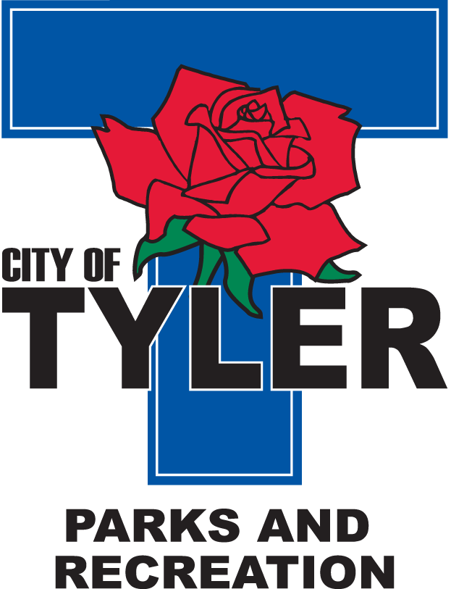  Welcome to The Tyler Senior Center  Open 9 a.m.-5 p.m. Monday-Friday    1915 Garden Valley Road (903) 597-0781  Meals on Wheels Lunch Served Daily 11:30 a.m.-12:30 p.m. | September  2025  Activities are subject to change
Monday | Tuesday | Wednesday | Thursday | Friday
1  CLOSED  For Labor Day | 2  10:00 Painting 11:00 Range of Motion  12:30 Line Dancers | 3  10:00 Coffee Center Chat  11:00 Bodyworks  12:30 Bridge Club  12:30 BINGO with Heritage Home Care | 4  11:00 Range of Motion  12:00 G.V. Singers  12:00 Angels Home Health  12:30 Line Dancers | 5  11:00 Bodyworks  12:00 42 Game  12:30 Bridge Club
8  11:00 Bodyworks  12:00 Bridge  12:00 Left, Right, Center Game | 9  10:00 Painting 11:00 Range of Motion  12:30 Line Dancers | 10  11:00 Bodyworks  12:30 Bridge Club  12:30 BINGO with Embark Care | 11  11:00 Range of Motion  12:00 G.V. Singers  12:00 “Kitchen Confidence” with Molina Healthcare  12:30 Line Dancers  2:00 AARP | 12  11:00 Bodyworks  12:00 42 Game  12:30 Bridge Club
15  11:00 Bodyworks  12:00 Puzzle Activities  12:30 Bridge Club | 16  10:00 Painting 11:00 Range of Motion  12:30 Line Dancers | 17  11:00 Bodyworks  12:30 Bridge Club  12:30 BINGO Reunion Plaza | 18  11:00 Range of Motion  12:00 G.V. Singers  12:00 Angels Home Health  12:30 Line Dancers | 19  10:00 till 12:00 p.m.  Senior Day at East Texas State Fair  Center Opening 12 p.m.  12:30 Bridge Club  Friday Night Dance from 6:30–9 p.m. Music by DJ Alex (doors open at 6 p.m.)
22  11:00 Bodyworks  12:30 Bridge Club  12:30 Arts & Crafts | 23  10:00 Painting  10–2 p.m. Fresh & Fit Health fair   | 24  11:00 Bodyworks  12:30 Bridge Club  12:30 BINGO with Trek Insurance | 25  11:00 Range of Motion  12:00 G.V. Singers  12:30 Line Dancers | 26  11:00 Bodyworks  12:00 42 Game  12:30 Bridge Club
29  11:00 Bodyworks  12:30 Bridge Club  September Birthdays Celebration | 30  10:00 Painting 11:00 Range of Motion  12:30 Line Dancing

