 | A G E N D A  Airport Advisory Board  Regular Monthly Meeting  Tyler Pounds Regional Airport  At Chamber of Commerce Genecov Room  Blackstone Building  315 N Broadway Suite 100 Tyler, Texas  Monday, September 15, 2025  1:30 pm | 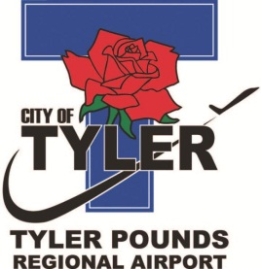
***********************************************************************************
Please call (903) 531-9825 if you need assistance with interpretation or translation for this City meeting.
Si usted necesita ayuda con la interpretación o traducción de cualquier material en este sitio o en una reunión pública de la Ciudad de Tyler por favor llame al (903) 531-9825.
***********************************************************************************

AMERICANS WITH DISABILITIES ACT NOTICE
The City of Tyler wants to ensure that City meetings are accessible to persons with disabilities. If any individual needs special assistance or accommodations to attend this board meeting, please contact the Airport at (903) 531-9825 in advance so accommodations can be made.

- Call meeting to order.
- Conduct a roll call and establish a quorum.
- Consider approval of the Minutes of the Airport Advisory Board meeting held on August 18, 2025.
- Presentation: Air Service Development
- Director's Report:
Update on Westside General Aviation (WSGA) Lease Agreement.
- Adjourn.

CERTIFICATE OF POSTING
This is to certify that on the __ day of September 2025, at __:__ _.m., the above notice was posted on the bulletin boards of City Hall.
City Clerk or Designee

This is to certify that on the __ day of September 2025, at __:__ _.m., the above notice was posted on the front door of the Blackstone Building, 315 N. Broadway, Tyler, Texas.

Staff Designee

