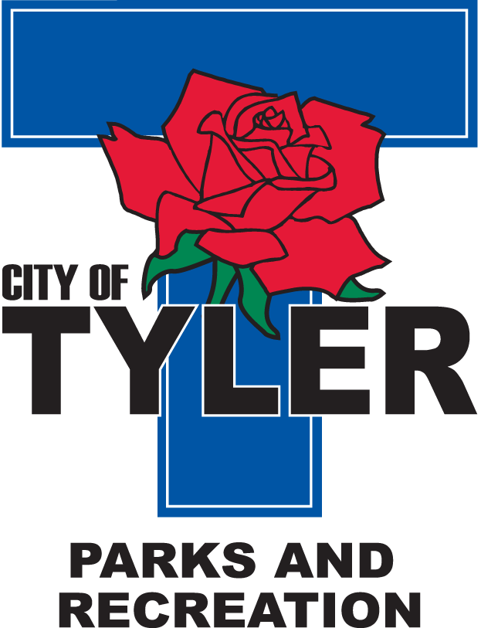  Welcome to The Tyler Senior Center  Open 9 a.m.-5 p.m. Monday-Friday    1915 Garden Valley Road (903) 597-0781  Meals on Wheels Lunch Served Daily 11:30 a.m.-12:30 p.m. | July  2025  Activities are subject to change
Monday | Tuesday | Wednesday | Thursday | Friday
 | 1  10:00 Painting 11:00 Range of Motion  12:30 Line Dancers  1:00 UT Blood Pressure Workshop | 2  10:00 Coffee Center Chat  11:00 Bodyworks  12:30 Bridge Club  12:30 BINGO with Synergy Home Care | 3  10:00 Painting 11:00 Range of Motion  12:30 Line Dancers  1:00 Senior Center Fair Exhibit | 4  Closed for July Fourth Holiday  
7  11:00 Bodyworks  12:00 Left, Right, Center Game  12:30 Bridge Club | 8  10:00 Painting 11:00 Range of Motion  12:30 Line Dancers | 9  11:00 Bodyworks  12:30 Bridge Club  12:30 BINGO with Embark Care | 10  11:00 Range of Motion  12:00 G.V. Singers  12:30 Line Dancers  2:00 AARP  2:00 Line Dancers perform @ Greenbriar | 11  11:00 Bodyworks  12:00 42 Game  12:30 Bridge Club
14  11:00 Bodyworks  12:30 Bridge Club  12:30 Arts & Crafts | 15  10:00 Painting 11:00 Range of Motion  12:00 Line Dancers  12:00 “Senior Living” with Primrose | 16  11:00 Bodyworks  12:30 Bridge Club  12:30 BINGO with Reunion Plaza | 17  11:00 Range of Motion  12:00 G.V. Singers  12:30 Line Dancers | 18  11:00 Bodyworks  12:00 42 Game  12:30 Bridge Club  Friday Night Dance from 6:30–9 p.m. Music by Mr. C Band (doors open at 6)
21  11:00 Bodyworks  12:00 Puzzle Games  12:30 Bridge Club | 22  10:00 Painting 11:00 Range of Motion  12:30 Line Dancing | 23  11:00 Bodyworks  12:30 Bridge Club  12:30 BINGO with Trek Insurance | 24  11:00 Range of Motion  12:00 G.V. Singers  12:00 Senior Living with Molina Healthcare  12:30 Line Dancers | 25  11:00 Bodyworks  12:00 42 Game  12:30 Bridge Club
28  11:00 Bodyworks  12:30 Bridge Club  July Birthdays Celebration | 29  10:00 Painting 11:00 Range of Motion  12:30 Line Dancing | 30  11:00 Bodyworks  12:30 Bridge Club  12:30 BINGO with Azalea Trails | 31  11:00 Range of Motion  12:00 G.V. Singers  12:30 Line Dancers

