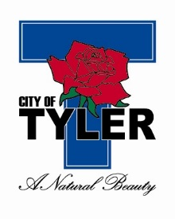
CITY OF TYLER COMMUNICATIONS OFFICE
Julie Goodgame (903) 531-1272 or cell (903) 245-5377, jgoodgame@tylertexas.com
Adriana Rodriguez (903) 595-7248 or cell (903) 245-9715, arodriguez@tylertexas.com

Press Release
For Immediate Release
Nov. 6, 2019


Super Shredder Day is tomorrow

Those looking for an opportunity to clear their homes of paper clutter or want to recycle electronics are invited to Super Shredder Day. On Thursday, Nov. 7 from 7 a.m. to 6 p.m., CBS19 and the City of Tyler Solid Waste Department have partnered to provide a shredding and recycling event in the parking lot of CBS19 Station at 2211 ESE Loop 323.

Residents may bring paper products and documents for shredding at no cost. Tyler Solid Waste will accept electronic devices, including computers and laptops at no charge as well.

TVs, computer monitors and microwaves will include a $5 fee for residential customers and $8 fee for commercial providers.

For more information, please contact Tyler Solid Waste at (903) 531-1388.

###
Download the City of Tyler app:


