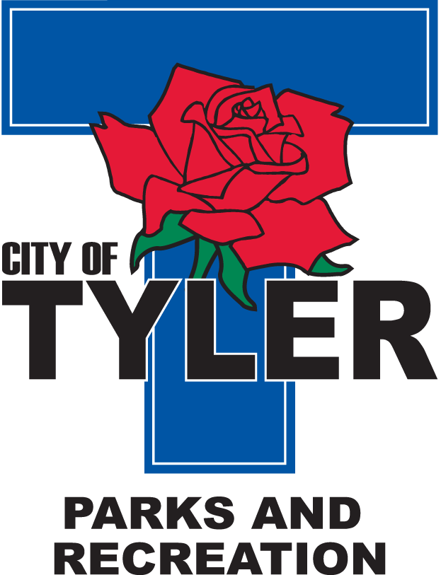  Welcome to The Tyler Senior Center  Open 9a.m.-5p.m. Monday-Friday    1915 Garden Valley Road (903) 597-0781    Meals on Wheels Lunch Served Daily 11:30a.m.-12:30p.m. | April  2025  Activities are subject to change

Monday | Tuesday | Wednesday | Thursday | Friday
 | 1  10:00 Painting 11:00 Range of Motion  12:30 Line Dancers  April’s Fool Day | 2  10:00 Coffee Center Chat  11:00 Bodyworks  12:30 Bridge Club  12:30 BINGO with Syengery Home Health | 3  10:00 Quilting Club  11:00 Range of Motion  12:00 G.V. Singers  12:30 Line Dancers | 4  11:00 Bodyworks  12:00 42 Game  12:30 Bridge Club
7  11:00 Bodyworks  12:00 Left, Right, Center Game  12:30 Bridge Club | 8  10:00 Painting 11:00 Range of Motion  12:30 Line Dancers | 9  11:00 Bodyworks  12:30 Bridge Club  12:30 BINGO with Embark Care | 10  10:00 Quilting Club  11:00 Range of Motion  12:00 G.V. Singers  12:30 Line Dancers  2:00 AARP | 11  11:00 Bodyworks  12:00 42 Game  12:30 Bridge Club
14  11:00 Bodyworks  12:00 Learning of Care with Angels Care Home Health  12:30 Bridge Club | 15  10:00 Painting  11:00 Range of Motion  12:00 Line Dancers  1:00 Haircuts for Seniors by Instructor LaVern Freeney | 16  11:00 Bodyworks  12:30 Bridge Club  12:30 BINGO with Reunion Plaza | 17  10:00 Quilting Club  11:00 Range of Motion  12:00 G.V. Singers  12:30 Line Dancers | 18  CLOSED  for  Good Friday
21  11:00 Bodyworks  12:00 Arts & Crafts  12:30 Bridge Club | 22  10:00 Painting 11:00 Range of Motion  12:30 Line Dancers  Earth Day | 23  11:00 Bodyworks  12:30 Bridge Club  12:30 BINGO with Trek Insurance | 24  10:00 Quilting Club  11:00 Range of Motion  12:00 G.V. Singers  12:30 Line Dancers | 25  11:00 Bodyworks  12:00 42 Game  12:30 Bridge Club  4:00 Line Dancers @ Oak Hill Terrace
28  11:00 Bodyworks  12:30 Bridge Club  April Birthdays Celebration | 29  10:00 Painting 11:00 Range of Motion  12:30 Line Dancers | 30  11:00 Bodyworks  12:30 Bridge Club  12:30 BINGO with Azalea Trails

