 | G A T H E R I N G N O T I C E  City Council Gathering  Annual Veterans Day BBQ Cookout  Fire Station Five  1532 S. Bennett Ave.  Tyler, Texas  Friday, November 8, 2024  11:00 a.m.
********************************************************************************
Please call (903) 531-1250 if you need assistance with interpretation or translation for this City meeting.

Si usted necesita ayuda con la interpretación o traducción de cualquier material en este sitio o en una reunión pública de la Ciudad de Tyler por favor llame al (903) 531-1250.
********************************************************************************

AMERICANS WITH DISABILITIES ACT NOTICE
The City of Tyler wants to ensure that City Council gatherings are accessible to persons with disabilities. If any individual needs special assistance or accommodations in order to attend this City Council gathering, please contact the City Manager’s Office at (903) 531-1250 in advance so accommodations can be made.
********************************************************************************
A Tyler Fire Department Annual Veterans Day BBQ Cook-out for invited guests has been scheduled. There is the possibility that a quorum of the City Council will be present at the Annual Veterans Day BBQ Cook-out on Friday, November 8, 2024, at 11:00 a.m., located at Fire Station Five at 1532 S. Bennett Avenue, Tyler, Texas.

Although some City-related items may be discussed, no action items will be considered by the City Council and no official action by the City Council is scheduled to be taken during this event.

CERTIFICATE OF POSTING

This is to certify that on the 4TH day of November 2024, at 4:56 P.M., the above notice was posted on the bulletin boards of City Hall.
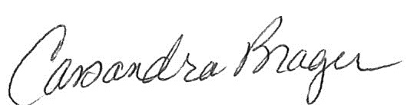
_______________________________________
City Clerk or Staff Designee

This is to certify that on the _____ day of _November, 2024, at _______ M., the above notice was posted on the front door of Fire Station Five, 1532 S. Bennett Avenue, Tyler, Texas.

_______________________________________
Staff Designee

