CAREER OPPORTUNITIES
Tyler Law Enforcement Cadets are offered every possible contact in the law enforcement community that can be provided. Cadets are given briefings by various Federal, State, County, and Local agencies to provide them with the information on this diverse career field. Tyler Law Enforcement Cadets also are offered the opportunity to ride along with police officers during a tour of duty. Cadets boost their self-confidence in career opportunities through participation in programs that increasingly test their knowledge. Cadets participate in scenario training as part of the program.

LIFE SKILLS
Cadets are involved in the community through various programs. Additionally, Cadets are made aware of the physical and mental demands of the career and participate in a variety of both organized and individual fitness programs.

THE BENEFITS OF BEING A CADET
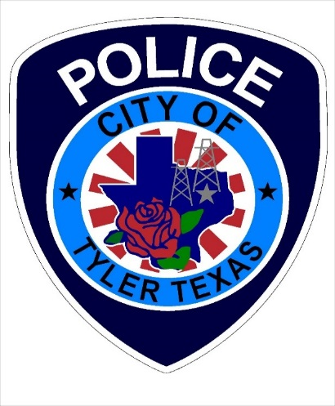

CHARACTER EDUCATION

Cadets are provided with the same forum for Cultural Diversity that patrol officers receive for annual required training. Additionally, Cadets learn laws and regulations regarding Racial Profiling and other current topics regarding ethical treatment of citizens. Cadets assist with numerous community programs.

LEADERSHIP
Unit #310 is organized in a similar fashion to the Police Department. Cadets are able to obtain leadership positions as team leader, unit sergeant, and unit lieutenant. These increasingly difficult tasks stress leadership and communication skills.
Cadets can compete in Explorer/Cadet Competitions testing their skills and leadership against their peers.

Tyler Police Department
711 W. Ferguson Street
Tyler, Texas 75702
Main Phone #: 903.533.2015
Email:
Cadet Supervisor-
Sgt. Kevin Mobley:
kmobley@tylertexas.com
Cadet Mentors:
James McCraw
jmccraw@tylertexas.com
Bianca Smedley
bsmedley@tylertexas.com
Xavier Johnson
xjohnson@tylertexas.com
Kerri Long
klong@tylertexas.com
Judah Wilson
jwilson@tylertexas.com

Tyler Police Department
UNIT 310
CADETS
WHAT IS PUBLIC SAFETY CADETS?
www.publicsafetycadets.org
Public Safety Cadets is a worksite-based program for young men and woman who have completed the 8th grade and are at least 14 years of age or are 15 years of age but have not yet reached their 21st birthday.
Law Enforcement Cadet Programs help youth to gain insight into a variety of programs which offer hands-on career activities. For young men and women who are interested in careers in the field of law enforcement. The Cadet program offers learning with lots of fun filled, hands-on activities which promote the growth and development of adolescent youth.
Meetings are held every Tuesday at 6:00pm at the Tyler Police Department located at 711 W. Ferguson St.

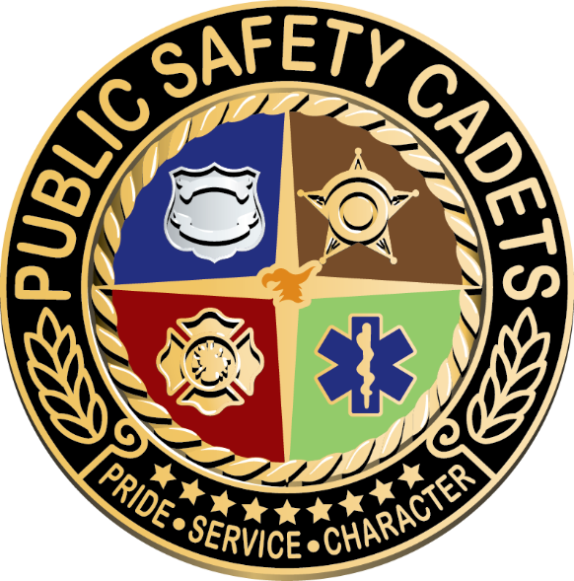
6

