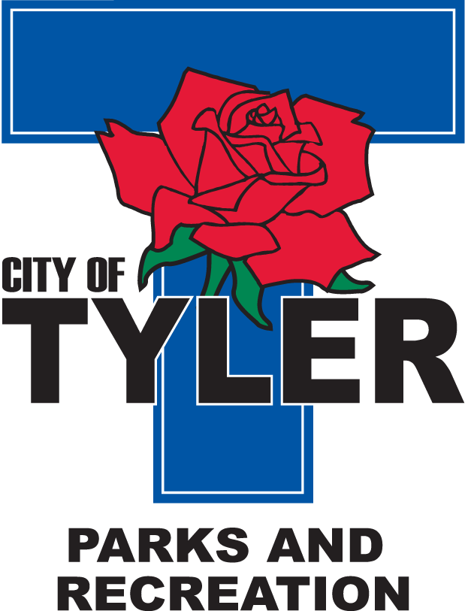  Welcome to The Tyler Senior Center  Open 9a.m.-5p.m. Monday-Friday    1915 Garden Valley Road (903) 597-0781    Meals on Wheels Lunch Served Daily 11:30a.m.-12:30p.m. | June  2024  Activities are subject to change

Monday | Tuesday | Wednesday | Thursday | Friday
3  11:00 Bodyworks  12:00 Left, Right, Center Game  12:30 Bridge Club | 4  9:30 Walking Club  10:00 Painting 11:00 Range of Motion  11:30 Clogger  12:30 Line Dancers | 5  10:00 Coffee Center Chat  11:00 Bodyworks  12:30 Bridge Club  12:30 BINGO with Synergy Homecare | 6  9:30 Walking Club 11:00 Range of Motion  11:30 Clogger  12:30 Line Dancers | 7  11:00 Bodyworks  12:00 42 Game  12:30 Bridge Club  National Donut Day
10  11:00 Bodyworks  12:00 Susan with Lakeview “Senior living housing”  12:30 Bridge Club | 11  9:30 Walking Club  10:00 Painting 11:00 Range of Motion  11:30 Clogger  12:00 UT Health  12:30 Line Dancers | 12  9:30 Walking Club  11:00 Bodyworks  12:30 Bridge Club  12:30 BINGO with Hospice Plus | 13  9:30 Walking Club  11:00 Range of Motion  12:00 G.V. Singers  12:00 TX Dot “Senior Traffic Safety”  12:30 Line Dancers  2:00 AARP | 14  11:00 Bodyworks  12:00 42 Game  12:30 Bridge Club    Flag Day
17  11:00 Bodyworks  12:30 Crafts  12:30 Bridge Club | 18  9:30 Walking Club  10:00 Painting 11:00 Range of Motion  11:30 Cloggers  12:00 Line Dancers | 19  CLOSED for Juneteenth Holiday | 20  9:30 Walking Club  11:00 Range of Motion  12:00 G.V. Singers  12:30 East Texas Food Bank “Nutrition”  12:30 Line Dancers | 21  11:00 Bodyworks  12:00 42 Game  12:30 Bridge Club  Friday Night Dance-doors open at 6 pm-Dance from 6:30-9 Pm.  Music by Ruffshod
24  11:00 Bodyworks  12:30 Bridge Club  12:30 Jeanne w/Trek Ins. “are you covered?”  June Birthdays Celebration | 25  9:30 Walking Club  10:00 Painting 11:00 Range of Motion  11:30 Cloggers  12:30 Line Dancing | 26  9:30 Walking Club  11:00 Bodyworks  12:30 Bridge Club  12:30 BINGO with Oakstreet | 27  9:30 Walking Club  10:00 Zoo Field Trip  11:00 Range of Motion  12:00 G.V. Singers  12:30 Line Dancers | 28  11:00 Bodyworks  12:00 42 Game  12:30 Bridge Club

