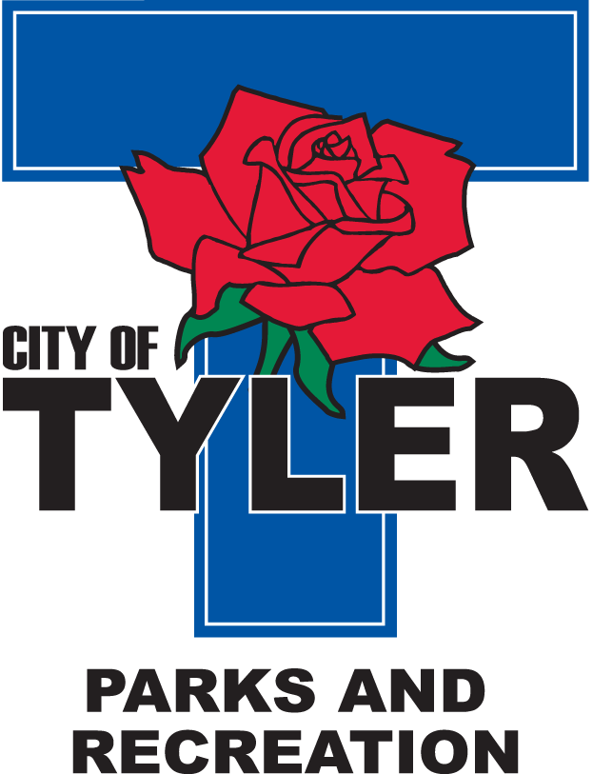  Welcome to The Tyler Senior Center  Open 9a.m.-5p.m. Monday-Friday    1915 Garden Valley Road (903) 597-0781    Meals on Wheels Lunch Served Daily 11:30a.m.-12:30p.m. | February  2024  Activities are subject to change
Monday | Tuesday | Wednesday | Thursday | Friday
 |  |  | 1  11:00 Range of Motion  12:00 G.V. Singers  12:30 Line Dancers  12:30 UT Blood Pressure Management Workshop | 2  11:00 Bodyworks  12:00 42 Game  12:30 Bridge Club  Groundhog Day
5  11:00 Bodyworks  12:00 Left, Right, Center Game  12:30 Bridge Club | 6  10:00 Painting 11:00 Range of Motion  11:30 Clogger  12:00 UT Tyler AI Communications  12:30 Line Dancers | 7  10:00 Coffee Center Chat  11:00 Bodyworks  12:30 Bridge Club  12:30 BINGO with Brookdale | 8  11:00 Range of Motion  12:00 G.V. Singers  12:30 Line Dancers  2:00 AARP | 9  11:00 Bodyworks  12:00 42 Game  12:30 Bridge Club
12  11:00 Bodyworks  12:30 Bridge Club  12:30 Crafts | 13  10:00 Painting 11:00 Range of Motion  11:30 Cloggers  12:00 Line Dancers | 14  11:00 Bodyworks  12:30 Bridge Club  12:30 BINGO Harbor Hospice  Valentines Day  | 15  11:00 Range of Motion  12:00 G.V. Singers  12:30 UT Blood Pressure Management Workshop  12:30 Line Dancers | 16  11:00 Bodyworks  12:00 42 Game  12:30 Bridge Club  Sweetheart Ball Dance -doors open at 6 pm. Dance from 6:30-9 Pm.  Music by Mr. C
19  11:00 Bodyworks  12:00 Black History Trivia  12:30 Bridge Club  President’s Day | 20  10:00 Painting 11:00 Range of Motion  11:30 Cloggers  12:30 Line Dancers  1:00 Black History Program | 21  11:00 Bodyworks  12:30 Bridge Club  12:30 BINGO with Reunion Plaza | 22  11:00 Range of Motion  12:00 G.V. Singers  12:00 Alberto with Reunion Plaza about Senior living  12:30 Line Dancers | 23  11:00 Bodyworks  12:00 42 Game  12:30 Bridge Club
26  11:00 Bodyworks  12:30 Bridge Club  February Birthdays Celebration | 27  10:00 Painting 11:00 Range of Motion  11:30 Cloggers  12:00 Movie Day  12:30 Line Dancing | 28  11:00 Bodyworks  12:30 Bridge Club  12:30 BINGO with OakStreet Health | 29  11:00 Range of Motion  12:00 G.V. Singers  12:30 Line Dancers  12:30 UT Blood Pressure Management Workshop  *Line Dancers perform at UT Tyler University for halftime entertainment at 5:00 pm.

