2023 COLD/SEVERE WEATHER RESPONSE PLAN

Tyler / Smith County

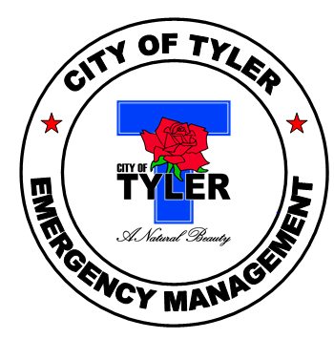

This plan can be accessed at the following links:

https://www.cityoftyler.org/government/departments/fire-department/emergency-management/emergency-management

https://www.smith-county.com/government/departments/emergency-management

PURPOSE

This Cold Weather Response Plan is designed to serve as a guide and to provide useful information to the public. It includes tips on avoiding exposures as well as recognizing the signs and symptoms of cold weather-related emergencies. Additionally, it highlights resources that are available to the public during the winter months, including sheltering locations.

RESPONSIBILITY / LEAD AGENCY

The Tyler Fire Department and the Smith County Fire Marshal’s office are the lead agencies for the Cold Weather Response Plan. Agencies or citizens needing information or administrative assistance should call the City of Tyler Fire Department at (903) 535-0005. After hours, or to report hazardous but non-emergency conditions, call either the Tyler Police Department at (903) 531-1000 or the Smith County Sheriff’s Office at (903) 566-6600. For public affairs information call the Northeast Texas Public Health District at (903) 535-0020. Call 211 as an additional resource.

……..… As always, in an emergency, please call 911 …….….

SCIENCE - HYPOTHERMIA

When exposed to cold temperatures, your body begins to lose heat faster than it can be produced. Prolonged exposure to cold will eventually use up your body’s stored energy. The result is hypothermia, a condition brought on when the body temperature drops below 90 degrees F. Body temperature that is too low affects the brain, making the victim unable to think clearly or move well. This makes hypothermia particularly dangerous because a person may not know it is happening and won’t be able to do anything about it.

Hypothermia is most likely at very cold temperatures, but it can occur even at cool temperatures
(above 40°F) if a person becomes chilled from rain, sweat, or submersion in cold water.

Victims of hypothermia are often:
- Elderly people with inadequate food, clothing, or heating; lower metabolic rate might prevent them from maintaining normal body temperatures when temperatures fall below 64.4°F
- Babies sleeping in cold bedrooms.
- People who remain outdoors for long periods - the homeless, hikers, hunters, etc.
- People who drink alcohol or use illicit drugs.

Symptoms of Hypothermia are:

- Uncontrollable shivering
- Slow speech
- Memory lapses
- Frequent stumbling
- Drowsiness
- Exhaustion

From 1991to 2011, a total of 16,911deaths in the United States, an average of 1,301 per year, were associated with exposure to excessive natural cold. The highest annual total of hypothermia-related deaths (1,536) was in 2010 and the lowest (1,058) was in 2006. Approximately 67% of hypothermia-related deaths was among males.

Source: National Vital Statistics System. Mortality public use data files, 1999-2010.
Available at http://www.cdc.gov/nchs/data_access/vitalstatsonline.htm

Winter Storm Uri February 13-17, 2021

- 210 people in Texas died because of the historic freeze that occurred in February 2021.
- Source: The Texas Department of State Health Services

SCIENCE - FROSTBITE

Frostbite is an injury to the body that is caused by freezing. Frostbite causes a loss of feeling and color in affected areas. It most often affects the nose, ears, cheeks, chin, fingers, or toes. Frostbite can permanently damage the body, and severe cases can lead to amputation. The risk of frostbite is increased in people with reduced blood circulation and among people who are not dressed properly for extremely cold temperatures.

At the first signs of redness or pain in any skin area, get out of the cold or protect any exposed skin where frostbite may be beginning. Any of the following signs may indicate frostbite:

- A white or grayish-yellow skin area
- Skin that feels unusually firm or waxy
- Pins and needles, followed by numbness
- Red and extremely painful skin and muscle as the area thaws

NOTE: Victims are often unaware of frostbite until someone else points it out because frozen tissues are numb in and near the affected area.

TREATMENT

Because frostbite and hypothermia both result from exposure, first determine whether there are signs of hypothermia, as described previously. Hypothermia is a more serious medical condition and requires immediate emergency medical assistance.

If frostbite or hypothermia is suspected, begin warming the person slowly and seek immediate medical help. Warm the person’s trunk first. Arms and legs should be warmed last because stimulation of the limbs can drive cold blood towards the heart and lead to heart failure. Put the victim in dry clothing and wrap his or her entire body in a blanket. If no other treatment is available, use your own body heat to help raise the victims core temperature or warm frost-bitten extremities.

Never give a frostbite or hypothermia victim caffeine (coffee or tea). Caffeine, a stimulant, can cause the heart to beat faster and speed up the effects cold has on the body. Alcohol, a depressant, can slow the heart and speed up the effects of cold body temperature.

If there is frostbite but no sign of hypothermia and immediate medical care is not available, proceed as follows:

- Get into a warm room as soon as possible.
- Unless necessary, do not walk on frostbitten feet or toes - this increases the damage.
- Immerse the affected area in warm - not hot - water (the temperature should be comfortable to the touch for unaffected parts of the body).
- Warm the affected area using body heat. The armpit can be used to warm frostbitten fingers.
- Do not rub the frostbitten area with snow or massage it at all. This can cause more damage.
- Do not use a heating pad, heat lamp, or the heat of a stove, fireplace, or radiator for warming. Affected areas are numb and can be easily burned.

WATCHES, ADVISORIES, AND WARNINGS

Monitor local and national weather channels and stations and reliable social media. Be alert to changing conditions.

Watch: Issued in the 24 to 72 hour forecast time frame when the risk of a hazardous winter weather event has increased (50 to 80% certainty that warning thresholds will be met). It is intended to provide enough lead time so those who need to set their plans in motion can do so.

- Wind Chill Watch: Conditions are favorable for wind chill temperatures to meet or exceed local wind chill warning criteria in the next 24 to 72 hours. Wind chill temperatures may reach or exceed -25°F.

- Winter Storm Watch: Conditions are favorable for a winter storm event (heavy sleet, ice storm, heavy snow and blowing snow or a combination of events) to meet or exceed local winter storm warning criteria in the next 24 to 72 hours. Criteria for snow is 7” more in 12 hours or less, or 9” or more in 24 hours covering at least 50% of the zone or encompassing most of the population. Criteria for ice is ½” or more over at least 50% of the zone or encompassing most of the population.

Advisory: Issued when a hazardous winter weather event is occurring, is imminent, or has a very high probability of occurrence (generally greater than 80%). An advisory is for less serious conditions that cause significant inconvenience and, if caution is not exercised, could lead to situations that may threaten life and/or property.

- Winter Weather Advisory: A winter storm event (sleet, freezing rain, snow and blowing snow, or a combination of events) is expected to meet or exceed local winter weather advisory criteria in the next 12 to 36 hours but stay below warning criteria. Criteria for snow is 4" or more in 12 hours covering at least 50% of the zone or encompassing most of the population.

- Freezing Rain Advisory: Any accumulation of freezing rain is expected in the next 12 to 36 hours (but will remain below ½”) for at least 50 percent of the zone or encompassing most of the population.

- Wind Chill Advisory: Wind chill temperatures are expected to meet or exceed local wind chill advisory criteria in the next 12 to 36 hours. Wind chill temperatures may reach or exceed -15°F.

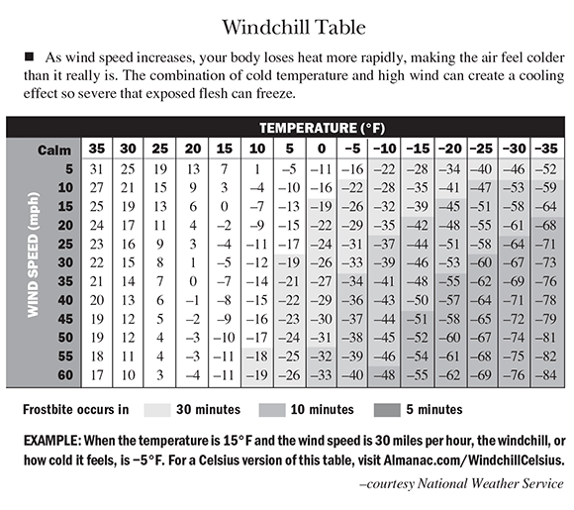

Warning: Issued when a hazardous winter weather event is occurring, is imminent, or has a very high probability of occurrence (generally greater than 80%). A warning is used for conditions posing a threat to life or property.
- Ice Storm Warning: An ice storm event is expected to meet or exceed local ice storm warning criteria in the next 12 to 36 hours. Criteria for ice is ½” or more over at least 50 percent of the zone or encompassing most of the population.

- Wind Chill Warning: Wind chill temperatures are expected to meet or exceed local wind chill warning criteria in the next 12 to 36 hours. Wind chill temperatures may reach or exceed -25°F.

- Winter Storm Warning: A winter storm (heavy sleet, ice storm, snow or blowing snow, or a combination of events) is expected to meet or exceed local winter storm warning criteria in the next 12 to 36 hours. Criteria for snow is 7" or more in 12 hours or less, or 9” or more in 24 hours covering at least 50% of the zone or encompassing most of the population.

PRECAUTIONS

Dressing properly is extremely important in preventing cold stress. The type of fabric worn also makes a difference. Cotton loses its insulation value when it becomes wet. Wool, silk and most synthetics, on the other hand, retain their insulation even when wet. The following are recommendations for working in cold environments:
- Do not wear tight fitting clothing.
- Wear at least three layers of loose-fitting clothing. Layering provides better insulation.
  - An inner layer of wool, silk or synthetic to keep moisture away from the body.
  - A middle layer of wool or synthetic to provide insulation even when wet.
  - Outer wind/rain protection layer that allows ventilation to prevent overheating.
- Wear a hat or hood reduce the amount of body heat that escapes from your head.
- Use a knit mask to cover the face and mouth (if needed).
- Use insulated gloves to protect the hands (water resistant if necessary).
- Wear insulated and waterproof boots (or protective footwear).

Safety Tips for The HOme

- Exercise caution when using space heaters.
- Do not heat your home with a gas range or oven or outdoor cooking appliances.
- Have your heating systems and fireplaces inspected by a licensed professional.
- Do not place a heating device within 3 feet of anything that might catch fire.
- During a power outage, use flashlights rather than candles.
- Use only approved extension cords of sufficient size.
- Exercise caution with Holiday decorations, including trees and candles.
- Install and maintain smoke and carbon monoxide detectors. Change the battery twice a year.
- Do not run a motorized vehicle or generator inside a garage or enclosed building. This could lead to elevated levels of carbon monoxide that could enter your living quarters.
- Insulate walls and attics.
- Caulk and weather strip the doors and windows.
- Install storm windows or cover windows with plastic from the inside.
- Insulate pipes from freezing by wrapping pipes in insulation or layers of old newspapers and wrap the newspaper with plastic to keep out moisture; let faucets drip a little to avoid freezing; know how to shut off water supply valves; keep proper tools nearby to perform this task.
- Consider acquiring emergency heating equipment.
- Consider purchasing a generator in case your electrical service is interrupted. Never operate powered generators inside the home and have qualified personnel connect your generator to your residential power supply.
- Survival techniques may become necessary. Think outside of the box concerning other places to obtain water if needed. e.g., bathroom storage tanks, water heaters, melting snow, filling bathtubs and other containers.
- Check the batteries in your flashlights, NOAA Weather Radio, cell phones and other portable devices prior to the storm.
- Assemble a disaster supply kit and make a family communication plan. An emergency kit should include a flashlight, extra batteries, a first aid kit, blankets, and enough food and water for one week per person. Go to: Ready.gov for more information.
- Prepare a plan and store supplies for the winter months: Important items may include rock salt, sand, shovels, snow shovel, heating fuel, extra clothes, candles, matches, pet supplies, blankets, etc.

Safety Tips for Workers

- Know the symptoms of cold stress.
- Monitor your physical condition and that of your coworkers.
- Dress properly for the cold.
- Stay dry. Moisture and dampness can increase the rate of heat loss from the body.
- Keep extra clothing (including underwear) handy in case you get wet and need to change.
- Drink warm sweetened fluids (no alcohol).
- Use proper engineering controls, safe work practices, and personal protective equipment (PPE) provided by your employer.

Safety Tips for Traveling

- Maintain a full tank of fuel and treat diesel with an anti-gel mixture. Apply engine block heaters, if equipped.
- Check the weather forecast.
- Travel only when necessary and plan long trips carefully.
- Make sure your vehicle is in good operating condition. Winterize your vehicle by checking key components and servicing the cooling and charging systems.
- Replace windshield wiper fluid with a wintertime mixture. Also, keep a windshield scrapper and small broom for snow and ice removal.
- Replace worn tires and check the air pressure. Install winter tries and snow chains as necessary.
- Avoid driving on overpasses and bridges – they often freeze more quickly than roads.
- Carry extra boots, gloves, hats, scarves, and warm clothes.
- Carry a mobile phone, phone charger and a backup power supply as needed.
- Listen to the radio or call the Department of Public Safety for the latest road conditions. As much as possible, travel during daylight hours and carry a companion. If alone, keep others informed of your schedule. Go to https://drivetexas.org/ for information as well.
- Use public transportation, when feasible.
- Carry a survival/emergency kit consisting of blankets, flashlight, extra batteries, first aid kit, water, high calorie canned or dried foods such as unsalted canned nuts, dried fruit, hard candy, a can opener, and a brightly colored cloth or flagging device or flares.
Go to: Ready.gov for more information.

Safety Tips for pets

- If it’s too cold for you, it’s too cold for your pets.
- Bring pets inside when temperatures are dropping.
- If they cannot come inside, provide adequate warm, dry, and draft free shelter.
- Provide access to water that is protected from freezing.
- Provide plenty of high calorie food.
- Protect pets from exposure to antifreeze. Even small amounts can be deadly.

ACTIONS TO CONSIDER AFTER A WINTER STORM

- Check on family, friends and neighbors and notify the same as to your condition.
- Phone lines could be overwhelmed or damaged from the storm. Keep conversations short and concise.
- Monitor local media for the latest information.
- Help people who may need special assistance (e.g., the elderly and people with access and functional needs.
- If you need shelter, call 211, the Salvation Army, American Red Cross, the fire department non-emergency number or text SHELTER + your zip code to 4FEMA (43362) to find the nearest shelter.

MEDICAL EVALUATION

Individuals at risk for hypothermia can call 911 for a medical evaluation. Paramedics will respond to identify any problems and provide transport to the appropriate medical facility in the event of an emergency.

SHELTERS

Overnight Locations:

• Salvation Army - 24-hour shelter for homeless or near homeless with a capacity of 200.
(903) 592-4361. In case of declared emergency, additional space for 250 is available in the Disaster Shelter

• American Red Cross - Open on demand. Depends on declared emergency. (903) 581-7981 or
1-866-505-4801

Daytime Locations:

- Medical Facilities including local hospitals, clinics, and stand-alone emergency rooms

• Salvation Army 633 N. Broadway, Open 24 hours, 7 days a week, (903) 592-4361

- Local Fire Stations Check with individual facilities regarding activities and accommodations

• Broadway Square Mall and other retail outlets (On City bus route)

- Hiway 80 Rescue Mission 601 E. Valentine (903) 617-6097 or (903) 216-9183 8:30am-11:30am and 1:00pm – 4:00pm

• Movie Theatres Check with individual facilities regarding activities and accommodations

• Churches Check with individual facilities regarding activities and accommodations

• Schools. Depends on a declared emergency and whether school is in session

City of Tyler Facilities:

- Tyler Fire Department for available shelter locations. Call 903-535-0005 or 911

• Glass Recreation Center 501 W. 32nd St., Monday through Friday 7am-10pm, Saturday 9am-3pm, closed Sunday. Open to the public during posted hours with estimated capacity of 500 individuals. Activities can be scheduled by calling (903) 595-7271

• Tyler Public Library 201 S. College. Monday through Thursday 10am-7pm, Friday 10am-6pm, Saturday 10am-5pm, Sunday 1pm-5pm. Open to the public during posted hours with an estimated capacity of 120 individuals. Activities can be scheduled through the library for Taylor Auditorium (capacity 100) by calling (903) 593-7323

• Senior Citizen Activity Center: 1915 Garden Valley Road, (903) 597-0781 for additional information about services, 8am to 5pm Monday through Friday, estimated capacity 125.

• Rose Garden 420 Rose Park Drive, (903) 531-1349, 8am-5pm. Monday through Friday with an estimated capacity 200.

Warming Centers:

- There are several warning centers are available upon demand in the event of severe weather in the City of Tyler. These are VOADS (Volunteer Organizations Active in Disaster) and community centers. Hours vary depending upon staffing and availability.

Smith County Day Time Locations:

- Smith County Office of Emergency Management (903) 590-2655
- Smith County ESD #1 (903) 882-3443
- Smith County ESD #2 (903) 617-6578
- Smith County Sheriff’s Office non-emergency (903)566-6600
- 911

TRANSPORTATION:

Transportation for at-risk individual’s enroute to heated shelters or daytime locations might be available through the following agencies. Please contact the individual agency for availability.

- Family, Friends, Neighbors
- Tyler Transit
- Hospital courtesy vans
- Cab companies

IDENTIFICATION OF ISOLATED/ELDERLY AT RISK INDIVIDUALS

The following should make effort to identify those who are at risk and to get them connected to transportation and heat. Remember, many do not have telephone or internet access.

• Family, Friends, Neighbors
- Local Fire Departments
- Police and Sherriff’s Departments (especially beat officers)
• Neighborhood Crime Watch
• Emergency Medical Services (EMS)
• Meals on Wheels
• Senior Citizen Centers
• Emergency Care Centers/Emergency Rooms
• Hospital Social Workers
• Home Health Nurses and Agencies
• Public Health Case Managers/Outreach Workers
• Animal Control Officers
• Church Volunteers
• Citizen Volunteers
• East Texas Council for Independent Living - particularly for disabled residents

WELFARE CONCERN:

Should a concern exist, please contact one of the following:
- Tyler Police and Tyler Fire Department (903) 531-1000 to request a welfare visit
- Smith County Emergency Dispatch / Fire Department and Sheriff’s Office (903) 566-6600
- Lindale Emergency Dispatch / Fire and Police (903) 882-3313
- People with disabilities such as access and functional needs, including limited mobility, communication barriers, transportation assistance, personal care, and special medical assistance, should register with the State of Texas Emergency Assistance Register (STEAR)-Public. https://www.dps.texas.gov/dem/stear/public.htm.
- If you do not have access to the internet, you can register for STEAR over the phone by dialing 211.
- The City of Tyler Fire Department and the Smith County FMO are the Lead Agency’s for the State of Texas Emergency Assistance Register (STEAR)-Public within the City of Tyler proper and Smith County.
- Sign up for RAVE alerts. Tyler and Smith County switched from Code Red to Smart 911 and the RAVE Alert system through their partnership with the ETCOG.
  - City of Tyler residents: https://www.smart911.com/smart911/registration/registrationLanding.action?cdnExternalPath=
or click on the link at http://fire.cityoftyler.org and scroll to the bottom of the page
  - Smith County residents: https://www.smart911.com/smart911/registration/registrationLanding.action?cdnExternalPath= or click on the link at http://smith-county.com/
- FOR EMERGENCIES, CALL 911

PUBLIC AFFAIRS NETWORK/HOTLINE:

Provide information to the public about what they should do, some general information on avoiding cold weather-related illness, and where to go for relief from the cold.

- 2-1-1 Texas at United Way www.211texas.org
- American Red Cross (903) 581-7981 www.redcross.org/tx/easttexas
• Salvation Army (903) 592-4361 www.salvationarmytexas.org/tyler
- Northeast Texas Public Health District (903) 535-0020 www.mynethealth.org
- KTBB AM600/KRWR 92.1 FM (903) 593-2519, jsims@ktbb.com
- KETK NBC56 (903) 581-5656 newsroom@ketk.com
• KLTV Channel 7 (903) 510-7777 newsroom@kltv.com
• KYTX CBS19 (903) 581-2211 sjackson@cbs19.tv
• Tyler Morning Telegraph (903) 596-6265, news@tylerpaper.com
• Alpha Media Group KOYE (La Invasora) 96.7 FM, KKUS 104.1 FM, KYKX 105.7 FM, KOOI
106.5
FM, Sports AM 1370, 903-581-9966
- Town Square Media KTYL 93.1 FM, KKTX 96.1 FM, KNUE 101.5 FM, KISX 107.3,
903-581-0606
- Reynolds Radio: Mega FM 99.3, The Blaze 102.7/106.9 FM (903)-581-5259
- MEGA 99.3 KAPW (903)-581-5259 Other Media (see telephone book)
- City of Tyler Access Channel, www.cityoftyler.org, or (903) 533-7444
- SMITH COUNTY PIO 1-903-590-4607
- ATMOS Gas Service 1-866-322-8667 to report a natural gas emergency (24/7)
- Center Point Energy 1-800-259-5544 to report a natural gas emergency (24/7)
- ONCOR 1-888-313-4747 to report down lines, power outages (24/7)

POWER LINE / TREE LIMB ISSUES

To report electrical / power line issues or a tree limb concerns, call Oncor at (888) 313-6862 or visit the website at http://www.askoncor.com/.

HAZARDOUS STREETS

To report hazardous street conditions in the City of Tyler, call (903) 535-1000. In Smith County call (903) 566-6600

UTILITY ASSISTANCE PROGRAMS:

Individuals with problems concerning payment should contact their utility company to develop a payment plan if needed. Agencies that may assist with temporary utility bill assistance include:

• Greater East Texas Community Action Program (GETCAP) (903) 592-3828 or
(800) 621-5746 or www.get-cap.org.
• PATH Call for information, 903-597-PATH (7284) or visit www.pathhelps.org
• Local Churches Call for information

DONATIONS:

To donate water, blankets, heaters, and transportation services, contact:

• Tyler Fire Department (903) 535-0005
- People Attempting To Help (PATH) (903) 597-4044
• Salvation Army (903) 592-4361
• Meals on Wheels (903) 593-7385
• KLTV Channel 7 (903) 510-7777
• KETK NBC56 (903) 581-5656
• KYTX CBS19 (903) 581-2211
- Smith County ESD #2 and Volunteer Fire Departments (903) 617-6578
- Smith County Office of Emergency Management (903) 590-2655

REPORTING SYSTEMS:

Emergency Rooms and EMS Providers keep records of the number of cold weather-related injuries and illnesses to allow monitoring of the community and to permit future development of Cold Weather Response Plans. This is coordinated by Texas Department of Health EMS staff.

USERS OF THIS PLAN:

Users of this plan are encouraged to direct questions to the above identified agencies. Should issues not be addressed in the plan, or if questions remain unanswered, users should contact the lead agency.
ADDITIONAL INFORMATION

Go to Ready.gov for additional information on building your emergency disaster kit and to create a plan in case a disaster or emergency arises.
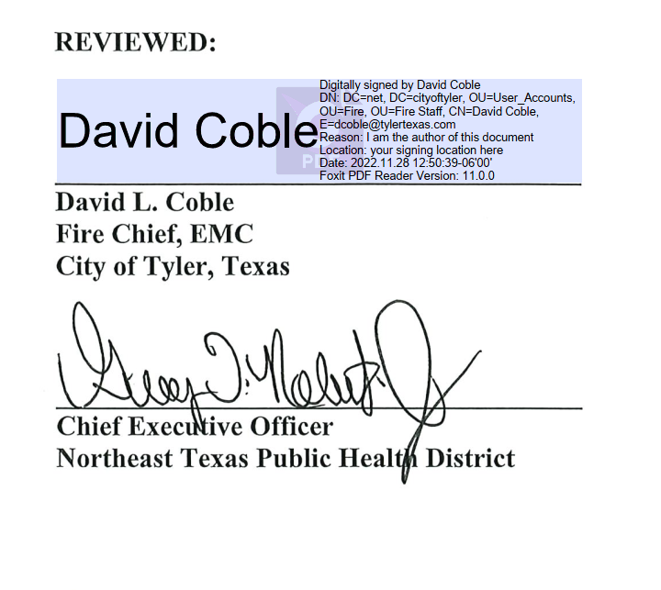

Smith County FMO
Smith County, Texas

