*Homecoming Spirit Week Sept 11-15th*
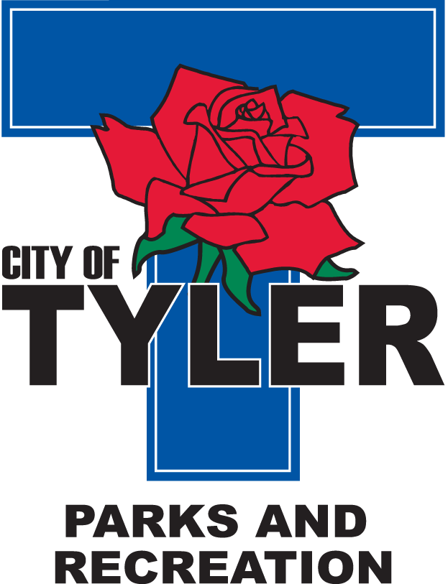  Welcome to The Tyler Senior Center  Open 9a.m.-5p.m. Monday-Friday    1915 Garden Valley Road (903) 597-0781    Meals on Wheels Lunch Served Daily 11:30a.m.-12:30p.m. | September  2023  Activities are subject to change
Monday | Tuesday | Wednesday | Thursday | Friday
1
10:00 Medicare with Karlee McNew
11:00 Bodyworks
12:00 42 Game
12:30 Bridge Club

4  Closed  for  Labor Day | 5  10:00 Painting 11:00 Range of Motion  11:30 Clogger  12:30 Line Dancers | 6  10:00 Coffee Center Chat  11:00 Bodyworks  12:30 Bridge Club  12:30 BINGO with Brookdale | 7  11:00 Range of Motion  12:00 G.V. Singers  12:30 Line Dancers  12:30 Left, Right, Center Game | 8  11:00 Bodyworks  12:00 42 Game  12:30 Bridge Club
11  11:00 Bodyworks  12:00 Memory Card Game  12:30 Bridge Club  Nerd Day   | 12  10:00 Painting 11:00 Range of Motion  11:30 Cloggers  12:00 Line Dancers  2:00 AARP  Superhero Day   | 13  11:00 Bodyworks  12:30 Bridge Club  12:30 BINGO with Harbor Hospice  Western Day   | 14  11:00 Range of Motion  12:00 G.V. Singers  12:30 Line Dancers  2:00 GV Singers at Oakbrook  2:00 AARP  Camo Day   | 15  11:00 Bodyworks  12:00 42 Game  12:30 Bridge Club  Sports Day  
18  11:00 Bodyworks  12:00 Left, Right, Center Game  12:30 Bridge Club | 19  10:00 Painting  10:00 Medicare by Steve Davis 11:00 Range of Motion  11:30 Cloggers  12:30 Line Dancing  1:00 UT Health Lifestyle Program | 20  11:00 Bodyworks  12:30 Bridge Club  12:30 BINGO with Reunion Plaza | 21  11:00 Range of Motion  12:00 G.V. Singers  12:30 Line Dancers | 22  11:00 Bodyworks  12:00 42 Game  12:30 Bridge Club  Friday Night Dance-doors open at 6pm-Music by Mr. C  Senior Fair Day- wear your shirts!
25  11:00 Bodyworks  12:30 Bridge Club  September Birthday Celebration | 26  10:00 Painting 11:00 Range of Motion  11:30 Cloggers  12:30 Line Dancing  1:00 ABBOTT with Melissa Ryan | 27  11:00 Bodyworks  12:30 Bridge Club  12:30 BINGO with Humana and Oak Street Health | 28  11:00 Range of Motion  12:00 G.V. Singers  12:30 Line Dancers | 29  11:00 Bodyworks  12:00 42 Game  12:30 Bridge Club

