
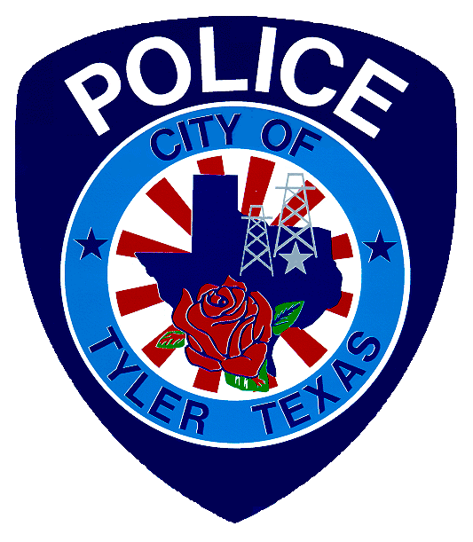

National Night Out
REGISTRATION FORM

Please join us in celebrating N.N.O. ™ by planning your own neighborhood celebration on the first Tuesday of October, between the hours of 5:00 PM and 9:00 PM. Questions? Please call the Tyler Police Department Community Response Unit at (903) 531-1096 or visit the TPD webpage at: www.cityoftyler.org/government/departments/police-department and click on the COMMUNITY tab at the top, then National Night Out for information.
REGISTRATION
Party Coordinator: _____________________________________________________________________________________
Coordinator’s Address __________________________________________________________Zip:_____________________
Home Phone: __________________________________Alternative Phone: _______________________________________
E-Mail: ______________________________________________________________________________________________
Party Co-Coordinator: __________________________________________________________________________________
Co-Coordinator’s Address: ______________________________________________________Zip:_____________________
Home Phone: __________________________________Alternative Phone: _______________________________________
E-Mail: ______________________________________________________________________________________________
Do you need your street blocked off? (Put X beside choice) YES___ NO___
Location to be blocked off? ____________________________________________________________________________________________________
Celebration Location (Address): ____________________________________________________________________
Start Time: ________________________________________End Time: __________________________________________
Party At: (Put X beside choice)
Backyard ____ Driveway ____ Other_____________________________________
Street ____ Park ____ _____________________________________
Clubhouse ____ Pool Area ____ _____________________________________
Events Planned: _____________________________________________________________________________________
___________________________________________________________________________________________________
Please submit completed form to the address below no later than the end of the 4th week of September:
City of Tyler Police Department – Community Response Unit
574 W Cumberland Rd
Tyler TX 75703
Bring the form by either Police Station, Ferguson St or Cumberland Rd, mail, or email form to cnance@tylertexas.com
Late registrations may be excluded from the Officer-Visitation List

